Week 4-w/b 04.05.2020
Year 1/2
Day | Literacy | Maths | Curriculum
Mon | Spelling – The spelling words are in the resources file.  Sapphires and Rubies - Write your spelling words in alphabetical order.  Emeralds – Write your spelling words and then write them in the long form, e.g. write can’t and then, can not  10:30 - Year 1 – Phonics  Year 2 – Spelling and Grammar Mat  If you don’t have a printer just draw and write it into your writing book.  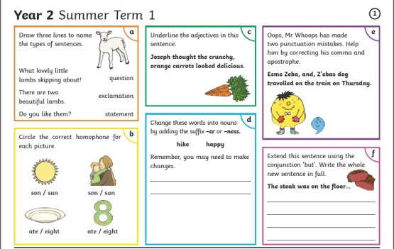 | Lesson 1: - Roll the Dice, Addition and Subtraction  Get three dice, roll and add the numbers.  3 + 6 + 4 =  Do 10  Roll three dice and put them in order from biggest to smallest.  e.g. 6, 5 and 3  Add together the first two numbers  6 + 5 = 11  Then take away the smallest number,  11 – 3 = 8  Do 10  Roll two dice to make a 2 digit number, then roll one dice and subtract that number.  e.g. I roll a 5 and a 1 to make 51. Then I roll a 4.  51 – 4 =  Extension – Roll the dice to make 2, two-digit numbers, add them. Do 5. Repeat, roll the dice to make 2, two-digit numbers and then subtract the smaller number from the bigger number. Do 5. | Design Technology-Science – Forces  Push or Pull toy sort. Can you go around your house and find all of the toys that require a push or pull force to make it work? Can you sort them into three groups?  Push Pull Push and Pull  Look at the Push and Pull powerpoint (or pdf) in the resources folder. Parents - Some of it you may need to change for your home learning situation.  Your task is to design a new toy that uses the push and/or pull force. Find the deign brief in the resources folder.  What materials will you need?  How will it work?  Design and plan your toy before building!  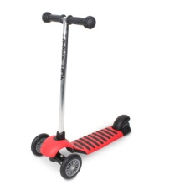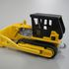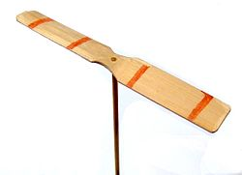  If you need some ideas, have a look at the ‘ideas of toys using push/pull forces’ in the resources folder.
Tues | Handwriting  Joining 3 letters - Use the diagonal join to join three letters without lifting your pencil. Always take the join from the end of one letter up to the start of the next letter. Make sure all the letters start at the correct height.  all ail air ell  10:30 - Year 1 – Phonics  Choose a challenge from the ‘Fantastic Mr Fox Challenge Ideas’ sheet in the resource folder. | Lesson 2 – Time, AM and PM  Revise hour and half hour times...  https://www.youtube.com/watch?v=VAFkVIiUM6I  AM and PM  https://www.youtube.com/watch?v=ziyhFgPFFEs&list=PLYM4yncims3-50vzyYZq_TOYbdX9yypaw&index=4  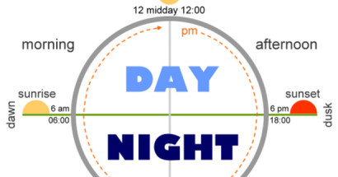  Complete the Tuesday maths work in resource file. | Music  Charanga – Yumu  I will send the log in details for your child to access the Yumu Charanga website via Dojo.  Lesson 4 – The Friendship Song  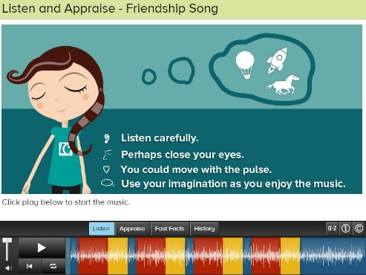
Wed | Spelling  Make a word search or crossword with your spelling words!  10:30 - Year 1 – Phonics  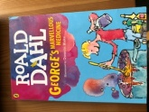  George’s Marvellous Medicine – Chapter 1  - What time did Mum ask George to give Grandma her medicine? Draw a clock showing the time.  - How does Granny feel about ‘growing’?  - How old is George?  - What does Grandma think caterpillars give you?  - How does Grandma make George feel?  - Draw Granny and write adjectives to describe her! | Lesson 3 – Time, The Minutes (part 1)  https://www.youtube.com/watch?v=-8kzwzsJFPE&list=PLYM4yncims3-50vzyYZq_TOYbdX9yypaw&index=5  Complete Wednesdays maths work in resource file  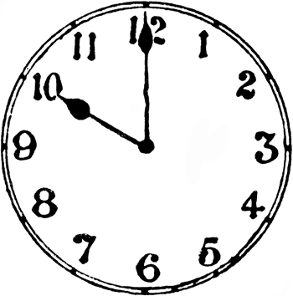 | P.E.  - Choose 6 exercises you want to do from the Fitness Cards (or choose 6 of your own).  - Number the exercises.  - Get a dice.  First, get an adult to help you count your heart beats, by taking your pulse.  Then roll the dice and do the exercise that is on the card for 30, 40 or 60 seconds (1 minute) depending on how fit you feel Roll the dice again, do the activity, roll it 5 more times.  Afterwards, take your pulse again, what has happened? Why? What else is different in your body? Have a big drink of water and a little rest (maybe read a book?)
Thurs | Handwriting – Spelling handwriting  10:30 - Year 1 – Phonics  - George’s Marvellous Medicine, Chapter 2. Draw and write about all of the plans George had for Grandma.  - View the VE power point and then read and follow a war time recipe!  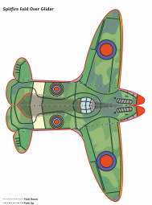 | Lesson 4 – Time, The Minutes (part 2)  https://www.youtube.com/watch?v=T2k01ovrfys&list=PLYM4yncims3-50vzyYZq_TOYbdX9yypaw&index=6  Predicting time... ask your parents to start you off and then tell them when you think the time is up!  How long is,  - A minute  - 5 minutes  - 10 minutes  - Half an hour  - 1 hour  Were you close?? | Geography  What is a map? Do you have any maps at home? Get them out and have a look at them.  What is the purpose of these maps? What do they all have on the side of them?  Look at the power point, ‘Mapping it out’ in the resource folder. You are going to make a sketch map of Arnside National School and the immediate area around it.  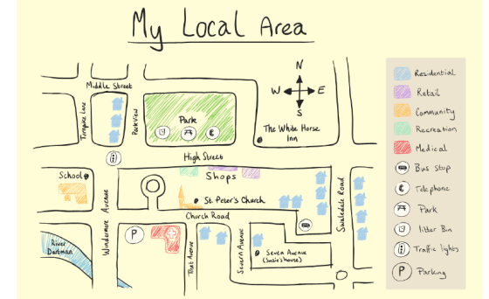
Fri | Spelling – Ask you Mum or Dad to test you, you can do it by saying it out loud or writing it down.  This Photo by Unknown Author is licensed under CC BY-SA-NC  10:30 - Year 1 – Phonics (if they do it?)  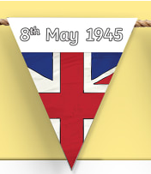  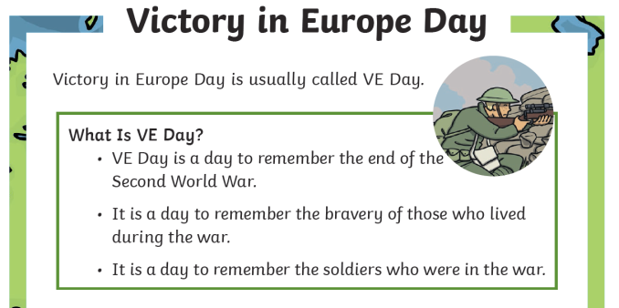  What can you do to remember?  Reading – Get your poetry book and read two of your favourite poems.  You can choose a poem this week, the first choice is and the second is Superheros I could have been. Hannah and Danny shared these poems, thank you Hannah and Danny!! | Lesson 5  If you are not confident with your five times tables, practise them! Skip counting in fives will help you with knowing the minute times.  Play TT Rock stars and then….  Free Choice Maths | Art – Texture Treasure Hunt  Focus artist – Max Ernst ( Surrealist Artist from Germany)  https://www.thenational.academy/year-1/foundation/to-go-on-a-texture-treasure-hunt-year-1-wk2-5  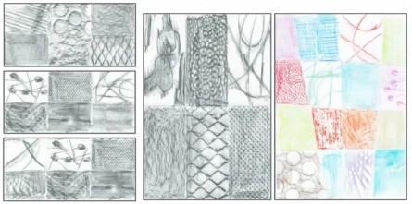

Lessons in red have resources to go with them, uploaded to our class page on the school website.
https://www.arnside.cumbria.sch.uk/classes/year-1-2

