Week 1-w/b 13.04.2020
Year 1/2
Day | Literacy | Maths | Curriculum
Mon | Easter Monday
Tues | Lesson 1  Homophones-What are Homophones?  https://www.bbc.co.uk/bitesize/topics/zqhpk2p/articles/zc84cwx  - Watch the short video.  - Choose the correct homophone.  - Take the quiz!  Spelling – write out your spelling words into alphabetical order  a b c d e f g  Easter Recount  How did you celebrate Easter? What did you do during the holiday? Did you camp in the garden? Bake? Watch movies? Hunt for eggs? Use the ‘Easter Snapshots’ or draw and write your own ideas. Use your writing resources and remember to… Use capital letters, spaces, punctuation and check it makes sense! | Lesson 1:  Make number cards using your strip of card from you home learning pack. (see photo instructions)  Take number cards 0-10. Turn the number cards over, select two numbers, add and subtract the number family  e.g.  7+3=10 3+7=10 10-3=7 10-7=3  Do 5  Take number cards 0-9. Turn over three numbers, make a two-digit number and  Add and subtract  e.g. 3 1 4  13+4=17 4+13=17 17-4=13 17-13=4  Do 5  If you want to…Turn over 4 numbers, add and subtract  e.g. 3 6 7 1  36+17= Partition 36 and 17  Add then tens 30+10=40  Add the ones 6+7=13  Add the totals 40+13=53 13+40=53 53-40=13 53-13=40  Do 5 | Geography  We have been looking at Iceland and Botswana, in particular we looked at the Kalahari Desert and Vatnajokal National Park.  We looked at flags, language, climate, location and population (how many people live there)  Now…  https://www.bbc.co.uk/teach/class-clips-video/geography-ks1-ks2-your-world-edinburgh-addis-ababa/zdy76v4  Make lists of how Edinburgh and Addis Ababa are similar and different.  What are the different geographical features you see in the clip?  Locate where both cities are on a world map, the continents that they belong to and the surrounding seas.
Wed | Lesson 2  Homophones-How to use their, they’re and there  https://www.bbc.co.uk/bitesize/topics/zqhpk2p/articles/z3cxrwx  - Watch the short video.  - Choose the correct homophone.  - Take the quiz!  Handwriting-Page 18 &19 - er  Fantastic Mr Fox  If you have not already listened to chapter 1, listen first.  Draw each farmer and label them with adjectives! Make up some of your own ways to describe them 😊 | Lesson 2  How many ways can you make 10…?  Show me as many ways as you can using all operations you know!  If time, choose a job from  ‘Free Choice Maths’ | Geography  Now watch this…  https://www.bbc.co.uk/teach/class-clips-video/geography-ks1-ks2-your-world-tokyo-london/zv9pbdm  Make lists of the similarities and differences between Tokyo and London.  Can you name some of the human geographical features they see in the clip?  Locate London and Tokyo and you write about the different modes of transport around cities
Thurs | Lesson 3  Homophones-How to use to, too and two  https://www.bbc.co.uk/bitesize/topics/zqhpk2p/articles/zc4jpbk  - Watch the short video.  - Choose the correct homophone.  - Take the quiz!  Spelling – Write your spelling words with blue vowels  Acrostic Poem  Write a poem about Easter or a topic of your choice!  Cakes are fun to make  At home with your family  Keep mixing with a spoon  Eggs, sugar and flour  Spread icing on top when cooked! | Lesson 3  Make a Number Machine  Start with 10, 50 or 100 – be creative!  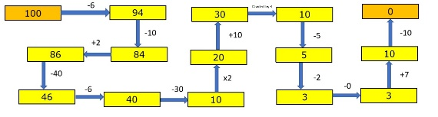 | Geography  Now I would like you to look at England and Senegal!  - Find a world map and locate England and Senegal  - Find out the population (how many people)  - Find out the languages spoken  - Find out about the climate. How warm and cold does it get?  - Draw the flags  - Draw each country  You can choose how to present the information. You could create a comparison chart or a poster for each country.  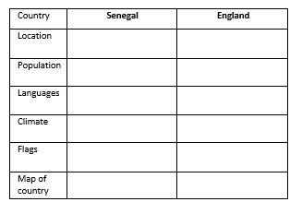
Fri | Lesson 4  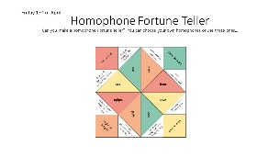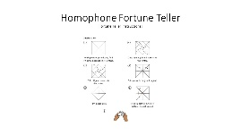  Spelling Test  Ask you Mum or Dad to test you, you can do it by saying it out loud or writing it down.  Book Review  Write a book review about a book you have read this week! How many stars would you give it and would you recommend this book? | Lesson 4  Print out a number square or draw one with a ruler.  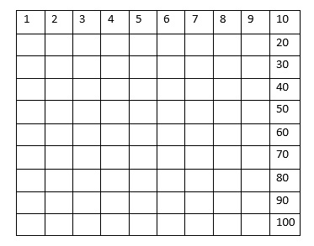  Write numbers to 100, be careful of your formation!  If time, choose a job from  Free Choice Maths | Art -Observational Drawing  Look around your house can you find something to draw? A bowl of fruit, a toy, a pot plant? Go outside and find some flowers, a tree or a minibeast…  Complete and observational drawing of in your black book.  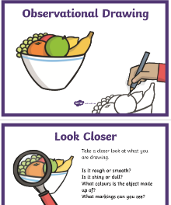

Lessons in red have resources to go with them, uploaded to our class page on the school website.
https://www.arnside.cumbria.sch.uk/classes/year-1-2

