Week 6-w/b 18.05.2020
Year 1/2
Day | Literacy | Maths | Curriculum
Mon | Spelling – The spelling words are in the resources file. Can you write your spelling words in a pyramid?  10:30 - Phonics  Creative Writing  Find this writing challenge card in the week 6 resource folder  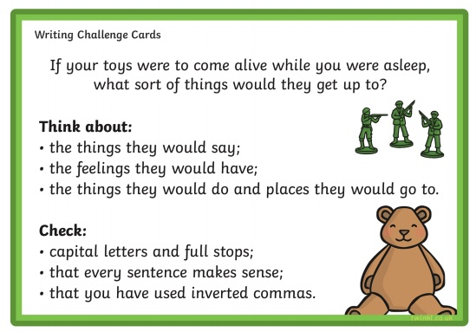 | Lesson 1: - Addition and Subtraction  Keep practising your number bonds!  You might like to do another speed test?  Then play one of these games!  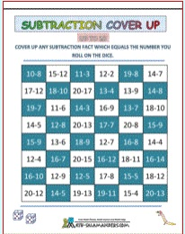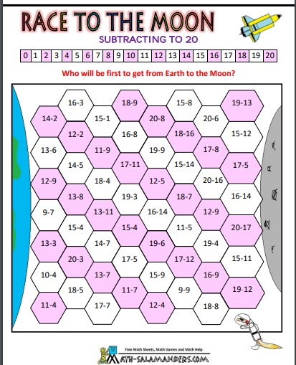  *If you do not have a printer, play a board game you have at home. | Science – What is light?  Science Lesson with Miss Ems from the National Oak Academy  https://www.thenational.academy/year-2/foundation/what-is-light-year-2-wk1-3  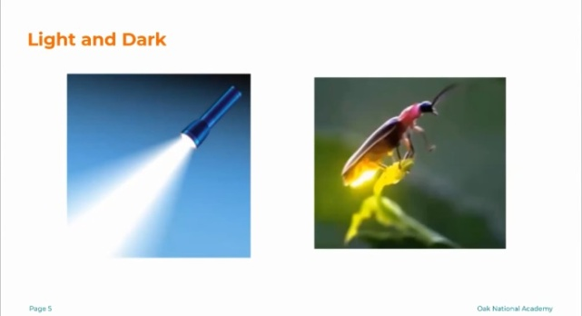  *Please note this is a lesson for Year 2, however, Year 1 children should enjoy this lesson also.
Tues | Handwriting  The diagonal join to a, c and o  ha da ho to do tch  10:30 - Phonics  George’s Marvellous Medicine  What is an advertisement? Can you look at some advertisements? Can you create a poster to advertise George’s Medicine? Find Tuesday’s literacy activity in the resource folder.  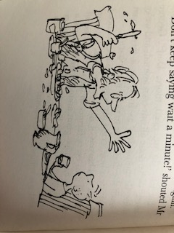 | Lesson 2 – Measurement-Capacity  Which container holds the most?  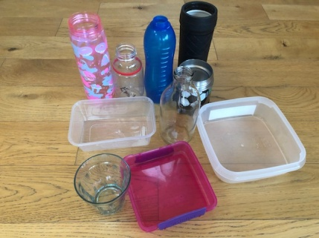  Find Tuesday’s maths in the resources folder | Music  Charanga – Yumu  Lesson 5 – The Friendship Song  That’s what friends are for  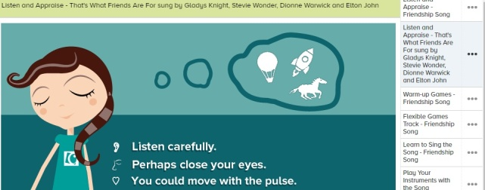
Wed | Spelling – Word Search  10:30 - Phonics  Roald Dahl Fact File  - Read some information about Roald Dahl, ‘Roald Dahl Information’ and look at the ‘Roald Dahl Fact File’ power point.  - Look around the Roald Dahl website, https://www.roalddahl.com/roald-dahl  - Complete a Fact File, there are three choices. | Lesson 3 – Measurement-Capacity  Estimate, more than and less than...  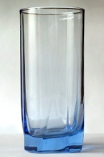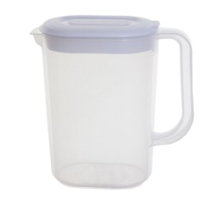  Find Wednesday’s maths in the resources folder | P.E. Make an obstacle course!  Can you include;  - Walking toe to-toe along a line.  - Jumping over something.  - Crawling through/under something.  Some ideas...  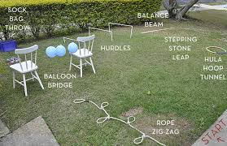
Thurs | Handwriting – Spelling handwriting  10:30 – Phonics  Book Review  Can you review Fantastic Mr Fox or George’s Marvellous Medicine OR review both and explain why you prefer one of the other!  There are templates in the resources folder or you can do your own in your writing book. | Lesson 4 – Measurement-Capacity  Standard units of measure  - Which of these bottles looks the largets? Which is the largest?  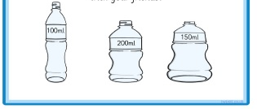  Find Wednesday’s maths in the resources folder | Science: How can we see objects?  Science Lesson with Miss Ems from the National Oak Academy  https://www.thenational.academy/year-2/foundation/how-can-we-see-objects-year-2-wk2-3#slide-1 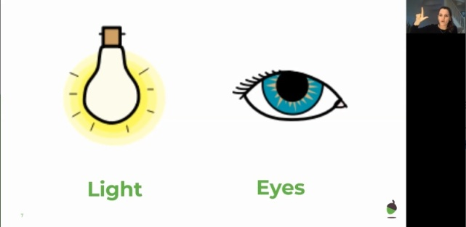  *Please note this is a lesson for Year 2, however, Year 1 children should enjoy this lesson also.
Fri | Spelling – Ask you Mum or Dad to test you, you can do it by saying it out loud or writing it down.  This Photo by Unknown Author is licensed under CC BY-SA-NC  10:30 - Phonics  Reading – Get your poetry book and read two of your favourite poems.  Ask your Mum and Dad to help you read ‘Three Little Pigs’, by Roald Dahl. Draw some pictures to illustrate the poem. | Lesson 5  Division with Clara the Hen!  https://www.bbc.co.uk/teach/supermovers/ks1-maths-multiplication-and-division-with-clara-the-hen/zbt9scw  Play TT Rock stars and then….  Free Choice Maths | Art – Shadow Art  Miss Harris will help you create shadow art  https://www.thenational.academy/year-1/foundation/to-create-shadow-art-year-1-wk5-5  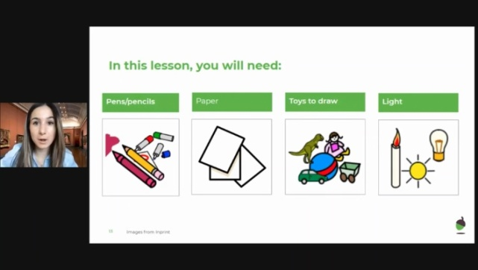
Lessons in red have resources to go with them, uploaded to our class page on the school website.
https://www.arnside.cumbria.sch.uk/classes/year-1-2

