Week 3-w/b 27.04.2020
Year 1/2
Day | Literacy | Maths | Curriculum
Mon | Spelling – find your child’s spelling words in the resources file and choose how to write them out, you might do some or all of your words!  You could choose,  - Chalk  - Paint  - Playdough (make the words)  - Water – use a paintbrush, dip it in the water and write it on concrete  - Cooked spaghetti (shape the words)  - Dots, then join with a coloured felt pen  DfE Phonics, 10:00 or 10:30  I sent out a message on Dojo on Sunday afternoon, but in case you missed it...there is a letter in the resource folder from the Department for Education about the phonics videos. Parents, if you feel you need to check how to pronounce the phonemes please watch this short video. https://www.youtube.com/watch?v=TTe5_Em0BHQ  I will send a message to you if I would like you to revise a particular level with your child. Otherwise, Year 1 parents please start with the Year 1 lesson.  Why are we doing this?  https://www.youtube.com/watch?v=u8C8BCB4hvc  (Instead of Phonics)  Year 2 – Prefixes https://www.bbc.co.uk/bitesize/topics/z8mxrwx  - Watch the video  - Do the activities  - Take the quiz | Lesson 1: - Number bonds to 20 and related subtraction facts  Note for parents: Children need to have instant recall of their number bonds to 10 and 20, including related subtraction facts.  Open the 27.4 Number bonds document and follow the instructions at the top.  Number bonds to 10 - Draw 2 tens frames on a piece of paper  Number bonds to 20 - Draw 4 tens frames of a piece of paper  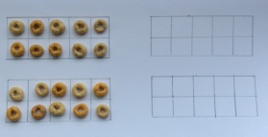  For further steps go to the, Number Bonds 27.4 pdf document in the week 3 resources folder | Science – Forces  Toy car experiment – find this document in the week 3 resource folder.  A force is a push or a pull.  Forces can make object move or stop, speed them up or slow them down.  If you push a toy car it moves, if you push it harder it moves faster.  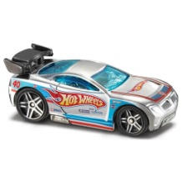  Forces can also make objects change direction or shape.  Watch this video,  https://www.bbc.co.uk/bitesize/topics/zn77hyc
Tues | Handwriting al Page 26-27  DfE Phonics, 10:00 or 10:30  Reading: Fantastic Mr Fox, Chapter 11 and 12  **This should be done over two days**  - Ask your Mum or Dad to help you read the questions from the resource folder.  - Listen to chapter 11 and 12 again  - *Year 1, verbally tell you parents your answers and then choose 1 question for each section to write your answer.  *Year 2, write your answers to these questions in complete, full sentences | Lesson 2 – Time – half hour  Go back to the horizontal number line and position the hand half way “past” the 2 and 3, as below:  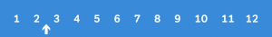  An arrow on the number line pointing between two and three to represents half past two. Explain that because the hour hand is halfway between the 2 and 3 (or half way past the 2) we say “it is half past 2”. This means it is half way past two hours. Repeat for various numbers.  Then, once again, rearrange your number cards into a circle to model a clock face and get your child to show various times using their hour hand only.  Then ask what time it will be half an hour later and show how it will be 3 o’clock.  Then half past 3, and so on. Repeat this using your hour hand only.  Once this is secure, there is lots of Maths you can do using your circular number line to work out what time it will be:  - Half an hour later  - Half an hour earlier  - An hour and a half earlier  - An hour and a half later | Music  Charanga – Yumu  Lesson 2 – Count on Me  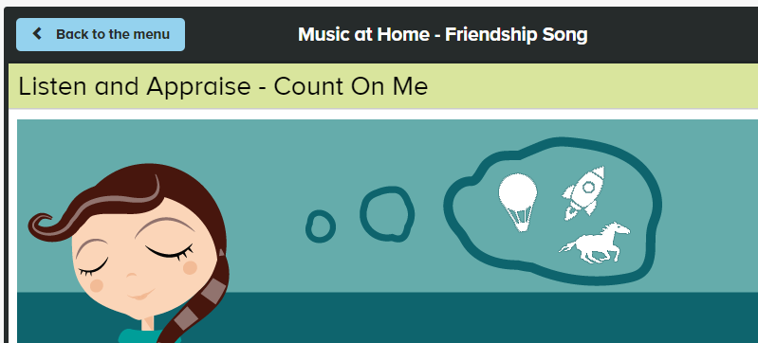  - Listen and appraise  - Play some games  - Sing the Friendship song
Wed | Spelling – write the focus sound in each word in a different colour.  e.g.  for OR station  DfE Phonics, 10:00 or 10:30  Reading: Fantastic Mr Fox, Chapter 11 and 12  Finish answering the questions and then email or Dojo your work | Lesson 3 – Time – half hour  Last week you watched this and stopped at 2 minutes, now start at 2 minutes  https://www.youtube.com/watch?v=XJqbhP_gIsk  Website with teaching clock, your child can use this to show you different times, or they can use their clock that they made.  https://www.visnos.com/demos/clock  Throughout the day when you are doing other things say things like, “we will have lunch at 12:30 and look, the hand is almost half way between the 12 and the 1 that must mean it is almost 12:30, so in a few minutes it will be time for lunch.”  Try and do this as much as possible every day!  Free Choice Maths | P.E – Yoga  In the Week 3 resource folder you will find Yoga Cards 29.4, please read the preparation and safety card first, it is the last card in the pdf  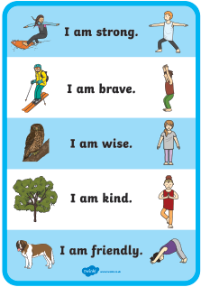
Thurs | Handwriting – Spelling handwriting  DfE Phonics, 10:00 or 10:30  (Instead of Phonics)  Year 2 Suffixes  https://www.bbc.co.uk/bitesize/topics/z8mxrwx/articles/zwgbcwx  - Watch the video  - Do the activities  - Take the quiz | Lesson 4 – Time  In your black book write and draw what time you do things in your day...  E.g.  At half past seven I got up.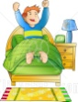  At eight o’clock I had my breakfast.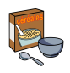  At half past eight I got dressed and brushed my teeth. 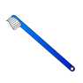  At 9 o’clock I did P.E with Joe. 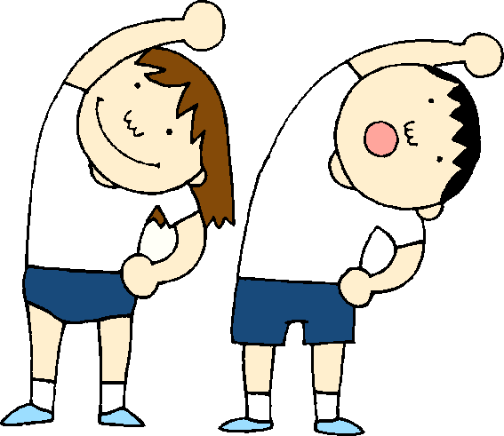 | Science - Forces  Ball Rolling Experiment – find the experiment in the week 3 resources folder.  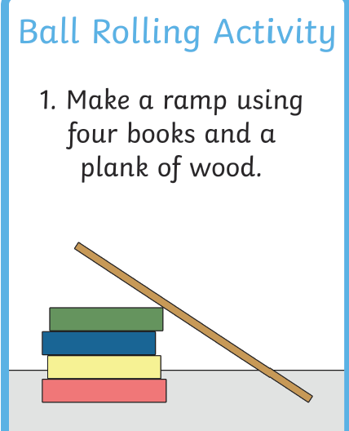
Fri | Spelling – Ask you Mum or Dad to test you, you can do it by saying it out loud or writing it down.  This Photo by Unknown Author is licensed under CC BY-SA-NC  DfE Phonics, 10:00 or 10:30  Reading – Get your poetry book and read two of your favourite poems.  Find The Rainbow poem in your home learning pack. Read it one or two times.  Can you find,  - Capital letters,  - Commas (explain why we use commas)  - An exclamation mark (explain what we do when we read an exclamation mark  - A word with some sounds you know, think about sounds you know made with two or three letters (parents normally I would say the sound and they would find it) | Lessons 5 – Finish your time work  OR  Play TT Rock stars and then….  Free Choice Maths | Art – Andy Goldsworthy  Use this link to go to the lesson, you will need the equipment below.  https://www.thenational.academy/year-1/foundation/to-investigate-the-colours-year-1-wk1-5/  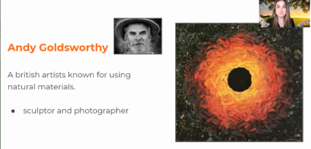  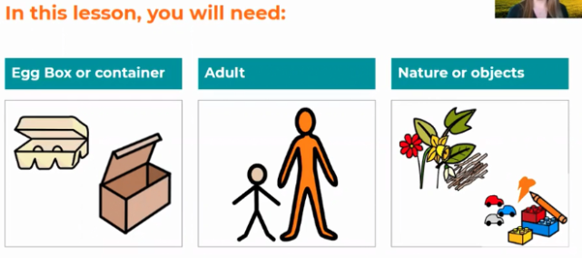  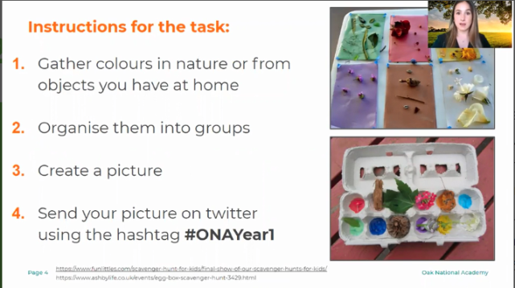

Lessons in red have resources to go with them, uploaded to our class page on the school website.
https://www.arnside.cumbria.sch.uk/classes/year-1-2

