Week 2-w/b 20.04.2020
Year 1/2
Day | Literacy | Maths | Curriculum
Mon | Spelling – find your child’s spelling words in the resources file and…  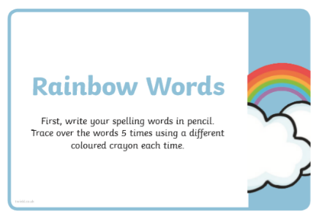  Reading-listen again to the part of Chapter 2 that is covered in the ‘Fantastic Mr Fox extract for the 20.4.’ in the resources folder for this week. (I will read it again in my lesson introduction). Alternatively, if you have the book read it with your child.  Create a story setting map (see the example of Winnie the Pooh). Remember to include the tree and fox hole, Boggis’s farm, Bunce’s farm and Bean’s farm. | Lesson 1: -Coin sort! In the ‘Free Choice Maths’ document one activity asks your child to sort your loose change. Could they sort the coins first and then do this activity which is in the resource folder? (Thank you to Phoebe for this activity!)  Ask Mum or Dad to put all of their loose change in a bowl. Can you find all of the different coins and group them together? Can you find all of the 1p coins and count them? The 2p coins and count in 2s? The 5p coins and count in 5s etc  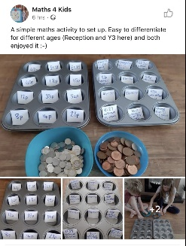 | Science – Rainbows  During this time, there has been a lot of talk about rainbows… have you made one to display?  Look at the power point ‘all about rainbows’ in the resources folder.  How to grow a Rainbow!  Have a go at the science experiment (in the resources folder)  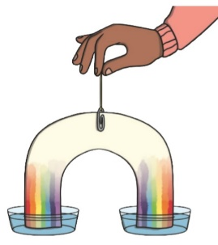  Do you know the song, ‘I can sing a rainbow’? Do you know the sign language for the song? Find a copy of the sign language in our resources file and have a go. https://www.youtube.com/watch?v=pkvrA_xwZ3E
Tues | Handwriting air Page 24-25  Comic Strips-Lesson 1 (Inspired by Illy, see his comic ‘Invisible Jake’, thanks Illy!)  Find the document ‘Creating a Comic’, it is in the Week 2 Resources and Examples folder on our class page. Read ‘Step 1’. Look at some comics that you have at home or the examples in the plan.  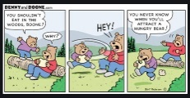  Look at the document ‘Creating a Comic’ again and read Steps 2-5.  In the resources file, find the 2 plans and choose the one you wish to use, you may only need 4 boxes or your might like to use the 8-box plan.  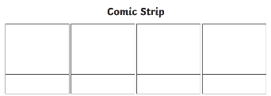 | Lesson 2 - Time  Go on a time hunt. Find and draw/photograph all of the ‘things’ in your house that your family use to know what time it is.  Find a clock that looks a bit like this (analogue clock)  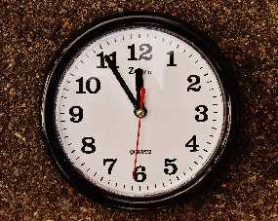  This is called an analogue clock.  Now find a clock that looks a bit like this (digital clock)  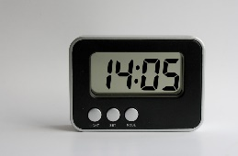  This is called a digital clock. We are going to learn about analogue clocks first.  Draw a confidence grid put a smiley face where you think is the right place for how much you know about telling the time. e.g.  😊  I do not feel confident I feel confident | Music  Charanga – Yumu  I will send the log in details for your child to access the Yumu Charanga website via Dojo.  Lesson 1 – The Friendship Song  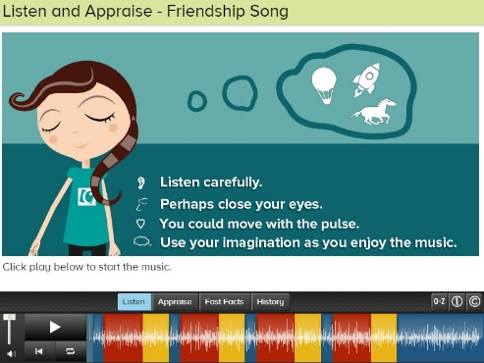
Wed | Spelling –  Emeralds have a crossword created by Illy and his family (Thank you!)  Rubies and Sapphires have a wordsearch to do.  The crossword and the wordsearch are in the resources folder.  Reading – read a book from Oxford Owls or Epic!  Comic Strips-Lesson 2  Finish your comic plan… | Lesson 3 – Time  Get your number cards, find the number cards 1-12 and make a number line from 1-12.  Get your clock materials from your Home Learning pack.  Make a long arrow and cut it out. Put it on the 1. This shows 1 hour, instead we call this 1 o’clock. Now put it on the 2, what do we call that? Keep counting until, 12 o’clock. What happens next on the analogue clock? Instead of 13 we put the number line in a circle and go back to 1.  Watch the first two minutes of this video, stop at 2 minutes.  https://www.youtube.com/watch?v=XJqbhP_gIsk  Look at the analogue clock in your house. Can you make your numbers go in a circle now? Put your arrow in the middle. What is one hour later than….? (do 5 or 6 of these), now 3 hours later? etc Two hours earlier? 4 hours later? (do 5 or 6 of these)  Solve it! - I went to the shop, I left home and 10 o’clock and got to the shop at 12 o’clock, how long did it take me to get to the shop? | P.E  What are you doing to stay fit and healthy during this time at home?  Why do we need to be fit to be healthy?  https://www.bbc.co.uk/bitesize/clips/z274d2p  Draw and write all of the things you are doing. It might be going for a walk each day with your family. Playing in the garden, doing morning or afternoon exercise like PE with Joe.  This Photo by Unknown Author is licensed under CC BY-SA
Thurs | Reading – read a book from Oxford Owls or Epic!  Comic Strips-Lesson 3  Publish your comic!  Look at the document ‘Creating a Comic’ again and read Step 6.  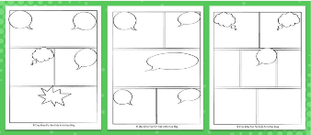 | Lesson 4 – Time  Let’s practise telling the time sheets…  There are four pages, work through. Go as slowly or as quickly as your child needs to. If your child needs to spend more than one day on these, no problem. If your child is finding it easy, they can whiz through.  When finished the above…  Using the materials in your Home Learning pack…  Make your clock  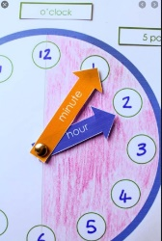 | Science - Minibeasts and Microhabitats  If you went out into your garden right now, which minibeasts might you find and where would you find them?  - Look at the microhabitats power point in the resource folder.  - Write a list of minibeasts you might find in your garden…  - What microhabitats might you find in your garden? Make a list.  - https://www.bbc.co.uk/bitesize/clips/z49g9j6  - Go out and explore your garden. If you have a magnifying glass, a tray, tweezers and gardening tools, take them with you.  - Take photos, or draw the minibeasts you see and record where you found them.  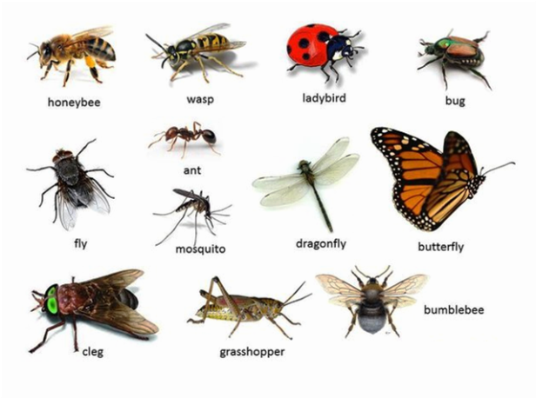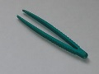  This Photo by Unknown Author is licensed under CC BY-NC-ND  This Photo by Unknown Author is licensed under CC BY-SA
Fri | Spelling – Ask you Mum or Dad to test you, you can do it by saying it out loud or writing it down.  This Photo by Unknown Author is licensed under CC BY-SA-NC  Reading – Get your poetry book and read two of your favourite poems, preform one for your family (like we did with the tongue twisters).  Sophia wrote a poem and said I could share it with you (Thank you Sophia!)  If you would like to print it out or even better, handwrite her poem into your poetry book, then publish it! | Lessons 5 – Finish your time work  OR  Play TT Rock stars and then….  Free Choice Maths | Craft – Origami Fish  There are instructions in the resource folder!  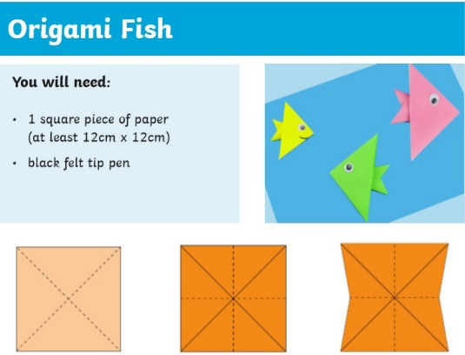

Lessons in red have resources to go with them, uploaded to our class page on the school website.
https://www.arnside.cumbria.sch.uk/classes/year-1-2

