Otter Class - Core Books
Types of Texts | Title | Author | Core Books
Archaic Language | The Owl and the Pussycat (A)  Jack and the Beanstalk (A)  The Tale of Squirrel Nutkin (B) | Edward Lear  Traditional-Ladybird  Beatrix potter | 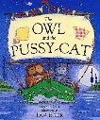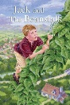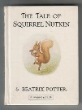
Non-Linear Text | Grandpa (B) | John Birmingham | 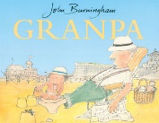
Narratively Complex | The Day the Crayons Quit (A)  Fantastic Mr Fox (B)  The Three Little Wolves and the Big Bad Pig (B)  The Giraffe the Pelly and Me (A) | Drew Daywalt  Roald Dahl  Eugine Trivizas  Roald Dahl | 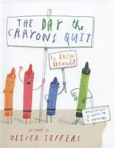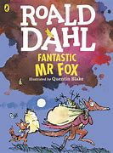  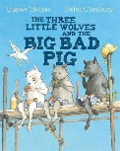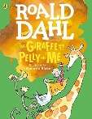
Complexity of Plot/Symbolism | Grandad’s Island (A)  The Lotus Seed (B)  I do not mind you, winter wind-Poem (A)  And if the Moon Could Talk (A) | Benji Davies  Sherry Garland  Jack Prelutsky  Kate Banks and Georg Hallensleben | 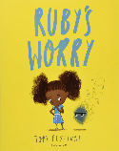  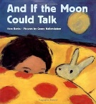
Resistant Text | Lost and Found (A)  The Colour Monster (A)  The book with no pictures (B) | Oliver Jeffers  Anna Llenas  B J Novak | 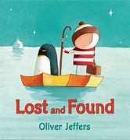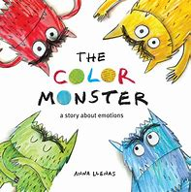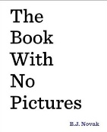
Non-Fiction Texts | Seasons Come, Seasons Go: Tree (A)  My First Book of Birds (A) |  | 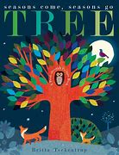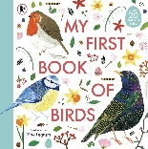
Stories from Around the World | Ossiri and the Bala Mengro (B)  Grandad Mandela (A) | Richard O’Neill and Katherine Quarmby  Zazi, Ziwelene and Zindzi Mandela and Sean Quails | 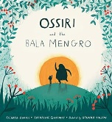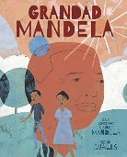
Modern Texts | Grandma Bird (B)  Winter Sleep (A)  The new small person (B)  Bear Snores on (A)  The Golden Glow (A)  Under and Over the snow (B)  Mad about Minibeasts (B)  The Storm Whale (B)  Alan’s big scary teeth (B) | Benji Davies  Sean Taylor and Alex Morss  Lauren Child  Karma Wilson  Benjamin Flouw  Roald Dahl  Giles Andreae  Benji Davies  Jarvis | 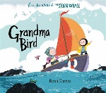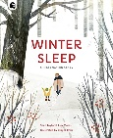  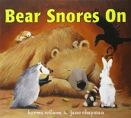  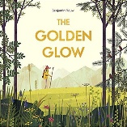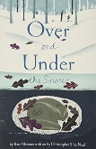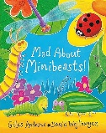  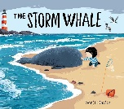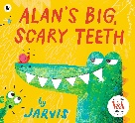
Curriculum Cycle Year A – 15 /Year B – 12
- Archaic Texts- The vocabulary, usage, syntax and contexts for cultural reference of texts over 50 or 100 years ago are different and typically more complex than texts written today.

- Non-Linear Texts – Traditionally, texts are sequenced from start to finish but in Non-Linear texts, time moves in fits and starts, flash backs and flash forwards are used.

- Narratively complex texts – Books are sometimes narrated by an unreliable narrator, so the story is missing elements or have been misunderstood by the narrator. (e.g. Warhorse)

- Complex Plot Texts - Texts which happen on a figurative or symbolic level.

- Resistant Texts - Texts written to deliberately resist easy meaning-making by readers. Poems often fall into this category. Readers have to assemble meaning around nuances, hints, uncertainties and clues.

