 | w/b 20.04.2020 | Reception – Home Learning |  | Week 2
Day | Phonics | English | Maths | Targeted Activities
Mon | Department of Education – Letters and sounds videos. https://www.youtube.com/channel/UCP_FbjYUP_UtldV2K_-niWw/featured?disable_polymer=1  Watch them live at the following times:  11 am – Phase 2 / 3: Learning to blend.  10 am – Phase 3 / 4: Reception Summer Term  10:30 am – Phase 5: Year 1 Summer Term  Please continue to use your jolly phonics strips alongside these online lessons and phonics play to practise the things that have been taught. | This week we are reading the book Rainbow fish.  https://www.youtube.com/watch?v=r9mryuEKkKc&safe=active  The rainbow fish is unique because of his beautiful shiny scales.  Think of some things that make you special. Can you list them? It might be that you have 2 brothers or that you can run really fast.  Complete the all about me page. | Starter: Count to 100  https://www.youtube.com/watch?v=0TgLtF3PMOc  Today we learning about number bonds to 5. Watch this episode of number blocks to help you.  https://www.bbc.co.uk/iplayer/episode/b0blsv9r/numberblocks-series-3-fruit-salad  Complete the number bonds to 5 worksheet. | Watch the holidays then and now power point.  What are some of the things that you like to do on holiday? Are any of the same as things that people used to do?  Complete the holiday differences sheet.
Tues | Department of Education – Letters and sounds videos. https://www.youtube.com/channel/UCP_FbjYUP_UtldV2K_-niWw/featured?disable_polymer=1  Watch them live at the following times:  11 am – Phase 2 / 3: Learning to blend.  10 am – Phase 3 / 4: Reception Summer Term  10:30 am – Phase 5: Year 1 Summer Term  Please continue to use your jolly phonics strips alongside these online lessons and phonics play to practise the things that have been taught. | At the start of the story the rainbow fish is not very kind to his friends.  Make a spider diagram of things that you need to be a good friend.  Write some instructions on how to be a good friend. Remember to number your instructions and start each one on a new line. | Starter:  Piggybank game  https://www.topmarks.co.uk/money/coins-game  Can you remember some of the ways to make 5 from yesterday? See if you can write them down. Do you notice any patterns?  Complete the Number bonds to 5 adding sheet. | Make a collage rainbow fish.  You can use the template in the resource file or make one of your own.  You could use paints, playdough or cut out some shiny materials.
Wed | Department of Education – Letters and sounds videos. https://www.youtube.com/channel/UCP_FbjYUP_UtldV2K_-niWw/featured?disable_polymer=1  Watch them live at the following times:  11 am – Phase 2 / 3: Learning to blend.  10 am – Phase 3 / 4: Reception Summer Term  10:30 am – Phase 5: Year 1 Summer Term  Please continue to use your jolly phonics strips alongside these online lessons and phonics play to practise the things that have been taught. | Being kind to each other is really important.  Look back through the book and find when the rainbow fish was really kind. Can you remember a time when someone was really kind to you?  Write some sentences about when someone was kind to you. Try to add some detail to your sentences. Can you add in when it was or where you were? | Starter : Go on a shape hunt in your house. How many triangles can you find? What about squares? Rectangles?  .  Read How many legs?  https://www.youtube.com/watch?v=gmUY5bXkVKQ  See if you can use some of the pages from the book to make your own number sentences.  Complete theAdding more tiger stripes sheet. See if you can write the number sentences to go with each tiger. | Watch the video on staying healthy.  https://www.youtube.com/watch?v=JgM9bXNVV5U&safe=active  What are some foods that are healthy? See if you can think of some foods that you eat that are good for you and some that you need to eat more of.  Make a healthy eating plate.  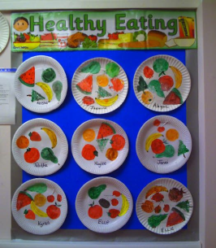
Thurs | Department of Education – Letters and sounds videos. https://www.youtube.com/channel/UCP_FbjYUP_UtldV2K_-niWw/featured?disable_polymer=1  Watch them live at the following times:  11 am – Phase 2 / 3: Learning to blend.  10 am – Phase 3 / 4: Reception Summer Term  10:30 am – Phase 5: Year 1 Summer Term  Please continue to use your jolly phonics strips alongside these online lessons and phonics play to practise the things that have been taught. | What was your favourite part of the book and why? If you can, tell an adult why you liked this book. If you didn’t like it, that’s ok too- as long as you can explain why!.  Complete the book review from the resource file. | Starter:  Sing the number bonds to 10 song.  https://www.youtube.com/watch?v=B_CI6__DvII  Can you write the number bonds to 10? See if you notice a pattern here too.  Complete the Number bonds to 10 sheet. | Make a celery stamp rainbow fish.  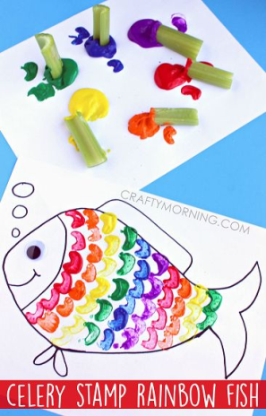
Fri | Department of Education – Letters and sounds videos. https://www.youtube.com/channel/UCP_FbjYUP_UtldV2K_-niWw/featured?disable_polymer=1  Watch them live at the following times:  11 am – Phase 2 / 3: Learning to blend.  10 am – Phase 3 / 4: Reception Summer Term  10:30 am – Phase 5: Year 1 Summer Term  Please continue to use your jolly phonics strips alongside these online lessons and phonics play to practise the things that have been taught. | English  Watch the rainbow fish on youtube. Use the puppets from the file to renact the story.  Complete the Read and colour sheets. | Starter:  Recap the months of the year with this song  https://www.youtube.com/watch?v=v608v42dKeI  Ask a grown up to test you on number bonds to 10. See if you can think of some pairs that make 10, or if they give you a number can you think of its friend to make 10?  Complete the Tiger number bonds sheet. | PSHE  Have you been using a tablet or smart phone during lock down? Can you think of some things they are really helpful for? Can you think of some things that they might not be good for?  Look at the power point and fill in the blanks.  Watch this video and try to sing along!.  https://www.thinkuknow.co.uk/parents/jessie-and-friends-videos/  Colour in safety sheet in the resource file.

