 | w/b 20.04.2020 | Reception – Home Learning |  | Week 2
Day | Phonics | English | Maths | Targeted Activities
Mon | Department of Education – Letters and sounds videos. https://www.youtube.com/channel/UCP_FbjYUP_UtldV2K_-niWw/featured?disable_polymer=1  Watch them live at the following times:  11 am – Phase 2 / 3: Learning to blend.  10 am – Phase 3 / 4: Reception Summer Term  10:30 am – Phase 5: Year 1 Summer Term  Please continue to use your jolly phonics strips alongside these online lessons and phonics play to practise the things that have been taught.  I have included a phase 3 phonics revision booklet in the resources. It would be really helpful if you could complete this over the week and send me some photos to use as an assessment for next year. | This week we are reading the book Barry the fish with fingers.  https://www.youtube.com/watch?v=Ewsgwj-wM4w  Barry the fish with fingers has many skills that he shares in the story.  Make a class list of all the wonderful skills you have. Concentrate on the spelling of each word.  I have included a handwriting pack for you to complete over the week. Make sure that you use a sharp pencil and you are sitting with good posture before you start. | Starter: Count to 100  https://www.youtube.com/watch?v=0TgLtF3PMOc  Today we learning about estimation. Watch this video to remind us about what estimating is.  https://www.youtube.com/watch?v=ygO4la2Ljug  Independent: Ask a grown up to make some jars of items for you to estimate. Once you have made your estimate, check by carefully counting them. | Make a jelly fish. You can use a paper plate cut in half for the body and streamers or string for the legs.  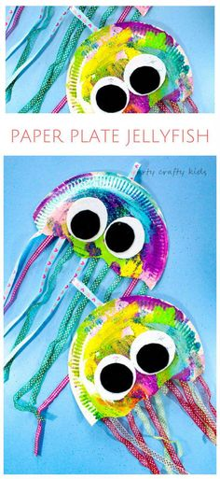
Tues | Department of Education – Letters and sounds videos. https://www.youtube.com/channel/UCP_FbjYUP_UtldV2K_-niWw/featured?disable_polymer=1  Watch them live at the following times:  11 am – Phase 2 / 3: Learning to blend.  10 am – Phase 3 / 4: Reception Summer Term  10:30 am – Phase 5: Year 1 Summer Term  Please continue to use your jolly phonics strips alongside these online lessons and phonics play to practise the things that have been taught. | Barry and his friends decide to have a party to celebrate that Puffy is safe.  what you would need for a party? Write a list of what you would need.  Use the party invitation template to write an invitation.. | Starter: https://www.topmarks.co.uk/learning-to-count/ladybird-spots  Open up the estimating power point and work through together.  Complete the Sweet shop estimating sheet. | Watch https://www.youtube.com/watch?v=H28dFnHl1qk  Make a poster about teeth hygiene. You might include how long you should brush your teeth for or what foods are not good for your teeth.
Wed | Department of Education – Letters and sounds videos. https://www.youtube.com/channel/UCP_FbjYUP_UtldV2K_-niWw/featured?disable_polymer=1  Watch them live at the following times:  11 am – Phase 2 / 3: Learning to blend.  10 am – Phase 3 / 4: Reception Summer Term  10:30 am – Phase 5: Year 1 Summer Term  Please continue to use your jolly phonics strips alongside these online lessons and phonics play to practise the things that have been taught. | Continue thinking about the party. Make a list of all the foods you could have. Can you think of some fishy ones?  Write some sentences about your perfect party. | Today we are learning about ordinal numbers. Watch this story to remind you what they are.  https://www.youtube.com/watch?v=SVEHVWLQPyc&safe=active  Order the dinosaurs ordinal numbers sheet. | Read the story “What makes a rainbow” https://www.youtube.com/watch?v=pAoJzDbWGks&safe=active  We have been using the rainbow as a sign of hope during lockdown.  Have a go at making a rainbow and then write what your hopes for the future are.  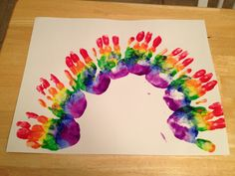
Thurs | Department of Education – Letters and sounds videos. https://www.youtube.com/channel/UCP_FbjYUP_UtldV2K_-niWw/featured?disable_polymer=1  Watch them live at the following times:  11 am – Phase 2 / 3: Learning to blend.  10 am – Phase 3 / 4: Reception Summer Term  10:30 am – Phase 5: Year 1 Summer Term  Please continue to use your jolly phonics strips alongside these online lessons and phonics play to practise the things that have been taught. | Re read the story and retell it in your own words.  Remember to say your sentence out loud before you write it. | Starter:  Play this game https://pbskids.org/peg/games/race-car  Complete the : Ice cream ordinal numbers sheet | Make a starfish. Concentrate on those fine motor skills!  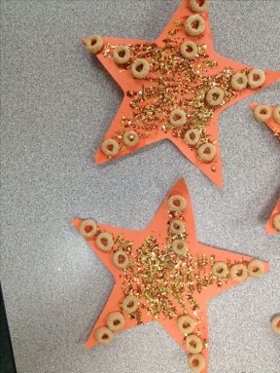
Fri | Department of Education – Letters and sounds videos. https://www.youtube.com/channel/UCP_FbjYUP_UtldV2K_-niWw/featured?disable_polymer=1  Watch them live at the following times:  11 am – Phase 2 / 3: Learning to blend.  10 am – Phase 3 / 4: Reception Summer Term  10:30 am – Phase 5: Year 1 Summer Term  Please continue to use your jolly phonics strips alongside these online lessons and phonics play to practise the things that have been taught. | Retell the story using props or toys that you have at home.  Complete the Under the sea writing. | Starter: Months of the year song  Recap number bonds to 10. See if you can write all the pairs that we learnt last week.  Complete the Star number bonds sheet | Watch the wellbeing power point and complete the activities.  Take part in this yoga class to relax you ready for the weekend!  https://www.youtube.com/watch?v=LhYtcadR9nw&safe=active

