 | w/b 20.04.2020 | Reception – Home Learning |  | Week 2
Day | Phonics | English | Maths | Targeted Activities
Mon | Department of Education – Letters and sounds videos. https://www.youtube.com/channel/UCP_FbjYUP_UtldV2K_-niWw/featured?disable_polymer=1  Watch them live at the following times:  11 am – Phase 2 / 3: Learning to blend.  10 am – Phase 3 / 4: Reception Summer Term  10:30 am – Phase 5: Year 1 Summer Term  Please continue to use your jolly phonics strips alongside these online lessons and phonics play to practise the things that have been taught. | This week we are using the book Sharing a shell.  https://www.youtube.com/watch?v=6KuSl9eXgpk  The tiny hermit crab loves his new shell and doesn't want to share it at first in the story.  Have you got a favourite toy that you really love and find hard to share?  Can you draw a picture of it and write a few sentences about what makes it special to you? | Start off the week by counting to 100. Count by yourself or sing along with our favourite song.  https://www.youtube.com/watch?v=0TgLtF3PMOc  We have looked at days of the week already this term. Remind yourself of the order of them and how we spell them by watching this video and playing the game.  https://www.bbc.co.uk/bitesize/articles/zm9hscw  Complete the days of the week train worksheet. | Open up the sea creature power point and learn about some of the creatures you might find in the sea.  We can make our body move in lots of different ways. We have learnt how to control our bodies in our PE lessons. Sea creatures all move in different ways too. Open up the sea creature posters and see if you can move in some of the ways the sea creatures move.
Tues | Department of Education – Letters and sounds videos. https://www.youtube.com/channel/UCP_FbjYUP_UtldV2K_-niWw/featured?disable_polymer=1  Watch them live at the following times:  11 am – Phase 2 / 3: Learning to blend.  10 am – Phase 3 / 4: Reception Summer Term  10:30 am – Phase 5: Year 1 Summer Term  Please continue to use your jolly phonics strips alongside these online lessons and phonics play to practise the things that have been taught. | See if you can design an even bigger shell for the hermit crab and his friends to share.  Either add some labels to it or write a few sentences to describe the new design. | Sing the days of the week song  https://www.youtube.com/watch?v=36n93jvjkDs  Read Cookies Week  https://www.youtube.com/watch?v=U1kFwQtrHr8  Can you make up some diary entries for one of your pets? If you haven’t got a pet make a diary for a wild animal! | Make a crab- you can either use the instructions in the resources, or have a go at making your own version.  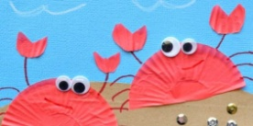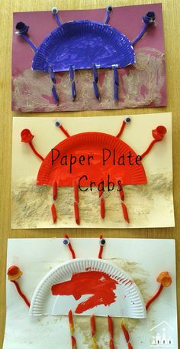
Wed | Department of Education – Letters and sounds videos. https://www.youtube.com/channel/UCP_FbjYUP_UtldV2K_-niWw/featured?disable_polymer=1  Watch them live at the following times:  11 am – Phase 2 / 3: Learning to blend.  10 am – Phase 3 / 4: Reception Summer Term  10:30 am – Phase 5: Year 1 Summer Term  Please continue to use your jolly phonics strips alongside these online lessons and phonics play to practise the things that have been taught. | In the story, the hermit crab shares his home with his friends.  Who do you share your home with?  Can you draw a picture of your home and write about who lives in it with you? | Read One year with Kipper  https://www.youtube.com/watch?v=J2k1zIpR9Ik  Practice the months of the year and the days of the week with this calendar.  https://www.starfall.com/h/holiday/calendar/?t=296184754 | In today’s literacy lesson we learnt about how the hermit crab shares his home.  Watch this clip about friendship  https://www.bbc.co.uk/bitesize/clips/zs8c87h  Sharing is one of the ways we can be a good friend. Can you think of some other ways to be a good friend?  Use the how to be a good friend sheet and try and write some of the ways you can be a good friend.
Thurs | Department of Education – Letters and sounds videos. https://www.youtube.com/channel/UCP_FbjYUP_UtldV2K_-niWw/featured?disable_polymer=1  Watch them live at the following times:  11 am – Phase 2 / 3: Learning to blend.  10 am – Phase 3 / 4: Reception Summer Term  10:30 am – Phase 5: Year 1 Summer Term  Please continue to use your jolly phonics strips alongside these online lessons and phonics play to practise the things that have been taught. | The bristle worm is really good at looking after the shell and keeping it clean, to make it feel like home for his friends.  How do you help take care of your home?  Make a list of all the things you do to help in your house. | Recap the months of the year with this song  https://www.youtube.com/watch?v=v608v42dKeI  Complete the months of the year worksheet. | 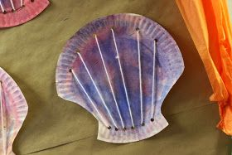  You will need to ask a grown up to cut a paper plate into this shell shape and to hole punch some holes into it. Once that is done, you can decorate it however you want. Imagine it was your home, how would you want it to look?  One it is decorated, it is time to thread it. You will need some wool or string. Carefully thread it through the holes to make it look like a clam shell. Don’t forget o send me some pictures!
Fri | Department of Education – Letters and sounds videos. https://www.youtube.com/channel/UCP_FbjYUP_UtldV2K_-niWw/featured?disable_polymer=1  Watch them live at the following times:  11 am – Phase 2 / 3: Learning to blend.  10 am – Phase 3 / 4: Reception Summer Term  10:30 am – Phase 5: Year 1 Summer Term  Please continue to use your jolly phonics strips alongside these online lessons and phonics play to practise the things that have been taught. | The rockpool is the habitat where the 3 sea creatures live.  Can you research rockpools and find out what other sea creatures like to live there?  I’ve included an under the sea habitats power point that might help you. | Recap the days of the week and the months of the year with our songs from earlier in the week.  Read the book Serens seasons  https://www.twinkl.co.uk/resource/serens-seasons-ebook-t-e-1000  Have a go at sequencing the seasons and writing about seasons using the sheets in the resources. | This week we have learnt about lots of creatures that live in the sea. Can you make me a poster about them all?  OR  Have a go at labelling this rock pool like the one from our story this week.  https://www.twinkl.co.uk/resource/y2-rock-pool-habitat-interactive-labelling-activity-tg-321-newlink

