EYFS Planning Week 4

Day | Phonics | English | Maths | Targeted Activities
Monday | Orange:  Pet themed picture rhyming cards  Say aloud the words ‘fox’ and ‘box’. Ask your child to repeat the words. ‘What do you notice about these words?’ Elicit that the words rhyme. Model saying other rhyming words, e.g. ‘chick’ and ‘lick’, ‘rat’ and ‘pat,’ and ‘hen’ and ‘pen’. ‘Can you think of any words which would rhyme with ‘frog’? What about ‘bee’?’ Give your child a picture of a pet from the Pet-Themed Rhyming Picture Cards. Discuss the pictures and say aloud the name of the pets. Take it in turns to take one of the remaining cards (with objects on) out of the bag. Discuss what each picture is. ‘What is the object called?’ Together, say aloud the name of the object. ‘Which pet name rhymes with…?’ Choose an object. Can your child correctly identify the word that rhymes? Model saying the words out loud to check, e.g. ‘fish, bat’, ‘fish, cake’, ‘fish, dish’. Can your child spot the rhyme? Place the pet and the rhyming object beside each other. Say the words aloud, exaggerating the rhyming words, e.g. ‘Fish, dish. Fish rhymes with dish.’ Repeat until all of the cards have been matched.  Pink: Last week you worked on the letter ‘t’, this week we are concentrating on the ‘t’ sound.  https://www.youtube.com/watch?v=t6Pn2zVz3eo  Print off the letter ‘t’ page from the ‘Find the Lower-Case Booklet’ from the resource file. Ask your child to colour in or stamp on top of the letter ‘t’, can they independently find them all? (if possible, I suggest you save this resource on your hard drive/desktop as we will be using these sheets weekly, if not this resource can be found in week2 resources)  Red – ‘ar’ Join in with Maddie as she introduces you to the ‘ar’ phoneme. (5) Twinkl Live Lessons: Phase 3 Phonics - 'ar' Lesson 23 - YouTube  Colour in the ‘ar’ colouring page from the resource file and try and read the words. | Stanley’s Stick  Listen to the story Stanley’s Stick:  https://www.youtube.com/watch?v=HfIuIQaOLlY&safe=active  After reading the book, talk about the different things Stanley turned his stick into.  Activity 1: Look at the pictures of Stanley’s stick and describe what he is using his stick for.  Activity 2: Write a list to say what each of the pictures shows.  Activity 3: Can you think of some other things he could use his stick for and add them to the list.  Finish the lesson by listening to the story ‘I’m not a stick’. Did you put any of these things on your list? https://www.youtube.com/watch?v=brtsSuJJ2Ww&safe=active  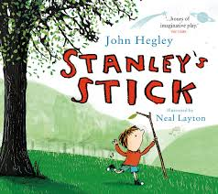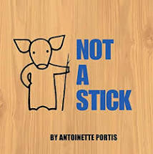  Reception Children Only:  Handwriting: We have worked on letter formation each day in phonics and literacy lessons and in our continuous provision in school. We now consolidate this by recapping letter formation in letter family groups. We are going to start with the Curly Caterpillar Letter Family Group; most of these letters start in the same way and this really helps children form the letters properly.  We suggest practising one letter each day.  Monday- c - curl around the caterpillar.  Practising ideas:  1 – Start big: felt tip pens on big sheets of paper, paintbrush in water on a wall outside or chalks.  2. Getting smaller: Use a pencil or crayon to practise writing the letter or use the letter formation sheets.  3. On a line: Try writing the letter in the correct place on a line. Discuss whether the letter is tall or hanging below the line.  *You don’t need to do all three practise ideas; it will depend on how confident your child is with letter formation. | Starter  Watch Six dinner Sid  (5) Six Dinner Sid - YouTube  See how many times you can spot the number 6.  Input:  Growing 6, 7, 8! - Week 1 | White Rose Maths Lesson 1  Activities:  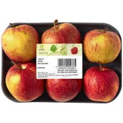  See how many ways you can find the number 6 in your house.  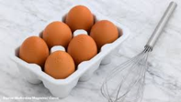  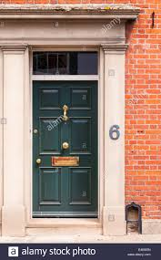  Complete the number six sheet | We have learnt where paper comes from and how it is made so today we are going to find out where glass comes from and how it is made. Watch Curious Cat below to find out.  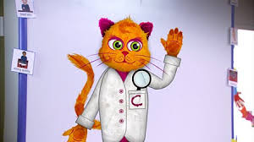  https://www.bbc.co.uk/teach/class-clips-video/primary-science-how-glass_is_made/zm2tf4j  Activity – Go on a hunt round your house (you could use a magnifying glass if you have one) and find all of the things you can that are made of glass. As you hunt discuss the properties of glass and why some things can’t be made from glass.  Extra Activity  Use a glass jar to make a homemade lava lamp! Follow the link below to watch the video or print out the instructions. Have fun and don’t forget to send us your pictures.  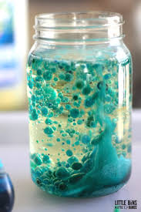
Tuesday | Orange:  Pet picture cards  Small world animal toys  Set up a pet day-care centre with small world toys. (Alternatively, you could lay out the Pet Picture Cards.) Describe one of the pets but do not tell your child its name, e.g. ‘This pet has four legs, a long tail and whiskers.’. ‘What pet could it be? What sound might that animal make?’ Ask your child to repeat the sound that the animal makes. Repeat this for the other Pet Picture Cards with either the adult describing the pet or a child. Model the animal sounds if needed.  Pink: Watch the ‘t’ story below and where prompted (6 ½ minutes into the film) get your child to point to the words whilst you read. They might want to attempt to read with you.  https://www.youtube.com/watch?v=ipLJbSr6rC4  If you can print off the ‘I begin with sheet’ and the ‘t sheet’ from the resource pack. Can your child cut out the pictures that begin with the letter ‘t’ and stick it on the sheet, be careful there might be a sneaky picture that doesn’t begin with ‘t’. If you can't print out look at the pictures on the screen and discuss.  Red – . Revise all the sounds we have learnt on Flashcards Speed Trials (phonicsplay.co.uk) (phase 3)  Recap the ‘ar’ phoneme with Mr Thorne (5) Mr Thorne Does Phonics - Episode AR - YouTube  Use your colouring in page from yesterday to try and write a sentence using the ar phoneme. Can you think of any other words to use that have the ar phoneme in? | Go on a walk and find an interesting stick. Talk about the different things your stick could be. Listen to somebody else telling the story ‘I’m not a stick:  https://www.youtube.com/watchv=bNAtimGfWnU&safe=active  Activity 1: Have fun playing with your stick. Take some photographs and we will try and guess what you have chosen for your stick to be.  Activity 2: Use your stick to draw a picture like in the video and write a label to say what you have chosen for your stick to be.  Activity 3: Draw a picture of your stick and write two sentences like the man in the video:  That is not a stick.  That’s …  Extra Activity: You could make your own little book - I’m not a stick if you would like and add a few different pictures of things your stick could be.  Reception Children Only:  Handwriting:  Tuesday- a – curl around the caterpillar, up, down and flick.  Practising ideas:  1 – Start big: felt tip pens on big sheets of paper, paintbrush in water on a wall outside or chalks.  2. Getting smaller: Use a pencil or crayon to practise writing the letter or use the letter formation sheets.  3. On a line: Try writing the letter in the correct place on a line. Discuss whether the letter is tall or hanging below the line. | Stater:  (5) Let's Get Fit | Count to 100 | Count to 100 Song | Counting to 100 | Jack Hartmann - YouTube  Input:  Growing 6, 7, 8! - Week 1 | White Rose Maths Session 2  Activities:  Can you use the blank ladybird templates to show me all the different ways you can make 7? You will need to make 7 spots first and then use them to put on each side of the lady bird.  Or draw your own ladybirds if you can’t print them. | Expressive Arts & Design  Today we are going to learn about Penguins  Watch the link below  https://www.youtube.com/watch?v=lAJB-dKTAQM&safe=active  Talk about the key points that your child has just learnt from video clip  To remind them about what they have just learnt. Now comes the fun bit, you will need:  - Egg box  - Black paint or felt tip  - White paper  - Orange card or orange felt tip  - Googly eyes or make some out of white paper  - Glue  First cut out the cup of an egg box and paint or colour it black, wait for it to dry.  Cut out a white u shape piece of paper and stick on the front for the penguin's tummy. Next cut out two large triangles for the feet and one small for the beak. Cut out two pieces of black paper for the flippers and stick on the side and finish with the eyes.  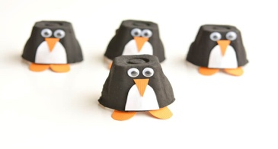  Why not make a few to make a penguin family.  Finish with the story Little penguin learns to swim, follow the link:  https://www.youtube.com/watch?v=i9dXoz9z4R0
Wednesday | Orange:  Pet cones  Introduce the rhyme, ‘At the vet’s, what pets can I see? Join in with me. I can see a…’ Explain that there are some very unusual pets at the vet’s today! Together, chant the rhyme. Show your child one of the Pet Cones. Say its name aloud, emphasising the initial sound, e.g. ‘h-h-h hamster’. Then, introduce another one of the Pet Cones from the same sound set, e.g. ‘h-h-h hippo’. Repeat until all of the ‘h’ animals have been introduced. Repeat the ‘h’ pet names with your child joining in. ‘Hamster, hedgehog, horse, hippo. They all start with ‘h’!’ Repeat the activity using a different set of animals with the same initial sound.  Pink: Watch the alphablocks letter ‘t’ how to read the letter ‘t’  https://www.youtube.com/watch?v=gqGX5lZQ5Nk  Let's have ago at writing the letter ‘t’ with your magic finger in the air or on your parents/carers back. Watch the video below  https://www.youtube.com/watch?v=93mdB3_GgSo  Now have ago at writing the letter ‘t’ in a tray of sand or flour, water and a paint brush, paper and pencil. Its's your choice. Take a photograph of your letter ‘t’ and send it to me.  Red –  Practice tricky words with the tricky words song.Phase 3 Tricky Words Song Say Hello To - YouTube  Today we are learning the ‘or’ phoneme.  'or' Words | Blending Phonics Phase 3 - YouTube  Complete the guess the gift worksheet. | 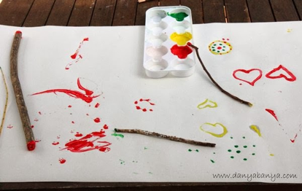  Today we are going to use our sticks to make marks and practise our writing.  Activity 1: Try tying a ribbon to the end of your stick and use it to practise writing or make shapes in the air. What words or shapes do you need to practise? You could write your name or phase 2 or 3 tricky words use the Phase 2 or 3 Tricky Word Mats to help.  Activity 2: Get a big sheet or paper, a roll of wrapping paper or some newspaper. Attach something (see Art for kids resource sheet for ideas) to the end of your stick using an elastic band or string and use your stick like a paintbrush (use the Phase 2 or 3 Tricky Word Mats to help. ) You could paint your name or phase 2 or 3 tricky words. If you don’t have any paint you could dip the end of your stick into water and write with it that way.  Activity 3: Practise writing phase 2, 3, 4 or 5 tricky words using the look, cover and write sheets or if you are feeling creative you could write them with a white wax crayon or the end of a candle and paint over them to reveal your writing.  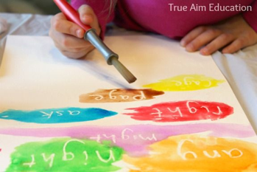  Reception Children Only:  Handwriting:  Wednesday- d – curl around the caterpillar, all the way up, down and flick.  Practising ideas:  1 – Start big: felt tip pens on big sheets of paper, paintbrush in water on a wall outside or chalks.  2. Getting smaller: Use a pencil or crayon to practise writing the letter or use the letter formation sheets.  3. On a line: Try writing the letter in the correct place on a line. Discuss whether the letter is tall or hanging below the line | Starter-  Ladybird Spots - Counting, Matching and Ordering game (topmarks.co.uk)  Input:  Growing 6, 7, 8! - Week 1 | White Rose Maths Session 3  Activities:  Complete the 6, 7, 8 dominoes sheet. | Topic  Emergency!!!  Today we are going to continue thinking about Superheroes all around us, but especially those that help us in an emergency. Please watch this video about how you would call for help in an emergency.  How to make an emergency 999 call – West Midlands Ambulance Service University NHS Foundation Trust (wmas.nhs.uk)  Its very important that you know how to ring this number in case there is an emergency at your house and you need to ring them. Practice making a pretend phone call to 999 with your grown up and explaining what has happened- maybe your grown up is feeling poorly and you need an ambulance for them. You can use the emergency service cards in the resource file for some ideas.  Another really important thing to be able to tell the 999 operator is your address. Have a go at trying to remember your address today. Maybe you could even practice writing it down.
Thursday | Orange:  Toy cat  Childrens instruments  Hold up the toy cat. ‘The cheeky cat has been collecting musical instruments and putting them in her bed.’ Ask your child to choose an instrument and let them explore playing it. ‘Do you know what this instrument is called?’ Tell your child the name of the instrument and play it. Encourage your child to explore making sounds with it. ‘Can you make a sound?’ Repeat the above until all the percussion instruments have been introduced.  Pink: Join in with the song below  https://www.youtube.com/watch?v=KlN7w90utho  Using the ‘Alphabet hats’ in resources, print off the letter ‘t’ hat, colour in and make. If you can’t print off, then make a head band using a strip of paper and draw things that begin with the letter ‘t’. Parents/ carers scribe underneath what it is. I would love to see a photograph of you wearing it! (if possible, I suggest you save this resource on your hard drive/desktop as we will be using these sheets weekly otherwise the resource can be found in week2 resources)  Red –  Revise tricky words on phonics play Tricky Word Trucks (phonicsplay.co.uk) You can try phase 2 and 3. We should start being confident in phase 2 tricky words now.  Recap the ‘or’ sound with Mr Thorne.  Go on a phoneme hunt around your house for words that have the ‘or’ sound in. Can you write the words for me? | .https://www.bbc.co.uk/teach/school-radio/nursery-rhymes-one-two-buckle-my-shoe/zkvtqp3  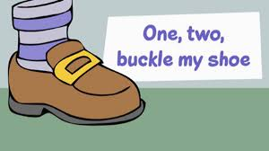  Activity 1: Listen to and join in with the rhyme. Print off the words and follow them as you join in. Pick out some rhyming words together.  Activity 2: Think of an action to add to each verse of the rhyme. Perform the poem to someone at home with your actions. Play matching pairs using the rhyming cards.  Activity 3: Pick out the rhyming words in the poem and colour them in together with a crayon. Have a go at writing some words that rhyme using the one of the rhyming words sheets in this week's resources.  Reception Children Only:  Handwriting:  Thursday- g – curl around the caterpillar up, down put a tail on it.  Practising ideas:  1 – Start big: felt tip pens on big sheets of paper, paintbrush in water on a wall outside or chalks.  2. Getting smaller: Use a pencil or crayon to practise writing the letter or use the letter formation sheets.  3. On a line: Try writing the letter in the correct place on a line. Discuss whether the letter is tall or hanging below the line. | Starter-  Remind yourself of 6 and 7 by watching the number block episodes. BBC iPlayer - Numberblocks - Series 2: Six  BBC iPlayer - Numberblocks - Series 2: Seven  Input:  Growing 6, 7, 8! - Week 1 | White Rose Maths Session 4  Activities:  Make a poster showing me all you know about 6, 7 and 8. Can you write the numerals? The words? Can you show me the numbers in a 10s frame? Can you show me hands with the right amount of fingers on? How else can you show me these numbers?  There is a representing 6, 7, 8 sheet that you can complete as well, or you can use it for ideas. | Music  Join in with this lesson  Good to be me (thenational.academy)  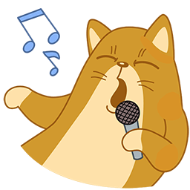  Additional activity-  We spent a lot of time last term working on our cutting skills, so in the topic resources I have put a cutting sheet for you to practice on.  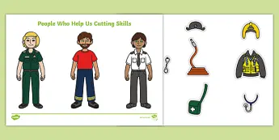
Friday | Orange:  Pet movement cards  Pet movement song  Who has a pet?’ Discuss what pets your child might know. Show your child the picture of the dog from the Pet Movement Cards. ‘What type of pet is this?’ ‘This dog is full of energy. He likes to jump. The sound of him jumping up makes a ‘boing, boing’ sound.’ While saying this, jump up and down. Get your child to copy the sound and movement. Introduce your child to the rest of the pets in the Pet Movements Cards. For each pet, introduce them, discuss what the animal might do and what sound it might make. Once your child has practised the different pet sounds and movements, sing the Pet Movements Song (to the tune of ‘The Wheels on the Bus’). You could use the suggested movements and sounds on the Pet Movements Song or change them to your own. Encourage your child to make the pet sounds and copy the movements.  Pink: To finish listen to the alphabet song from sesame street  https://www.youtube.com/watch?v=p-f6aboKAEE  Choose and print off one of the letter ‘t’ sheets from the ‘Letter Formation Activity Sheets’ from the resource file. Using a mark making implement ask your child to complete a sheet. If you wish to do more than one ‘t’ sheet, great. But please choose which you feel is more appropriate for your child’s ability.  (Can be found in week2’s resource file. If possible, I suggest you save this resource on your hard drive/desktop as we will be using these sheets weekly)  Red –  Have a look at the phonics mats in the resource file and choose 1 or 2 to revise the sounds we have learnt in the last few weeks. These can be kept as an activity to as and when you have time.  Practice reading at phonics play Dragons Den (phonicsplay.co.uk) Try and choose some graphemes that we have been learning (phase 3). | Listen again to the story Stanley’s Stick:  https://www.youtube.com/watch?v=HfIuIQaOLlY&safe=active  Activity 1: Today instead of making a story map or sequencing the story, we are going to make a story stick! You are going to decorate your stick with something from each part of the story and then use the stick to retell the story to somebody at home. Start at one end of the stick and think about what you are going to use to represent the first part of the story. For example, you could paint the first bit grey to remind you of Stanley stood at the station. Move to the next part of your stick and the next part of the story. Maybe you could find a leaf outside and tie it to the next part of the stick to remind you of where Stanley’s stick came from. Do you have a whistle? If so, you could hand that onto the next part of the stick to remind you that Stanley used his stick as a whistle.  Below is an example of a story stick from the internet – not our story though! Please send in pictures of your story sticks for us to share on Class Dojo.  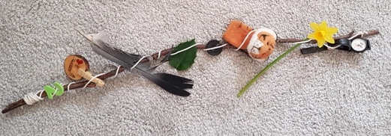  Activity 2: Instead of using all decorations or objects to retell the story on your stick, write out the parts of the story that are starred on the sheet using the writing bubbles and hang them on your story stick.  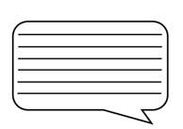  Reception Children Only:  Handwriting:  Friday- q - curl around the caterpillar, straight down and kick.  Practising ideas:  1 – Start big: felt tip pens on big sheets of paper, paintbrush in water on a wall outside or chalks.  2. Getting smaller: Use a pencil or crayon to practise writing the letter or use the letter formation sheets.  3. On a line: Try writing the letter in the correct place on a line. Discuss whether the letter is tall or hanging below the line. | Starter-  The Subitizing Song! [suhb-itizing] (Version 1-- dots, ten-frames, fingers- up to 10) - YouTube  Input:  Growing 6, 7, 8! - Week 1 | White Rose Maths Session 5  Activities:  There are lots of ways to show one more and one less using practical materials. Have a look round your house to see what you could use.  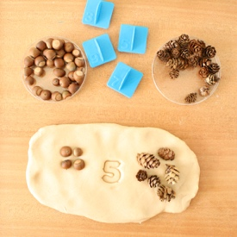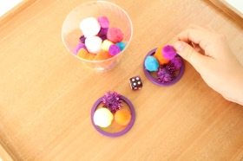 | RE-  Special places  Today we are learning about special places. Churches are very special to Christians. Have a look at this video to learn about Churches.  Church Tours « RE:quest  Can you think of a place that is special to you? It might be a room in your house, or it might be someone else's house. It could be a place outside that is special because you feel calm there. Or a place in a different country because you have lot of lovely memories there.  In the resource file there is a sheet called “A church is a special place for Christians.” You can use this to draw me a church then draw me your special place and try and write where is it.
Above is the planning for Nursery and Reception children. For phonics, please follow the planning for your child’s colour group, previously given via Dojo. For all other areas, please pick the activity you feel is most suited to your child’s ability and interests. Government guidance states that activities should be completed where possible and some examples are sent back to school. This can be done by photographing the completed work, or videoing the activity, and sending it back via Dojo or the class emails. Teachers will then be able to provide some feedback.
Nursery Children: nursery@arnside.cumbria.sch.uk Reception Children: C1@arnside.cumbria.sch.uk

