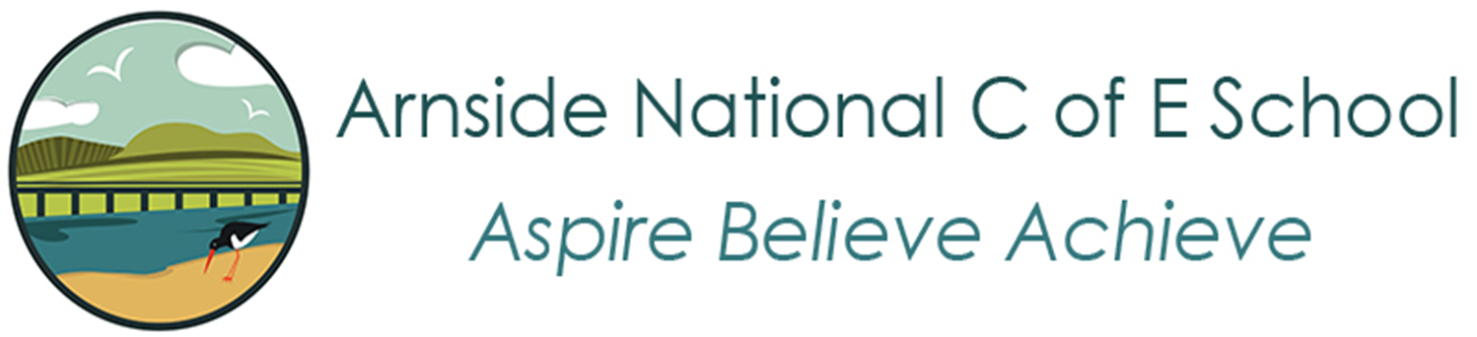

Science Curriculum Cycle
Academic Year | EYFS/Year 1/Year 2 | Year 3/Year 4/Year 5 | Year 6
2020-2021 | Year A | Year A | Year A
2021-2022 | Year B | Year B | Year A
2022-2023 | Year A | Year C | Year A
2023-2024 | Year B | Year A | Year A
2024-2025 | Year A | Year B | Year A

Year A
 | EYFS + KS1 | Hedgehog Class  (Nursery and Reception) | Otter Class  (Year 1 & 2) | Butterfly Class & Swift Class  (Year 3/4/5) | Osprey Class  (Year 6)
AT 1 | Seasons, Plants and Weather | Me and my body | Animals, including Humans  My Body, my senses | Forces  (other than magnetism) | Light
AT 2 |  | The Three Little Pigs | Materials  Let’s build | Animals  (Skeletons and muscles/movement teeth and food chains) | Electricity
Spr 1 |  | Baby Animals | Animals, including humans  Animals around us | States of matter | Animals incl humans
Spr 2 |  | African Animals | Animals, including humans  Amazing African Animals | Sound
Sum 1 |  | The Tiny Seed | Plants  How does your garden grow? | Plants | Evolution and inheritance
Sum 2 |  | Minibeasts | Living things and their habitats  Let’s investigate a microhabitat | Earth and Space | Living things and their habitats
Year B
 | EYFS + KS1 | Hedgehog Class  (Nursery and Reception) | Otter Class  (Year 1 & 2) | Butterfly Class & Swift Class  (Year 3/4/5)
AT 1 | Seasons, Plants and Weather | Healthy Me | Animals, including Humans  What keeps me healthy? | Living things and their habitats
AT 2 |  | Hibernation / We’re going on a Bear Hunt | Seasonal Changes  What changes take place across seasons? | Humans  (Nutrition and diet skeletons and muscles/movement (digestive system, teeth)
Spr 1 |  | Winter/Birds | Animals, including Humans  The Big Garden Bird Watch | Rocks
Spr 2 |  | Our World | Materials  Protect our planet
Sum 1 |  | Plants all around us | Plants  Wonderful, wild Plants | Electricity
Sum 2 |  | Water habitats and life-cycles | Living things and their habitats (water)  What lies beneath? | Plants

Year C
Butterfly Class & Swift Class
(Year 3/4/5)

AT 1 | Forces  magnetism
AT 2 | Living things and their habitats
Spr 1 | Properties and changes of materials
Spr 2

Sum 1 | Light
Sum 2 | Animals incl humans  (Stages of growth)

