Day | Literacy | Maths | Curriculum
Mon | Lesson 1 – Henry’s Freedom Box 1  Use the following link:  https://www.hamilton-trust.org.uk/blog/learning-home-packs/  > Learning at Home Packs for English  > Year 4 English Week 10  > Year 4 Day 1  Look at the front cover and listen to the reading of the story. Complete map of events and rearrange so that they’re in the right order.  Spellings:  See spelling list at the bottom of page.  Log in to Purple Mash and complete the spelling quiz in your 2dos.  Grammar Activities:  Here is a comprehensive list of Grammar games to play, just work through the lists if you want something extra to do:  https://www.bbc.co.uk/bitesize/topics/zhrrd2p  https://www.topmarks.co.uk/english-games/7-11-years/spelling-and-grammar | Lesson 1 – Tenths as decimals  Summer Term Week 7  Click on the following link to watch the lesson presentation  https://vimeo.com/425565433  Complete the worksheet.  https://resources.whiterosemaths.com/wp-content/uploads/2020/05/Lesson-1-Tenths-as-decimals-2019-1.pdf  Mark and correct your answers.  https://resources.whiterosemaths.com/wp-content/uploads/2020/05/Lesson-1-Answers-Tenths-as-decimals-2019-1.pdf | French – On the Move: How do I get to...?  https://www.twinkl.co.uk/resource/tp2-l-122-planit-french-year-4-on-the-move-lesson-pack-5  Use the power point from the above lesson pack to learn how to ask for and give directions to places in town.  Use the Twinklville map from the resources section in the lesson pack, or make your own map and practise giving directions to different locations.  Watch the following video clip:  https://www.bbc.co.uk/teach/class-clips-video/french-ks2-following-directions/z6r3cqt
Tues | Lesson 2 – Henry’s Freedom Box 2  Use the following link:  https://www.hamilton-trust.org.uk/blog/learning-home-packs/  > Learning at Home Packs for English  > Year 4 English Week 10  > Year 4 Day 2  Listen to the author reading the story and think about which reading you prefer. Look at the questions and write your own answers. Choose three key events and make an illustration for each one with a caption to explain it. | Lesson 2 – Divide 1 digit by 10  Summer Term Week 7  Click on the following link to watch the lesson presentation  https://vimeo.com/425565628  Complete the worksheet.  https://resources.whiterosemaths.com/wp-content/uploads/2020/06/Lesson-2-Dividing-1-digit-by-10-2019.pdf  Mark and correct your answers.  https://resources.whiterosemaths.com/wp-content/uploads/2020/06/Lesson-2-Answers-Dividing-1-digit-by-10-2019.pdf | ICT Coding  Log onto Purple Mash and watch the introductory video about coding  https://www.purplemash.com/#tab/pm-home/computing/2code_lessons  Complete the code for the following programs and follow the challenges:  Helicopter swipe game  Turtle road crossing
Wed | Lesson 3 – Missing Words  Use the following link:  https://www.hamilton-trust.org.uk/blog/learning-home-packs/  > Learning at Home Packs for English  > Year 4 English Week 10  > Year 4 Day 3  Read extract 1 and write what the missing words could be. Read background to Henry’s Freedom Box and answer the comprehension questions. Imagine you’re Henry and write a letter to a friend from when you were a child. | Lesson 3 – Hundredths as Decimals  Summer Term Week 7  Click on the following link to watch the lesson presentation  https://vimeo.com/425565862  Complete the worksheet.  https://resources.whiterosemaths.com/wp-content/uploads/2020/06/Lesson-3-Hundredths-as-decimals-2019.pdf  Mark and correct your answers.  https://resources.whiterosemaths.com/wp-content/uploads/2020/06/Lesson-3-Answers-Hundredths-as-decimals-2019.pdf | Mountains - Lesson 3 How Mountains are Made  Use the twinkl powerpoint from the following lesson plan to learn how mountains are made:  https://www.twinkl.co.uk/resource/tp2-g-039-planit-geography-year-5-magnificent-mountains-lesson-4-how-mountains-are-made-lesson  Watch the following video clip which shows how the Southern Uplands of Scotland were formed:  https://www.bbc.co.uk/bitesize/clips/z4dx  The task sheet and activity sheet, in the Twinkl lesson pack above, have a variety of experiments you can try at home which demonstrate how different types of mountains are formed.  The following website gives more information about how different types of mountains are formed. Click on the quiz at the bottom of the page to see how much you have learnt:  https://www.ducksters.com/science/earth_science/mountain_geology.php
Thurs | Lesson 4 – Sea Fever  Use the following link:  https://www.hamilton-trust.org.uk/blog/learning-home-packs/  > Learning at Home Packs for English  > Year 4 English Week 10  > Year 4 Day 4  Read Sea Fever and answer the poetry questions. Remind yourself about possessive apostrophes and complete Sea Fever sentences. | Lesson 4 – Divide 1 or 2 digits by 100  Summer Term Week 7  Click on the following link to watch the lesson presentation  https://vimeo.com/425565990  Complete the worksheet.  https://resources.whiterosemaths.com/wp-content/uploads/2020/05/Lesson-4-Dividing-1-and-2-digits-by-a-hundred-2019.pdf  Mark and correct your answers.  https://resources.whiterosemaths.com/wp-content/uploads/2020/05/Lesson-4-Answers-Dividing-1-and-2-digits-by-a-hundred-2019.pdf | Art/Design – Alfred Wainwright  Look at the pictorial map information given below about Eskdale. Work on your own design of this based on Arnside. Use the internet or local maps (if you have any) and create your own map like the one circled below but based on map work of Arnside and draw it underneath last week’s work of the Knott. Try to use this picture as a model and work on just one part – draw the map section. We will keep adding different parts to this picture each week.  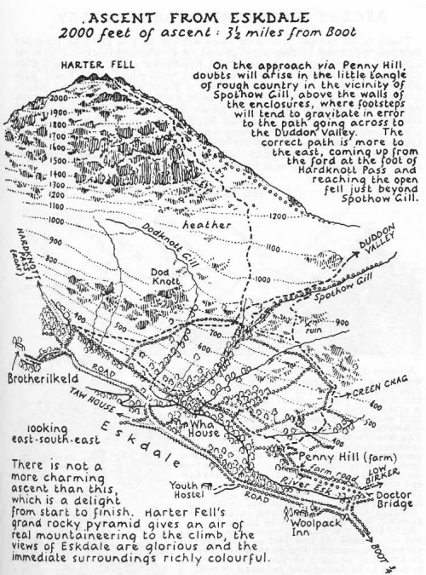
Fri | Lesson 5 – Jewellery  Use the following link:  https://www.hamilton-trust.org.uk/blog/learning-home-packs/  > Learning at Home Packs for English  > Year 4 English Week 10  > Year 4 Day 5  Look carefully at the jewellery and write a descriptive sentence for each. Read the poem ‘Amulet’ and think about which images are best described in the poem. Practice using possessive apostrophes and complete plural possession sentences. | Lesson 5 - Maths Mastery  Summer Term Week 7  https://www.twinkl.co.uk/resource/year-4-diving-into-mastery-divide-1-or-2-digits-by-100-teaching-pack-t-m-31349  Choose some activities from the above teaching pack.  OR  Complete the daily maths lesson on BBC Bitesize:  https://www.bbc.co.uk/bitesize/tags/z63tt39/year-4-and-p5-lessons | Arnside Archive  The Arnside Archive Group have invited the people of Arnside to write a diary about your experiences during the Covid-19 Pandemic. Each week the children could write a diary entry for the week. This could be a family diary, photos, pictures, jokes, practical tips etc.  Activity – Write your diary entry for the previous week.

* If the link is tricky to use, try ‘Chrome’ as your web browser as it doesn’t seem to work as well on Internet Explorer.

This Weeks Spellings – Homophones and near homophones
Heel
Heal
Main
Mane
Medal
Meddle
Key
Quay
Check
Cheque

