Day | Literacy | Maths | Curriculum
Mon | Lesson 1 - Determiners  Use the following link: https://www.hamilton-trust.org.uk/blog/learning-home-packs/  > Learning at Home Packs for English  > Year 4 English Week 9  > Year 4 Day 1  Read the poem ‘Hero Dad’.  Read the revision card about determiners and then complete the worksheet ‘Determiners: Identify, Choose, Use’  The following video clip will help explain determiners:  https://www.youtube.com/watch?v=v40NP-HyBrE  Spellings:  See spelling list at the bottom of page.  Log in to Purple Mash and complete the spelling quiz in your 2dos.  Grammar Activities:  Here is a comprehensive list of Grammar games to play, just work through the lists if you want something extra to do:  https://www.bbc.co.uk/bitesize/topics/zhrrd2p  https://www.topmarks.co.uk/english-games/7-11-years/spelling-and-grammar | Lesson 1 – Add 2 or more fractions  Summer Term Week 6  Click on the following link to watch the lesson presentation  https://vimeo.com/420682145  Complete the worksheet.  https://resources.whiterosemaths.com/wp-content/uploads/2020/05/Lesson-1-Add-2-or-more-fractions-2019.pdf  Mark and correct your answers.  https://resources.whiterosemaths.com/wp-content/uploads/2020/05/Lesson-1-Answers-Add-2-or-more-fractions-2019.pdf | French – On the Move: I like to move it, move it! J’aime bouger, bouger!  https://www.twinkl.co.uk/resource/tp2-l-121-planit-french-year-4-on-the-move-lesson-pack  Follow the power point from the lesson pack above which teaches the children the vocabulary for different body parts and actions.  See if you can give and receive instructions about how to move.  Watch the following video clip of Heads, Shoulders, Knees and Toes, in French. See if you can sing along:  https://www.youtube.com/watch?v=7YEZAwUfaeE
Tues | Lesson 2 – Hero Dad  Use the following link: https://www.hamilton-trust.org.uk/blog/learning-home-packs/  > Learning at Home Packs for English  > Year 4 English Week 9  > Year 4 Day 2  Re-read the poem and find the determiners. Note the different types of determiner.  Have a go at writing your own Hero poem. | Lesson 2 – Subtract 2 fractions  Summer Term Week 6  Click on the following link to watch the lesson presentation  https://vimeo.com/420682290  Complete the worksheet.  https://resources.whiterosemaths.com/wp-content/uploads/2020/05/Lesson-2-Subtract-2-fractions-2019.pdf  Mark and correct your answers.  https://resources.whiterosemaths.com/wp-content/uploads/2020/05/Lesson-2-Answers-Subtract-2-fractions-2019.pdf | ICT Coding  Log onto Purple Mash and watch the introductory video about coding  https://www.purplemash.com/#tab/pm-home/computing/2code_lessons  Complete the code for the following programs and follow the challenges:  Fun with Fish  Bubbles
Wed | Lesson 3 – Stories from Africa  Use the following link: https://www.hamilton-trust.org.uk/blog/learning-home-packs/  > Learning at Home Packs for English  > Year 4 English Week 9  > Year 4 Day 3  Read the four stories from Africa and answer the questions.  Try to sum up the whole story in just one sentence. | Lesson 3 – Fractions of a quantity  Summer Term Week 6  Click on the following link to watch the lesson presentation  https://vimeo.com/420682496  Complete the worksheet.  https://resources.whiterosemaths.com/wp-content/uploads/2020/05/Lesson-3-Fractions-of-a-quantity-2019.pdf  Mark and correct your answers.  https://resources.whiterosemaths.com/wp-content/uploads/2020/05/Lesson-3-Answers-Fractions-of-a-quantity-2019.pdf | Mountains - Lesson 2 Features of a mountain  Use the twinkl powerpoint from the following lesson plan to learn about features of different mountains:  https://www.twinkl.co.uk/resource/tp2-g-038-planit-geography-year-5-magnificent-mountains-lesson-3-features-of-mountains-lesson-pack  Watch the following video clip showing images of Mount Roraima in Guyana:  https://www.bbc.co.uk/teach/class-clips-video/expedition-to-guyana-mount-roraima-no-narration/z6c7nrd  Watch the following video clip about mountain ranges around the word:  https://www.bbc.co.uk/bitesize/clips/z27tfg8  Use the activity sheet from the lesson pack to draw and label a mountain. Choose 1, 2 or 3 star, at an appropriate level for you.
Thurs | Lesson 4 – Stories from Africa  Use the following link: https://www.hamilton-trust.org.uk/blog/learning-home-packs/  > Learning at Home Packs for English  > Year 4 English Week 9  > Year 4 Day 4  Read three more stories from Africa, pick your favourite and make a storyboard. | Lesson 4 – Calculate quantities  Summer Term Week 6  Click on the following link to watch the lesson presentation  https://vimeo.com/420690130  Complete the worksheet.  https://resources.whiterosemaths.com/wp-content/uploads/2020/05/Lesson-4-Calculate-quantities-2019.pdf  Mark and correct your answers.  https://resources.whiterosemaths.com/wp-content/uploads/2020/05/Lesson-4-Answers-Calculate-quantities-2019.pdf | Art/Design – Alfred Wainwright  Look at the pictorial map information given below about Eskdale. Work on your own design of this based on Arnside. Try to use this picture as a model and work on just one part – draw the Knott and investigate how high the Knott is and include this on your picture too like the picture below. We will keep adding different parts to this picture each week.  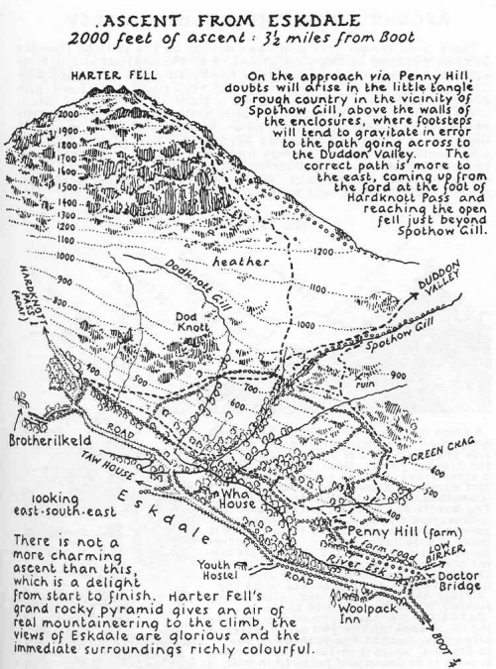
Fri | Lesson 5 – Conjunctions and fronted advervials  Use the following link: https://www.hamilton-trust.org.uk/blog/learning-home-packs/  > Learning at Home Packs for English  > Year 4 English Week 9  > Year 4 Day 5  Read through the stories and hunt for conjunctions and fronted adverbials.  Write your own version of an African story.  OR  Watch the following BBC Bitesize clips and play the grammar games:  https://www.bbc.co.uk/bitesize/topics/zwwp8mn/articles/zp937p3  https://www.bbc.co.uk/bitesize/topics/zwwp8mn/articles/zqk37p3  https://www.bbc.co.uk/bitesize/topics/zwwp8mn/articles/z9wvqhv | Lesson 5 - Maths Mastery  Summer Term Week 5  https://www.twinkl.co.uk/resource/year-4-diving-into-mastery-calculate-fractions-of-a-quantity-teaching-pack-t-m-31111  Choose some activities from the above teaching pack, to find fractions of a quantity.  OR  Complete the daily maths lesson on BBC Bitesize:  https://www.bbc.co.uk/bitesize/tags/z63tt39/year-4-and-p5-lessons | Arnside Archive  The Arnside Archive Group have invited the people of Arnside to write a diary about your experiences during the Covid-19 Pandemic. Each week the children could write a diary entry for the week. This could be a family diary, photos, pictures, jokes, practical tips etc.  Activity – Write your diary entry for the previous week.

* If the link is tricky to use, try ‘Chrome’ as your web browser as it doesn’t seem to work as well on Internet Explorer.

This Weeks Spellings – Possessive apostrophes with plural words:
children’s
people’s
men’s
mice’s
women’s
geese’s
fishermen’s
oxen’s
teeth’s
police’s

