Day | Literacy | Maths | Curriculum
Mon | Lesson 1 – ‘Butterflies’ by Kevin Crossley Holland  Use the following link: https://www.hamilton-trust.org.uk/blog/learning-home-packs/  > Learning at Home Packs for English  > Year 5 English Week 1  > Year 5 Day 1  Children read the story, complete activities and practice adverbials. | Lesson 1 – Decimals upto 2 DP  Click on the following link:  https://whiterosemaths.com/homelearning/year-5/ and click on Lesson 1  Watch the video clip which explains the mathematical concepts and follow the link to ‘Get the Activity’. The children can then complete the activity and check their answers.  Maths Mastery  https://www.twinkl.co.uk/resource/year-5-diving-into-mastery-decimals-as-fractions-1-teaching-pack-t-m-31393 | Charanga Music – Dancing in the Street  https://www.cumbriacharanga.co.uk/yumu/login  Logon to the above link and complete session 1  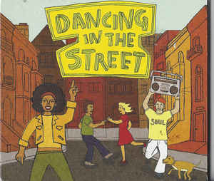
Tues | Lesson 2 –Past Present Verb Tenses  Use the following link: https://www.hamilton-trust.org.uk/blog/learning-home-packs/  > Learning at Home Packs for English  > Year 5 English Week 1  > Year 5 Day 2  Children read ‘Ouch’ practice past and present verbs and complete ‘Ouch’ activities. | Lesson 2 – Decimals and Fraction (1)  Click on the following link:  https://whiterosemaths.com/homelearning/year-5/ and click on Lesson 2  Watch the video clip which explains the mathematical concepts and follow the link to ‘Get the Activity’. The children can then complete the activity and check their answers. | Science – What is a Force?  Watch the two video clips below:  https://www.bbc.co.uk/bitesize/topics/zvpp34j/articles/zywcrdm  https://www.bbc.co.uk/bitesize/topics/zsxxsbk/articles/zxw6gdm  Complete the following investigation:  https://www.twinkl.co.uk/resource/science-forces-year-5-home-learning-tasks-tp2-s-300
Wed | Lesson 3 – ‘Hunted’  Use the following link: https://www.hamilton-trust.org.uk/blog/learning-home-packs/  > Learning at Home Packs for English  > Year 5 English Week 1  > Year 5 Day 3  Children read ‘Hunted’, answer questions and create storyboard. | Lesson 3 – Decimals and Fraction (2)  Click on the following link:  https://whiterosemaths.com/homelearning/year-5/ and click on Lesson 3  Watch the video clip which explains the mathematical concepts and follow the link to ‘Get the Activity’. The children can then complete the activity and check their answers. | Lake District Topic Lesson 1 – Mountains Create a Poster  Click on the following link:  https://www.bbc.co.uk/bitesize/topics/z3fycdm/articles/zvys8xs  Task: Create a factfile/poster about a Lake District Mountain range of your choice. You could include information about how mountains are formed –  https://www.bbc.co.uk/bitesize/topics/z849q6f/articles/z4g3qp3
Thurs | Lesson 4 – ‘Skimbleshanks’  Use the following link: https://www.hamilton-trust.org.uk/blog/learning-home-packs/  > Learning at Home Packs for English  > Year 5 English Week 1  > Year 5 Day 4  Children read the poems, complete activities and use parenthesis to extend sentences. | Lesson 4 – Understanding Thousandths  Click on the following link:  https://whiterosemaths.com/homelearning/year-5/ and click on Lesson 4  Watch the video clip which explains the mathematical concepts and follow the link to ‘Get the Activity’. The children can then complete the activity and check their answers. | Art/Design – Observational Drawing  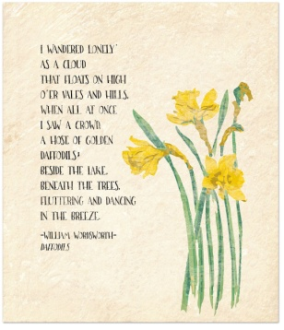  Handwriting – Write a verse of the William Wordsworth Poem – ‘I wandered lonely as a cloud’  Observational Drawing - Use either daffodils from your garden or look on ‘Google images’ - create an observational drawing of a daffodil to illustrate your poem.
Fri | Lesson 5 – London Video Clip  Use the following link: https://www.hamilton-trust.org.uk/blog/learning-home-packs/  > Learning at Home Packs for English  > Year 5 English Week 1  > Year 5 Day 5  Children watch video clip and complete activities. | Lesson 5 – Thousandths as Decimals  Click on the following link:  https://whiterosemaths.com/homelearning/year-5/ and click on Lesson 5  Watch the video clip which explains the mathematical concepts and follow the link to ‘Get the Activity’. The children can then complete the activity and check their answers. | Arnside Archive  The Arnside Archive Group have invited the people of Arnside to write a diary about your experiences during the Covid-19 Pandemic. Each week the children could write a diary entry for the week. This could be a family diary, photos, pictures, jokes, practical tips etc.  Activity – Write your diary entry for the previous week.
Year 5 Week 1

