Day | Literacy | Maths | Curriculum
Mon
Tues | Week 1 Spellings:  knuckle, ceiling, receipt, inefficient, proficient, sought, drought, admiration, considerable, perceive  Spelling Quiz on PurpleMash  Literacy Lesson 1 - Historical Context  Click on the link below:  https://classroom.thenational.academy/lessons/to-understand-the-historical-context-of-oliver-twist-75jkgd  In this lesson, we will learn about the historical context of the story of Oliver Twist. In addition, we will look closely at the author, setting and characters. | Lesson 1 – Multiply 3-digits by 1-digit  Spring Term Week 1  Click on the following link to watch the lesson presentation:  https://vimeo.com/486775113  Complete the worksheet:  https://resources.whiterosemaths.com/wp-content/uploads/2020/09/Y4-Spring-Block-1-WO7-Multipl-3-digits-by-1-digit-2019.pdf  Mark and correct your answers:  https://resources.whiterosemaths.com/wp-content/uploads/2020/09/Y4-Spring-Block-1-ANS7-Multipl-3-digits-by-1-digit-2019.pdf | Science – How is Igneous Rock Formed?  https://classroom.thenational.academy/lessons/how-is-igneous-rock-formed-70v66r  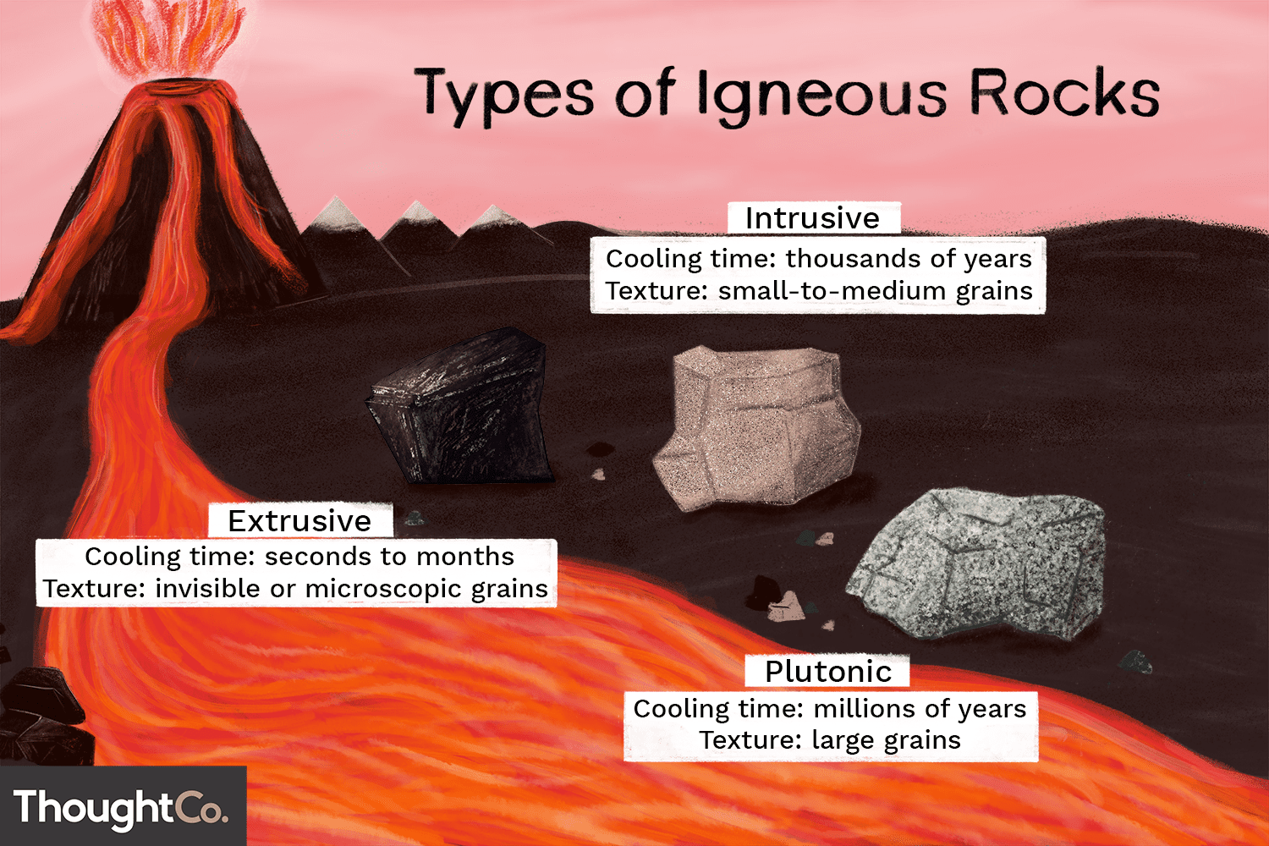  In this lesson, we are going to be learning about igneous rock. We are going to learn about the structure of the Earth, how to recognise igneous rock and some of the uses of igneous rock. We will also learn how igneous rock is made, using ice and chocolate as a model! You will need a piece of paper and a pencil for this lesson.
Wed | Literacy Lesson 2 - Suffixes  Click on the link below:  https://classroom.thenational.academy/lessons/to-investigate-suffixes-tion-cian-sion-ssion-c8up2c  In this lesson, we will investigate the suffixes -tion, -ssion, -sion and -cian. | Lesson 2 – Multiply 4-digits by 1-digit  Spring Term Week 1  Click on the following link to watch the lesson presentation:  https://vimeo.com/486775551  Complete the worksheet:  https://resources.whiterosemaths.com/wp-content/uploads/2019/11/Y5-Spring-Block-1-WO1-Multiply-4-digits-by-1-digit-2019.pdf  Mark and correct your answers:  https://resources.whiterosemaths.com/wp-content/uploads/2019/11/Y5-Spring-Block-1-ANS1-Multiply-4-digits-by-1-digit-2019.pdf | Computing – Systems  https://classroom.thenational.academy/lessons/systems-cgvpad  This lesson will introduce you to the concept of a system. You will develop their understanding of components working together to make a whole. You will also explore how digital systems might work and the physical and electronic connections that exist.
Thurs | Literacy Lesson 3 – Word Class  Click on the link below:  https://classroom.thenational.academy/lessons/to-explore-word-class-68tkjc  In this lesson, we will explore word class. We will focus on identifying nouns, adjectives, adverbs and verbs in sentences. We then explore what prepositions are and identify these in sentences | Lesson 3 – Multiply 2-digits by 2-digits  Spring Term Week 1  Click on the following link to watch the lesson presentation:  https://vimeo.com/488553863  Complete the worksheet:  https://resources.whiterosemaths.com/wp-content/uploads/2019/11/Y5-Spring-Block-1-WO3-Multiply-2-digits-by-2-digits-2019.pdf  Mark and correct your answers:  https://resources.whiterosemaths.com/wp-content/uploads/2019/11/Y5-Spring-Block-1-ANS3-Multiply-2-digits-by-2-digits-2019.pdf | History – Education  During which period of history would you like to go to school?  Over the next two weeks, you will need to research schools and education from one of the following periods of history:  Tudors, Georgians, Victorians, 20th Century before World War II or 20th Century after WWII.  Research a typical school day for your chosen historical period.  Try to answer the following questions as well as the questions you would like to ask:  - who went to school?  - did it cost anything?  - what ages did they go to school?  - what types of buildings were they in?  - did they have to go to school?  - what were they taught?  - were there different types of school?  - what type of teachers were there?  - how were they treated at school?  You need to think about how you will present your findings.
Fri | Literacy Lesson 4 – Analyse Film Clip  Click on the link below:  https://classroom.thenational.academy/lessons/to-analyse-a-film-clip-and-generate-vocabulary-6nh3gr  In this lesson, we will watch and analyse the opening clip to a film version of Oliver Twist. We will generate nouns and adjectives to describe the setting and characters and verbs and adverbs to describe the action. Finally, we will use our new vocabulary to help us write sentences. | Lesson 4 – 3 digits by 2-digits  Spring Term Week 1  Click on the following link to watch the lesson presentation:  https://vimeo.com/488555095  Complete the worksheet:  https://resources.whiterosemaths.com/wp-content/uploads/2019/11/Y5-Spring-Block-1-WO4-Multiply-3-digits-by-2-digits-2019.pdf  Mark and correct your answers:  https://resources.whiterosemaths.com/wp-content/uploads/2019/11/Y5-Spring-Block-1-ANS4-Multiply-3-digits-by-2-digits-2019.pdf | RE – What did Jesus teach people about the Kingdom of God?  Lesson 1 – Who was Jesus?  https://classroom.thenational.academy/lessons/who-was-jesus-6mv66c  In this lesson you will be learning about the life, teachings and death of Jesus. You will need a piece of paper and a pencil for this lesson.

