Day | Literacy | Maths | Curriculum
Mon | Lesson 1 – Message to myself in 6 months time  Use the following link:  https://www.hamilton-trust.org.uk/blog/learning-home-packs/  > Learning at Home Packs for English  > Year 5 English Week 10  > Year 5 Day 1  Watch the video clip ‘a message to myself in 6 months time’ and the listening questions. Revise formal and informal language and record your ideas.  Spellings:  See spelling list at the bottom of page.  Log in to Purple Mash and complete the spelling quiz in your 2dos  Grammar Activities:  Here is a comprehensive list of Grammar games to play, just work through the lists if you want something extra to do:  https://www.bbc.co.uk/bitesize/topics/zhrrd2p  https://www.topmarks.co.uk/english-games/7-11-years/spelling-and-grammar | Lesson 1 – Decimals as Fractions  Summer Term Week 7  Click on the following link to watch the lesson presentation:  https://vimeo.com/425602384  Complete the worksheet:  https://resources.whiterosemaths.com/wp-content/uploads/2020/05/Lesson-1-Decimals-as-fractions-2-2019.pdf  Mark and correct your answers:  https://resources.whiterosemaths.com/wp-content/uploads/2020/05/Lesson-1-Answers-Decimals-as-fractions-2-2019.pdf  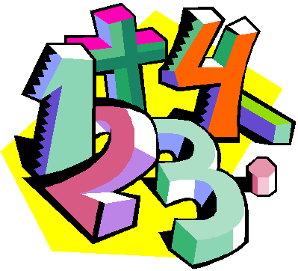 | French – On the Move: How do I get to...?  https://www.twinkl.co.uk/resource/tp2-l-122-planit-french-year-4-on-the-move-lesson-pack-5  Use the power point from the above lesson pack to learn how to ask for and give directions to places in town.  Use the Twinklville map from the resources section in the lesson pack, or make your own map and practise giving directions to different locations.  Watch the following video clip:  https://www.bbc.co.uk/teach/class-clips-video/french-ks2-following-directions/z6r3cqt
Tues | Lesson 2 – Emotion Words  Use the following link:  https://www.hamilton-trust.org.uk/blog/learning-home-packs/  > Learning at Home Packs for English  > Year 5 English Week 10  > Year 5 Day 2  Watch the video message again and look at the film stills. Investigate the emotions and write definitions in your own words. | Lesson 2 – Understanding Thousandths  Summer Term Week  Click on the following link to watch the lesson presentation:  https://vimeo.com/425602576  Complete the worksheet:  https://resources.whiterosemaths.com/wp-content/uploads/2020/06/Lesson-2-Understand-thousandths-2019.pdf  Mark and correct your answers:  https://resources.whiterosemaths.com/wp-content/uploads/2020/05/Lesson-2-Answers-Understand-thousandths-2019.pdf  . | ICT Coding  Log onto Purple Mash and watch the introductory video about coding  https://www.purplemash.com/#tab/pm-home/computing/2code_lessons  Complete the code for the following programs and follow the challenges:  Helicopter swipe game  Turtle road crossing
Wed | Lesson 3 – Another message to yourself in 6 months time  Use the following link:  https://www.hamilton-trust.org.uk/blog/learning-home-packs/  > Learning at Home Packs for English  > Year 5 English Week 10  > Year 5 Day 3  Watch the next ‘message to yourself in 6 months time’ and revise noun phrases. Use the noun phrase builder and add prepositions.  . | Lesson 3 – Rounding Decimals  Summer Term Week 7  Click on the following link to watch the lesson presentation:  https://vimeo.com/425603173  Complete the worksheet:  https://resources.whiterosemaths.com/wp-content/uploads/2020/05/Lesson-3-Rounding-decimals-2019.pdf  Mark and correct your answers:  https://resources.whiterosemaths.com/wp-content/uploads/2020/05/Lesson-3-Answers-Rounding-decimals-2019.pdf | Mountains - Lesson 3 How Mountains are Made  Use the twinkl powerpoint from the following lesson plan to learn how mountains are made:  https://www.twinkl.co.uk/resource/tp2-g-039-planit-geography-year-5-magnificent-mountains-lesson-4-how-mountains-are-made-lesson  Watch the following video clip which shows how the Southern Uplands of Scotland were formed:  https://www.bbc.co.uk/bitesize/clips/z4dx  The task sheet and activity sheet in the Twinkl lesson pack above have a variety of experiments you can try at home which demonstrate how different types of mountains are formed.  The following website gives more information about how different types of mountains are formed. Click on the quiz at the bottom of the page to see how much you have learnt:  https://www.ducksters.com/science /earth_science/mountain_geology.php
Thurs | Lesson 4 – Deanna Roger’s message  Use the following link: https://www.hamilton-trust.org.uk/blog/learning-home-packs/  > Learning at Home Packs for English  > Year 5 English Week 10  > Year 5 Day 4  Watch Deanna Roger’s message and highlight on the transcript the poetic features of the script. Think about your own memories and use the memory planner to write and raw about 6 of your own memories. | Lesson 4 – Order and Compare decimals  Summer Term Week 7  Click on the following link to watch the lesson presentation:  https://vimeo.com/425603300  Complete the worksheet:  https://resources.whiterosemaths.com/wp-content/uploads/2020/05/Lesson-4-Order-and-compare-decimals-2019.pdf  Mark and correct your answers:  https://resources.whiterosemaths.com/wp-content/uploads/2020/05/Lesson-4-Answers-Order-and-compare-decimals-2019.pdf | Art/Design – Alfred Wainwright  Look at the pictorial map information given below about Eskdale. Work on your own design of this based on Arnside. Use the internet or local maps (if you have any) and create your own map like the one circled below but based on map work of Arnside and draw it underneath last week’s work of the Knott. Try to use this picture as a model and work on just one part – draw the map section. We will keep adding different parts to this picture each week.  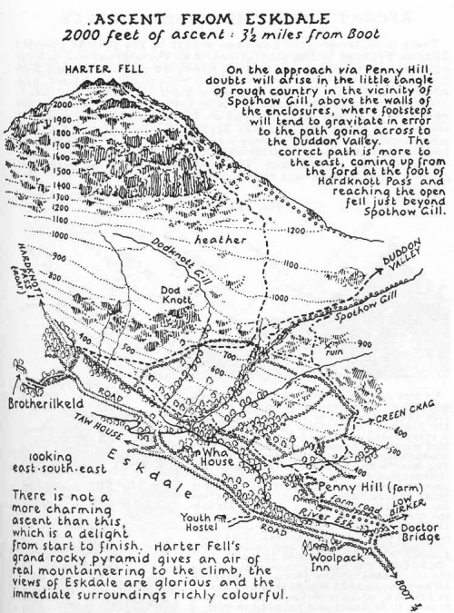
Fri | Lesson 5 – These are the hands  Use the following link:  https://www.hamilton-trust.org.uk/blog/learning-home-packs/  > Learning at Home Packs for English  > Year 5 English Week 10  > Year 5 Day 5  Read the poem these are the hands by Michael Rosen and highlight the verbs and nouns. Think about some of the people who have helped during this time and turn your ideas into a poem. | Lesson 5 – Maths Mastery  Summer Term Week 7  https://www.twinkl.co.uk/resource/year-5-diving-into-mastery-understanding-thousandths-teaching-pack-t-m-31379  Choose some activities from the above teaching pack, using fractions as operators.  OR  Complete the daily maths lesson on BBC Bitesize:  https://www.bbc.co.uk/bitesize/tags/zhgppg8/year-5-and-p6-lessons | Arnside Archive  The Arnside Archive Group have invited the people of Arnside to write a diary about your experiences during the Covid-19 Pandemic. Each week the children could write a diary entry for the week. This could be a family diary, photos, pictures, jokes, practical tips etc.  Activity – Write your diary entry for the previous week.

This week’s spellings: Mixed spellings
Illuminate
Admiration
Foundation
Forgotten
Gardening
Great
Grate
Fascinate
Expression
possession

