Day | Literacy | Maths | Curriculum
Mon | Lesson 1 – Sinbad Introduction  Use the following link: https://www.hamilton-trust.org.uk/blog/learning-home-packs/  > Learning at Home Packs for English  > Year 5 English Week 12  > Year 5 Day 1  Read Sinbad introduction 1 and 2 and follow the link and listen to the story of Sinbad’s first voyage. Use the story summary to retell the story. Revise clauses and conjunctions.  Spellings:  See spelling list at the bottom of page.  Log in to Purple Mash and complete the spelling quiz in your 2dos.  Grammar Activities:  Here is a comprehensive list of Grammar games to play, just work through the lists if you want something extra to do:  https://www.bbc.co.uk/bitesize/topics/zhrrd2p  https://www.topmarks.co.uk/english-games/7-11-years/spelling-and-grammar | Lesson 1 – Subtracting decimals  Summer Term Week 9  Click on the following link to watch the lesson presentation:  https://vimeo.com/430338565  Complete the worksheet.  https://resources.whiterosemaths.com/wp-content/uploads/2020/06/Lesson-1-Subtracting-decimals-with-the-same-number-of-decimal-places.pdf  Mark and correct your answers.  https://resources.whiterosemaths.com/wp-content/uploads/2020/06/Lesson-1-Answers-Subtracting-decimals-with-the-same-number-of-decimal-places.pdf | PSHE – Think Positive!  It has been a long time since we were last all together. Some of you will have been enjoying time at home with family and perhaps having a little more freedom. Some of you will be missing friends and the experiences and routines of school.  It is therefore, a good time to reflect upon this strange experience we have all shared and remember to think positive and look forward to the future.  With that in mind, use the following worksheets to reflect upon your lockdown experiences.  Go to:  https://www.twinkl.co.uk/share  Then type in the code:  AU3286
Tues | Lesson 2 – Sinbad’ Fifth Voyage  Use the following link: https://www.hamilton-trust.org.uk/blog/learning-home-packs/  > Learning at Home Packs for English  > Year 5 English Week 12  > Year 5 Day 2  Look carefully at the Sinbad illustration and listen to the second part of Sinbads’s Fifth Voyage. Revise phrases and prepositions.  https://www.bbc.co.uk/bitesize/topics/zwwp8mn/articles/zw38srd  https://www.bbc.co.uk/bitesize/articles/zbkwqp3  Complete the online activities or the Expanded Noun Phrase worksheet by adding a prepositional phrase. | Lesson 2 – Subtracting decimals with a different number of decimal places  Summer Term Week 9  Click on the following link to watch the lesson presentation:  https://vimeo.com/430338659  Complete the worksheet.  https://resources.whiterosemaths.com/wp-content/uploads/2020/06/Lesson-2-Subtracting-decimals-with-a-different-number-of-decimal-places.pdf  Mark and correct your answers.  https://resources.whiterosemaths.com/wp-content/uploads/2020/06/Lesson-2-Answers-Subtracting-decimals-with-a-different-number-of-decimal-places.pdf | ICT Coding  Log onto Purple Mash and watch the introductory video about coding:  Complete the code for the following programs and follow the challenges (set as 2dos)  Driving Game  Dancer
Wed | Lesson 3 – Sinbad’s Fifth Voyage  Use the following link: https://www.hamilton-trust.org.uk/blog/learning-home-packs/  > Learning at Home Packs for English  > Year 5 English Week 12  > Year 5 Day 3  Listen to the last part of Sinbad’s Fifth Voyage. Read another version of the story. Use one of the illustrations of the story and write using this as a focus. | Lesson 3 –Multiply decimals by 10 100 and 1000  Summer Term Week 9  Click on the following link to watch the lesson presentation:  https://vimeo.com/430338787  Complete the worksheet.  https://resources.whiterosemaths.com/wp-content/uploads/2020/06/Lesson-3-Multiplying-decimals-by-10-100-and-1000.pdf  Mark and correct your answers.  https://resources.whiterosemaths.com/wp-content/uploads/2020/06/Lesson-3-Answers-Multiplying-decimals-by-10-100-and-1000.pdff | Mountains - Lesson 5 Mountain Travel  https://www.twinkl.co.uk/share  Enter the code:  PN3184  Use the power point from the above lesson pack to think about the economic, environmental and social impact of tourism on mountainous regions.  Does tourism have a positive or negative effect on an area and what can be done to protect mountain environments?  Complete the activity sheets from the pack at an appropriate level for you.  Watch the following video clips to learn about tourism in the Alps:  https://www.bbc.co.uk/bitesize/topics/z3fycdm/articles/zb3ywty  https://www.bbc.co.uk/programmes/p0114m0t
Thurs | Lesson 4 – Poetry  Use the following link: https://www.hamilton-trust.org.uk/blog/learning-home-packs/  > Learning at Home Packs for English  > Year 5 English Week 12  > Year 5 Day 4  Read the three poems written by Grace Nichols and answer the questions. The poem ‘you’ and compare them. Read the poem ‘I’m telling you’ and learn it by heart. | Lesson 4 – Divide decimals by 10 100 and 1000  Summer Term Week 9  Click on the following link to watch the lesson presentation:  https://vimeo.com/430338904  Complete the worksheet.  https://resources.whiterosemaths.com/wp-content/uploads/2020/06/Lesson-4-Dividing-decimals-by-10-100-and-1000.pdf  Mark and correct your answers.  https://resources.whiterosemaths.com/wp-content/uploads/2020/06/Lesson-4-Answers-Dividing-decimals-by-10-100-and-1000.pdf | Art/Design – Alfred Wainwright  Look at the pictorial map information given below about Eskdale. In particular look at the information circled in red on the diagram. Create a paragraph about Arnside and add this to your pictorial representation of our village. We will keep adding different parts to this picture each week.  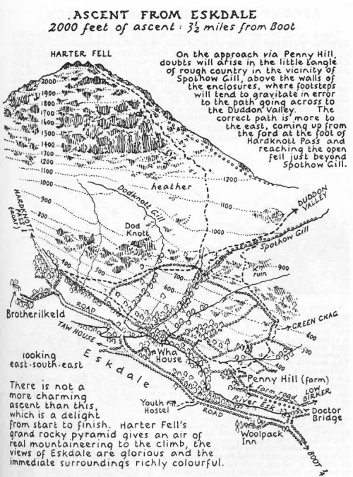
Fri | Lesson 5 – Vocabulary for Villains  Use the following link: https://www.hamilton-trust.org.uk/blog/learning-home-packs/  > Learning at Home Packs for English  > Year 5 English Week 12  > Year 5 Day 5  Read ‘Vocabulary for villains’ and choose 6 words that you think are most interesting. Read the draft poem and complete work. Write your own insult poem. | Lesson 5 - Maths Mastery  Summer Term Week 9  https://www.twinkl.co.uk/share  Enter the code:  TG8109  Use the above lesson pack to complete maths mastery tasks on money.  OR  Complete the daily maths lesson on BBC Bitesize:  https://www.bbc.co.uk/bitesize/tags/z63tt39/year-4-and-p5-lessons | Arnside Archive  The Arnside Archive Group have invited the people of Arnside to write a diary about your experiences during the Covid-19 Pandemic. Each week the children could write a diary entry for the week. This could be a family diary, photos, pictures, jokes, practical tips etc.  Activity – Write your diary entry for the previous week.

* If the link is tricky to use, try ‘Chrome’ as your web browser as it doesn’t seem to work as well on Internet Explorer.

This Week’s Spellings –: Statutory Words
accommodate
accompany
according
achieve
aggressive
amateur
ancient
apparent
appreciate
attached

