Day | Literacy | Maths | Curriculum
Mon | Lesson 1 – ‘The Lost Thing’ by Shaun Tan  Use the following link:  https://www.hamilton-trust.org.uk/blog/learning-home-packs/  > Learning at Home Packs for English  > Year 5 English Week 9  > Year 5 Day 1  Read the opening of the story. Explore questions and answer as sentences inside the speech bubbles  OR  Study the paintings and answer the questions.  Spellings:  See spelling list at the bottom of page.  Log in to Purple Mash and complete the spelling quiz in your 2dos  Grammar Activities:  Here is a comprehensive list of Grammar games to play, just work through the lists if you want something extra to do:  https://www.bbc.co.uk/bitesize/topics/zhrrd2p  https://www.topmarks.co.uk/english-games/7-11-years/spelling-and-grammar | Lesson 1 – Multiply unit and non-unit fractions by an integer  Summer Term Week 6  Click on the following link to watch the lesson presentation:  https://vimeo.com/420244176  Complete the worksheet:  https://resources.whiterosemaths.com/wp-content/uploads/2020/05/Lesson-1-Multiply-unit-and-non-unit-fractions-by-integers.pdf.  Mark and correct your answers:  https://resources.whiterosemaths.com/wp-content/uploads/2020/05/Lesson-1-Answers-Multiply-unit-and-non-unit-fractions-by-integers.pdf | French – On the Move: I like to move it, move it! J’aime bouger, bouger!  https://www.twinkl.co.uk/resource/tp2-l-121-planit-french-year-4-on-the-move-lesson-pack  Follow the power point from the lesson pack above which teaches the children the vocabulary for different body parts and actions.  See if you can give and receive instructions about how to move.  Watch the following video clip of Heads, Shoulders, Knees and Toes, in French. See if you can sing along:  https://www.youtube.com/watch?v=7YEZAwUfaeE
Tues | Lesson 2 – Parenthesis  Use the following link:  https://www.hamilton-trust.org.uk/blog/learning-home-packs/  > Learning at Home Packs for English  > Year 5 English Week 9  > Year 5 Day 2  Look at the prompt cards to remind you about how to use parenthesis.  Add extra information to the sentences, using parenthesis.  Watch the following video about parenthesis:  https://www.bbc.co.uk/teach/supermovers/ks2-english-commas-brackets-dashes-with-ben-shires/zh32cqt. | Lesson 2 – Multiply mixed numbers by an integer  Summer Term Week 6  Click on the following link to watch the lesson presentation:  https://vimeo.com/420244296  Complete the worksheet:  https://resources.whiterosemaths.com/wp-content/uploads/2020/05/Lesson-2-Multiply-mixed-numbers-by-integers-2019.pdf  Mark and correct your answers:  https://resources.whiterosemaths.com/wp-content/uploads/2020/05/Lesson-2-Answers-Multiply-mixed-numbers-by-integers-2019.pdf  . | ICT Coding  Log onto Purple Mash and watch the introductory video about coding  https://www.purplemash.com/#tab/pm-home/computing/2code_lessons  Complete the code for the following programs and follow the challenges:  Fun with Fish  Bubbles
Wed | Lesson 3 – Macavity the Mystery Cat  Use the following link:  https://www.hamilton-trust.org.uk/blog/learning-home-packs/  > Learning at Home Packs for English  > Year 5 English Week 9  > Year 5 Day 3  Look at Arthur Robbins’ illustrations and answer the questions.  Then, practise reading Macavity the Mystery Cat aloud.  . | Lesson 3 – Fraction of an amount  Summer Term Week 6  Click on the following link to watch the lesson presentation:  https://vimeo.com/420244399  Complete the worksheet:  https://resources.whiterosemaths.com/wp-content/uploads/2020/05/Lesson-3-Fractions-of-an-amount-2019.pdf  Mark and correct your answers:  https://resources.whiterosemaths.com/wp-content/uploads/2020/05/Lesson-3-Answers-Fractions-of-an-amount-2019-1.pdf | Mountains - Lesson 2 Features of a mountain  Use the twinkl powerpoint from the following lesson plan to learn about features of different mountains:  https://www.twinkl.co.uk/resource/tp2-g-038-planit-geography-year-5-magnificent-mountains-lesson-3-features-of-mountains-lesson-pack  Watch the following video clip showing images of Mount Roraima in Guyana:  https://www.bbc.co.uk/teach/class-clips-video/expedition-to-guyana-mount-roraima-no-narration/z6c7nrd  Watch the following video clip about mountain ranges around the word:  https://www.bbc.co.uk/bitesize/clips/z27tfg8  Use the activity sheet from the lesson pack to draw and label a mountain. Choose 1, 2 or 3 star, at an appropriate level for you.  You may also like to look at the following webpage for more information:  https://www.oddizzi.com/teachers/explore-the-world/physical-features/mountains/parts-of-a-mountain/
Thurs | Lesson 4 – Macavity the Mystery Cat  Use the following link: https://www.hamilton-trust.org.uk/blog/learning-home-packs/  > Learning at Home Packs for English  > Year 5 English Week 9  > Year 5 Day 4  Fill in the missing words from the poem. Then, complete a Police Custody Record for Macavity. | Lesson 4 – Using fractions as operators  Summer Term Week 6  Click on the following link to watch the lesson presentation:  https://vimeo.com/420244575  Complete the worksheet:  https://resources.whiterosemaths.com/wp-content/uploads/2020/05/Lesson-4-Fractions-as-operators-2019.pdf  Mark and correct your answers:  https://resources.whiterosemaths.com/wp-content/uploads/2020/05/Lesson-4-Answers-Fractions-as-operators-2019.pdf | Art/Design – Alfred Wainwright  Look at the pictorial map information given below about Eskdale. Work on your own design of this based on Arnside. Try to use this picture as a model and work on just one part – draw the Knott and investigate how high the Knott is and include this on your picture too like the picture below. We will keep adding different parts to this picture each week.  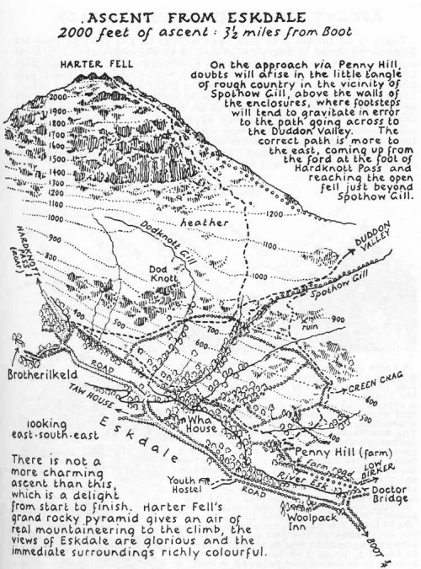
Fri | Lesson 5 – Macavity the Mystery Cat  Use the following link:  https://www.hamilton-trust.org.uk/blog/learning-home-packs/  > Learning at Home Packs for English  > Year 5 English Week 9  > Year 5 Day 5  Read and write a playscript for Macavity. | Lesson 5 – Maths Mastery  Summer Term Week 6  https://www.twinkl.co.uk/resource/year-5-diving-into-mastery-fractions-as-operators-t-m-31340  Choose some activities from the above teaching pack, using fractions as operators.  OR  Complete the daily maths lesson on BBC Bitesize:  https://www.bbc.co.uk/bitesize/tags/zhgppg8/year-5-and-p6-lessons | Arnside Archive  The Arnside Archive Group have invited the people of Arnside to write a diary about your experiences during the Covid-19 Pandemic. Each week the children could write a diary entry for the week. This could be a family diary, photos, pictures, jokes, practical tips etc.  Activity – Write your diary entry for the previous week.
This week’s spellings - Words with silent letters:
tomb
numb
subtle
doubt
thumb
crumb
limb
climb
plumber
debt

