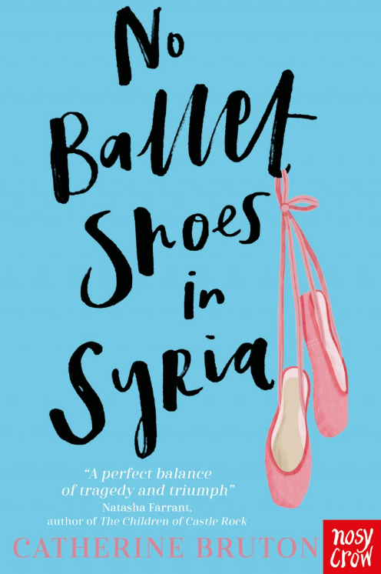
This is the story of Aya, an 11-year-old asylum seeker from Syria, who has just arrived in Britain with her mum and baby brother.
It is a moving and thought-provoking story of hope and kindness, which was recommended to me by a child in Year 5. I thoroughly enjoyed reading it, and I hope you do too!

Title: No Ballet Shoes in Syria
Author: Catherine Bruton
Illustrator: Elisabetta Barbazza.
Genre: Fiction



Mrs Barrott Recommends… 

