Title: The Girl who Stole an Elephant
Author: Nizrana Farook
Illustrator: David Dean
Genre: Adventure

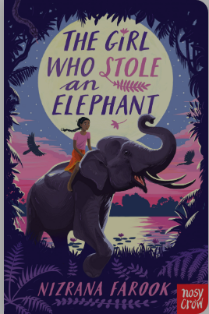
This great adventure story has an exotic setting and is a real page-turner. The characters are fun and original. Chaya is rebellious a girl who is lively, brave, and never far from trouble. Her best friend Neelan is a quiet, intelligent, thoughtful boy who tries desperately to keep Chaya on the right track (not always very successfully). Nour is a character who surprises the reader (and Chaya) at every turn.



Mrs Pearce Recommends… 

