Title: Michael Recycle
Author: Ellie Bethel
Illustrator: Alexandra Colombo
Genre: Fiction

This is a great book with an important message~ ‘Recycling is everyone’s business.’
My children love reading this with their grandparents and reminding them to recycle!
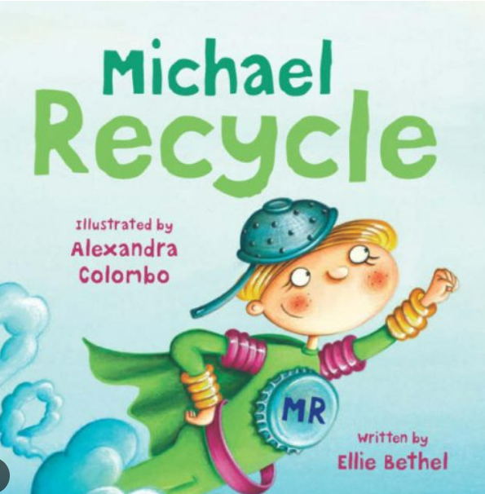

Mrs Russell Recommends… 

