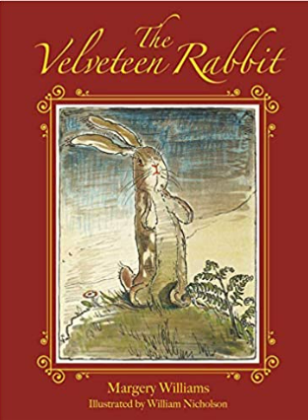
Title: The Velveteen Rabbit
Author: Margery Williams
Illustrator: William Nicholson
Genre: Fiction



What does it mean to be real? This is the story about a new toy to a nursery
who wants to know the answer to this question? Will the Velveteen rabbit ever become real? Find out by reading this book!

Mrs Shepherd Recommends… 

