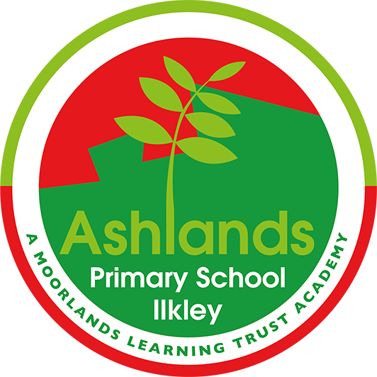
ASHLANDS READING SPINE 2024-2025

Our literature spine has been carefully developed to broaden children’s literature repertoire and encourage them to become wider, more avid and life-long readers. These are our core English texts through which our writing units are derived. We understand that the teaching of reading and writing needs to be intrinsically linked and as such our children read as readers, read as writers and write as readers across all English lessons. Where possible, cross-curricular links are made and texts are chosen because of their connection with wider learning in areas such as history or geography. Some texts have been chosen because of the fantastic route they offer into discussing and exploring many social, emotional and cultural issues thus developing the cultural capital of our children.

NURSERY | Autumn 1 | Autumn 2 | Spring 1 | Spring 2 | Summer 1 | Summer 2
Topic Title | Our Colourful Rhyming World | Into the night. | The wonders of winter | Choose your own adventure | Into the garden | Off we go
Texts | 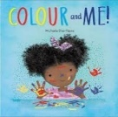  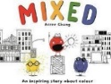  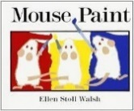   | 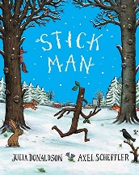  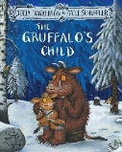  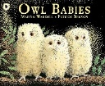 | 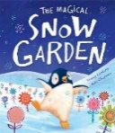  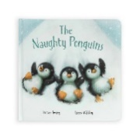 | 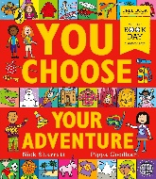 | 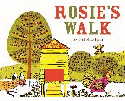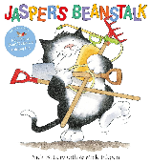 |   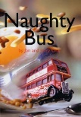
Fiction outcome | Enjoy listening to stories | Listen to simple stories and understand what is happening, with the help of the pictures.  Repeat words and phrases from familiar stories. | Develop their phonological awareness, so that they can  Spot and suggest rhymes  Recognise words with the same initial sound. | Understand simple questions about ‘who’ ‘what’ and ‘where’.  Use their imagination to create their own adventures. | Engage in extended conversations about stories, learning new vocabulary | Understand ‘why’ questions  e.g ‘Why did Mummy think the baby was hungry?’
Non-Fiction outcome | Colours carry critical importance in the development of children’s cognitive skills.  Linking colour with deeper meanings we assign to them e.g. red for danger.  Exposing children to different shades of colour can help them make important connections and expand their vocabulary. We link with Zones of Regulation/Autumn. | Children will explore shadows and light and dark.  Learn about nocturnal animals as the seasons change into the darker nights. | Learning new vocabulary describing different climates  Talk about feeling and behaviours – link to Z of R.  THe Penguins were playing tricks and thought it was fun, but others were getting hurt. | After discovering about the Polar regions in the previous term they will create their own adventure and decide what other places in the world they want to learn about  The jungle  The grasslands  The desert | Understanding the world - scientific language (plants, growth)  Days of the week. | Continuation on directions, preposition, looking at different places the children might go across the summer.
Poetry outcome | Nursery rhymes associated with colour | Rhyming strings – Julia Donaldson texts. | Picking out the rhyming couples
Ongoing and developing objectives | Rhyme and rhythm is continual throughout the year through Phase 1 phonics songs and games.

Reception | Autumn 1 | Autumn 2 | Spring 1 | Spring 2 | Summer 1 | Summer 2
Topic Title | Marvellous Me | Our Community | Traditional Tales and familiar stories | Into the Wild | The Great Outdoors | Ticket Around the World
Texts | The Colour Monster by Anna Llenas  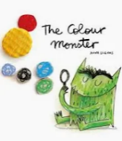  Super Duper You by Sophie Henn  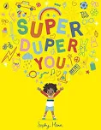 | On the Way Home by Jill Murphy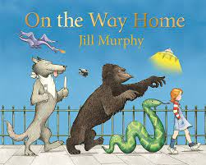  Clothesline Clues to Jobs People Do by Katherine Helling and Deborah Hembrook  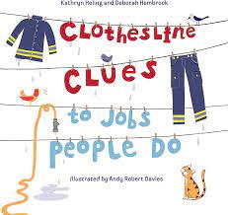 | We're going on a Bear Hunt by Michael Rosen  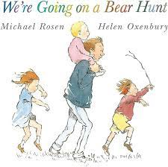  There is no Dragon in this Story by Lou Carter  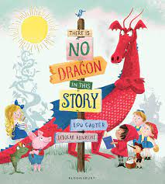 | Little Red and the Very Hungry Lion  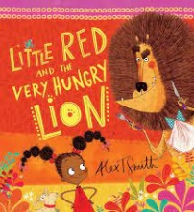  We all went on Safari  By Laurie Krebs  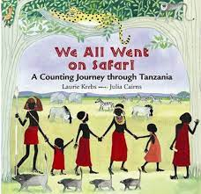  Handa’s Surprise by Eileen Browne  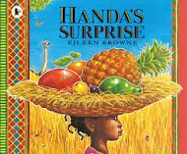 | The King Of Tiny Things by Jeanne Willis  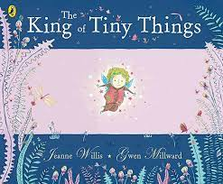  What the Ladybird Heard by Julia Donaldson  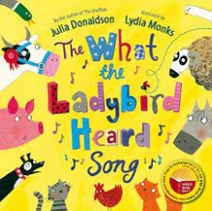 | Around the World in 80 Ways by Katy Halford  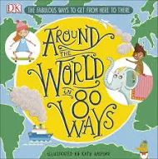  The Suitcase by Clotilde Perrin  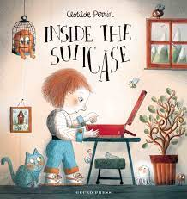
Fiction Outcome | Recognise and begin to write some or all of my name.  Reading individual letters by saying the sounds for them.  Begin to write some letters using our letter rhymes.  Engage in storytimes.  Listen to and talk about stories to build familiarity and understanding.  (Development Matters CLL) | Write recognisable letters, most of which are correctly formed  Develop phonic knowledge by linking sounds to letters, naming and sounding some of the letters of the alphabet | Retell the story, once they have developed a deep familiarity with the text, some as exact repetition and some in their own words  Blending captions and short sentences.  Write CVC words.  Begin to write captions and short sentences. | Use clear sentences to share my knowledge and ideas.  Ask questions to find out more about animals that interest me | Read common exception words in simple sentences.  Write a simple sentence with a capital letter and full stop. | Learning new rhymes and poems from different parts of the world to develop my vocabulary.
Non-Fiction  Outcome | To use the Zones of Regulation appropriately as a means of registering emotions  Engage in non-fiction books. | Listen to and talk about selected non-fiction to develop a deep familiarity with new knowledge and vocabulary. | Talk about other cultures | Listen to and talk about non-fiction to develop a deeper familiarity with new knowledge and vocabulary. | Talk about what we can see in our school grounds.  Find out about the lives of our resident bees.  Know how to care for minibeasts and why we need them.  Talk about the things I notice about their colours, patterns, similarities and differences.  Know how we grow plants to attract minibeasts and help other plants grow. | Extended sentences using common exception words and capital letters and full stops. Reread what I have written to check it makes sense.  Talk about the places I have visited or would like to see.  I can tell you about a visit I have been on and what it was like. Including our Farm visit.  How can we care for our world? What can we do?  How are places similar or different to where I live?
Poetry Outcomes | Listen carefully to rhymes and songs, paying attention to how they sound. |  | Learn rhymes, poems and songs. | Learn rhymes, poems and songs from other countries. | Show your enjoyment of poems using your voice and manner to give emphasis to carefully chosen words and phrases. | Help children to join in with refrains and learn some verses by heart using call and response.
Key skills being taught and built upon from the NC  (see AP assessment grids) | Physical Development  Use their core muscle strength to achieve a good posture when sitting at a table or sitting on the floor and that they can move and rotate their lower arms and wrists independently.  Use anticlockwise movement and retrace vertical line.  Hold a pencil correctly in preparation for fluent writing using the tripod grip in almost all case  Writing  Enjoys creating texts to communicate meaning for an increasingly wide range of purposes - this could be very early stages of mark-making and the emphasis is on communicating meaning  Give meaning to the marks they make as they draw, write, paint and type | Writing  Develop phonic knowledge by linking sounds to letters, naming and sounding some of the letters of the alphabet  Segment the sounds in words and blend them together  Spell words by identifying the sounds and then writing the sound with letter/s | Writing  Begins to break the flow of speech into words to hear and say the initial  Spell words by identifying sounds in them and representing the sounds with a letter or letters sounds in words  Reading  Blend sounds into words, so that they can read short words made up of known letter– sound correspondences. Ask children to work out the word you say in sounds: for example, h-a-t > hat; sh-o-p > shop. Show how to say sounds for the letters from left to right and blend them. | Writing  Begins to break the flow of speech into words to hear and say the initial sounds in words  Develop phonic knowledge by linking sounds to letters, naming and sounding some of the letters of the alphabet  Segment the sounds in words and blend them together | Writing  Segment the sounds in words and blend them together  Spell words by identifying the sounds and then writing the sound with letter/s  Use their developing phonic knowledge to write things such as labels and captions | Writing  Write short sentences with words with known sound-letter correspondences - they also are beginning to understand what finger spaces, capital letters and a full stops are, and how they are used  Re-read what they have written to check it makes sense  Write recognisable letters, most of which are correctly formed  Spell words by identifying sounds in them and representing the sounds with a letter or letters  Write simple phrases and sentences that can be read by other
Ongoing and developing objectives | ELG  Listening, Attention and Understanding Listen attentively and respond to what they hear with relevant questions, comments and actions when being read to and during whole class discussions and small group interactions; Make comments about what they have heard and ask questions to clarify their understanding. Hold conversation when engaged in back-and-forth exchanges with their teacher and peers.  Speaking Participate in small group, class and one-to-one discussions, offering their own ideas, using recently introduced vocabulary;  Offer explanations for why things might happen, making use of recently introduced vocabulary from stories, non-fiction, rhymes and poems when appropriate. Express their ideas and feelings about their experiences using full sentences, Including use of past, present and future tenses and making use of conjunctions, with modelling and support from their teacher.  Comprehension: Demonstrate understanding of what has been read to them by retelling stories and narratives using their own words and recently introduced vocabulary; Anticipate – where appropriate – key events in stories;  Use and understand recently introduced vocabulary during discussions about stories, non-fiction, rhymes and poems and during role-play.  Word Reading: Say a sound for each letter in the alphabet and at least 10 digraphs; Read words consistent with their phonic knowledge by sound-blending; Read aloud simple sentences and books that are consistent with their phonic knowledge, including some common exception words.  Writing: Write recognisable letters, most of which are correctly formed; Spell words by identifying sounds in them and representing the sounds with a letter or letters; Write simple phrases and sentences that can be read by others.

Year 1 |  | Autumn 1 | Autumn 2 | Spring 1 |  | Spring 2 |  | Summer 1 |  | Summer 2
Topic Title |  | Mighty Me | Our World | Wonderful Weather |  | Toys |  | Explore and Discover |  | Where is Shanghai?
Texts |  | Unit 1: Supertato, by Sue Hendra and Paul Linnet  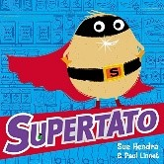  Pupil Fact Files  Unit 2: This is Me, by George Webster  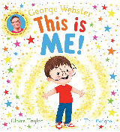 | Unit 1: Firework Senses poem  Unit 2: Beegu, by Alexis Deacon  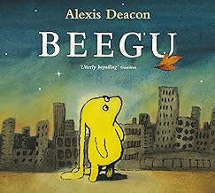  Nativity: Speaking and listening skills  Performing skills | 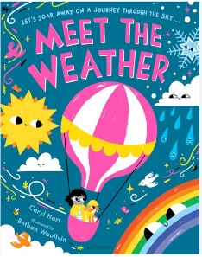  Unit 1: Meet the Weather  Unit 2: A Cloudy Lesson  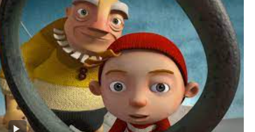 |  | Unit 1: Lost in the Toy Museum  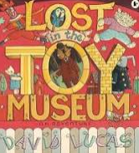  Unit 2: Buzz Lightyear Fact File (stand alone week due to assessment week)   |  | Unit 1: The Lion Inside  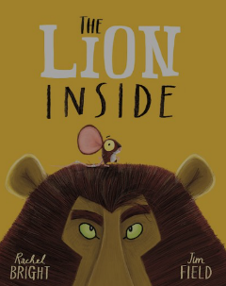  Unit 2: Postcard from an explorer/ discoverer  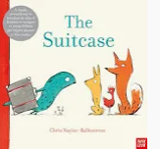 |  | 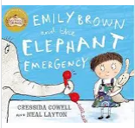  Unit 1: Emily and the Elephant Emergency  Unit 2: If you were a City  
Fiction Outcome |  | Information text  Purpose and audience: To inform others about themselves and times when they are special. | Story Recount  Purpose and audience: To retell a familiar story to their buddy reading class. | Weather Riddle  Purpose and audience:  To entertain their friend by writing a riddle about their favourite weather.  Digital Literacy  To design a cloud and describe it.  Purpose and audience:  to write a description of a cloud. |  | Letter  Purpose and audience:  To help find their lost toy and encourage them to come home. |  | Character Description  Purpose and audience:  To write to inform their buddy class about the mouse. |  | Setting Description
Non-Fiction  Outcome |  | Information text  Purpose and audience: To write an all about me factfile to give others specific factual information. |  |  |  | Buzz or Woody Factfile  Purpose and audience:To write own sentences about a topic for Woody and the other toys to read. |  | Postcard from Safari |  | Shanghai Fact file
Poetry  Outcome |  |  | Poetry writing  Purpose and audience: To write a senses poem with a firework theme to be shared with the class. |  |  | I’m an Easter Poem  (stand along week) |  | The Ugly Five  Animal Riddles
Key skills being taught and built upon from the NC  (see AP assessment grids) |  | Units 1 + 2:  Write sentences which can be read by themselves and others (without punctuation).  Use capital letters for their name and the personal pronoun  Begin to space words accurately  use their phonic knowledge to write words in ways which match their spoken sounds – some being spelt correctly and others being phonetically plausible  Use question marks | Units 1+2:  Write sentences which can be read by themselves and others (without punctuation).  Use the joining word and  write a sequence of sentences to form short narratives, including personal experiences and those of others (real or fictional) | Unit 1:  use capital letters and full stops to demarcate some sentences accurately  Use the joining word and  Read aloud their writing to each other and the teacher  Unit 2:  Use the suffix er and est. |  | Unit 1:  use capital letters and full stops to demarcate some sentences accurately  Use the joining word and  Read aloud their writing to each other and the teacher  use question marks to demarcate some sentences  use exclamation marks to demarcate some sentences  use exclamation marks to demarcate some sentences  Unit 2:  use capital letters and full stops to demarcate some sentences accurately  Use the joining word and  Use capital letters for names.  Read aloud their writing to each other and the teacher  Check what they have written by reading aloud. |  | Unit 1:  write a sequence of sentences to form short narratives,  use capital letters and full stops to demarcate some sentences accurately  Use the joining word and  Read aloud their writing to each other and the teacher  Use the suffix er and est.  use simple past and present verbs mostly accurately
Ongoing and developing objectives |  | Use their phonic knowledge to write words in ways which match their spoken sounds – some being spelt correctly and others being phonetically plausible  Spelling Year 1 common exception words  Physical Development - Holds pencil between thumb and two fingers, no longer using whole hand grasp  Spell some suffixes from the year 1 spelling patterns [see National Curriculum ]
Year 2 | Autumn 1 |  | Autumn 2 | Spring 1 | Spring 2 |  | Summer 1 |  | Summer 2
Topic Title | Wonderful World |  | Remember November | Flying High | Flying High |  | Castles |  | We’re all going on a Summer holiday
Texts | Unit 1: I wish I was a pirate by Krystal Whitehead  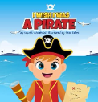  Pirates of Scurvy Sands by Jonny Duddle  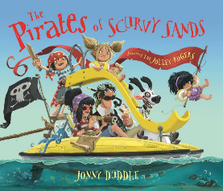  Unit 2: Dear Greenpeace by Simon James  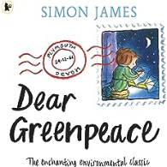  Unit 3: Factfile on Endangered animals (Bee factfile linked to Ashlands Bee Week)  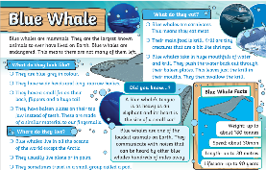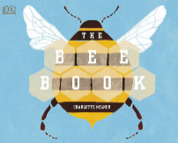 |  | Unit 1:  Samuel Peyps  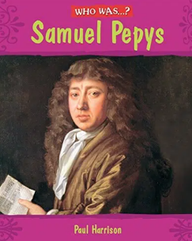  Unit 2:  Vlad and The Great Fire of London  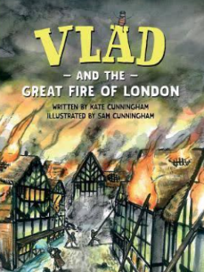  Unit 3: Poetry  A variety of Christmas poems.  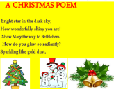 | Unit 1:  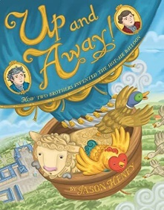  Up and Away  Unit 2:  Amelia Earhart  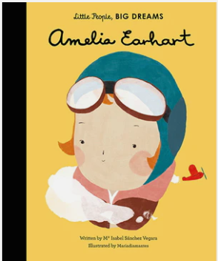 | Unit 1:  Emma Jane’s Aeroplane  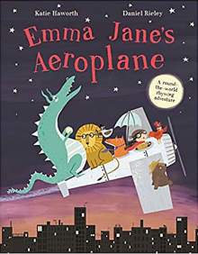  Unit 2:  Journey Aaron Becker  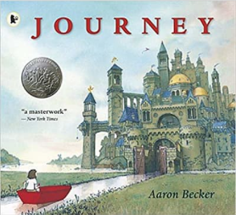 |  | (Jack and the Baked Bean)  Unit 1 (3 weeks)  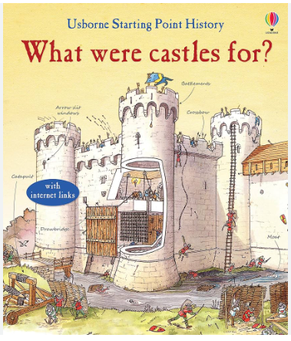  Unit 2 (1 week)  Dragon Poetry  Unit 3  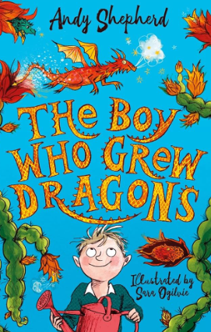  We may also use some other texts around this and will update accordingly |  | Lighthouse Keeper’s Lunch
Fiction Outcome | Letter writing:  Purpose and audience: To write a letter to Greenpeace to persuade them that you have seen an endangered animal |  | Story:  Purpose and audience: To recount and retell a story based on real events. | Description:  Purpose and audience: To write a description of a hot air balloon, to inform and entertain. | Story:  Purpose and audience: |  | Story: TBC  Purpose and Audience
Non-Fiction  Outcome | Information text: Factfile  Purpose and audience: To create a factfile on bees in order to inform others about an endangered animal. |  | Diary Writing: Samuel Pepys  Purpose and audience: Write a diary entry informing others about real events from the past. | Newspaper report:  Purpose and audience: Write a newspaper article about Amelia Earhart going missing, to inform and entertain. |  |  | Application for a job (of a Monarch)  This will include: laws/castle description/event plan & description  Purpose and Audience  To apply for a fictitious job; professional writing to inform and describe. |  | Instructions (beach theme)
Poetry  Outcome | Poetry writing:  Purpose and audience: To write a pirate themed poem to entertain others. |  | Poetry writing  Purpose and audience: To write a poem with a Christmas theme to entertain others. |  | Poetry writing:  Purpose and audience: To write a |  | Poetry Writing  To write a poem about a dragon using different poetry styles (TBC) |  | Seaside Poems
Key skills being taught and built upon from the NC  (see AP assessment grids) | Unit 1:  segment spoken words into phonemes and represent these by graphemes, spelling many of these words correctly and making phonically-plausible attempts at others (rhyme)  Unit 2:  Demarcate most sentences in their writing with capital letters and full stops, and use question marks correctly when required.  Use co-ordination (e.g. or / and / but) and some subordination (e.g. when / if / that / because) to join clauses.  Write simple, coherent narratives about personal experiences and those of others (real or fictional).  Spell some common exception words  Use spacing between words that reflects the size of the letters.  Unit 3:  Write about real events, recording these simply and clearly.  Use co-ordination (e.g. or / and / but) and some subordination (e.g. when / if / that / because) to join clauses.  Spell some common exception words  Use spacing between words that reflects the size of the letters |  | Unit 1:  Demarcate most sentences in their writing with CL and FS, including using CL for proper nouns.  Write about real events, recoding these simply and clearly.  Use past tense correctly and consistently.  Use coordination and subordination  Make phonically plausible attempts.  Spell CEW  Begin to use adjectives (expanded noun phrases)  Plan or say what they will write  Write down key words and new vocabulary.  Unit 2:  Spell CEW  Write simple coherent narratives  Past tense  Co-ordination and subordination  Expanded noun phrases  Unit 3:  Know the difference between a statement, question and exclamation and command.  Handwriting and presentation. | Unit 1:  Begin to demarcate sentences with commas in a list.  Write simple, coherent narratives about personal experiences (fictional).  Use present tense mostly correctly and consistently.  Use expanded noun phrases for description.  Make phonically plausible attempts.  Spell CEW.  Plan or say what they will write.  Use the suffix –ly to turn adjectives into adverbs.  Unit 2:  Write about real events, recording these simply and clearly  Know the difference between a statement, question and exclamation.  Begin to demarcate sentences with exclamation marks.  Use coordination and/or subordination. Use apostrophes for possession. |  |  | Unit 1  using subordinating conjunctions.  Adjectives and adverbs for descriptive writing.  Past and present progressive tense.  Apostrophes for contractions and possession.  Recap and recall previously taught objectives for writing.  Handwriting – joining.  Poetry  Using language for audience engagement  Similies (adjectives for description)  Suffixes -ful -less -er -est -ly  Writing for different purposes.  Reading aloud with intonation to make their intention clear.  Unit 2  Recap and recall all previously taught objectives.  Sentence types including questions and exclamatory sentences.  past/present progressive tense  Writing with intonation; tone of voice.  Suffixes -ful -less -er -est -ly
Ongoing and developing objectives | Demarcate most sentences in their writing with capital letters and full stops, and use question marks correctly when required.  Spell many common exception words.  Form capital letters and digits of the correct size, orientation and relationship to one another and to lower-case letters.  Use spacing between words that reflects the size of the letters.

Year 3 | Autumn 1 | Autumn 2 | Spring 1 | Spring 2 | Summer 1 | Summer 2
Topic Title | Sticks and Stones | Travellers and Settlers | Earthquakes and Volcanoes | Celts and Romans | Explorers and Adventurers | Pyramids and Pharaohs
Texts | Unit 1: Stone Age Boy, by Satoshi Kitamura  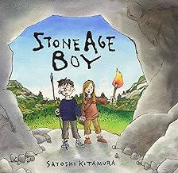  Unit 2: Skara Brae  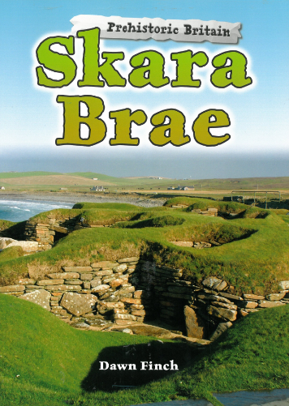 | Unit 1: How to Wash a Wooley Mammoth, by Michelle Robinson  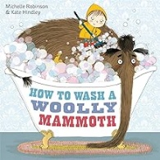  Unit 2: Adventure in New Delhi, by Amy Allatson  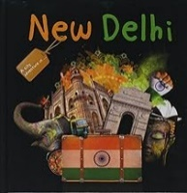 | Firework Maker’s Daughter, by Philip Pullman  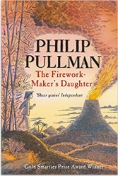  Escape from Pompeii, by Christina Balit  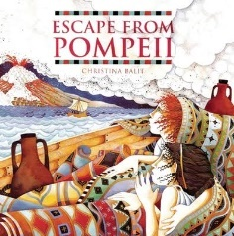 | I Was There…  Boudica’s Army, by Hilary McKay  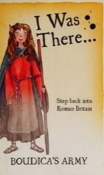  Various non-fiction books on ancient Rome  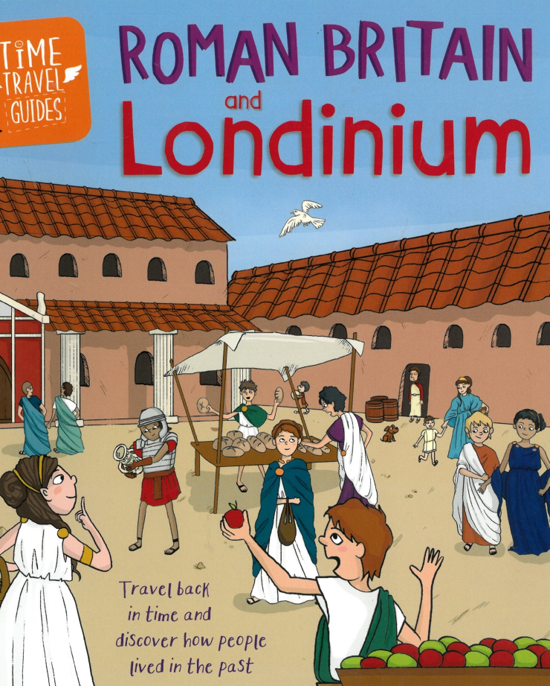 | The Whale 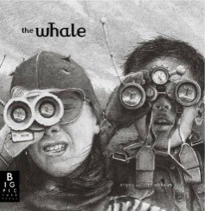  Nim’s Island by Wendy Orr  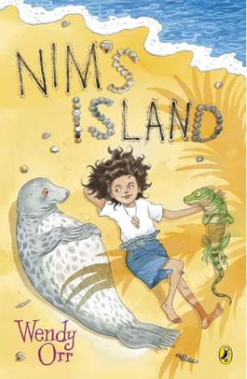 | Cinderella of the Nile,  By Beverley Naidoo  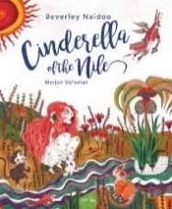  Howard & the Mummy, by Tracey Fern  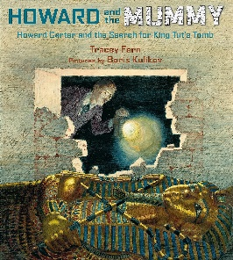
Fiction Outcome | Narrative  Purpose and audience: To write a portal story in first person in the style of Stone Age Boy for younger children. | Narrative - Diary  Purpose and audience: To write a diary comparing New Delhi to home (to be read by other Y3 children) | Narrative  Purpose and audience: To write a continuation of the story of a firework maker’s daughter (to be read by other Y3 children). | Letter  Purpose and audience: To write a letter home from Britannia, describing to friends in Rome what life is like in Celtic Britain (to be read by other Y3 children). | Letter  Purpose and audience: To write a ship’s log entry.  Narrative  Purpose and audience: To write an adventure story to entertain children of a similar age.
Non-Fiction  Outcome | Information text  Purpose and audience: To write a leaflet about Skara Brae in order to inform the general public. | Instructional text  Purpose and audience: To write a set of instructions about washing a Woolly Mammoth for younger children. | Non-Chronological Report  Purpose and audience: To write a non-chronological report about Pompeii (non-fiction). | Explanation text  Purpose and audience: Write an explanation text about the Londinium during the Roman occupation (to be read by other Y3 children). |  | Persuasive Argument - King Tut’s curse
Poetry  Outcome |  |  | Poetry writing: Volcano Poetry  Purpose and audience: To write poems about volcanoes to entertain others. | Being You Poems |  | Ode to a Commode
Key skills being taught and built upon from the NC  (see AP assessment grids) | Unit 1:  Use adverbs to express time.  Use prepositions to express place and time.  Begin to use paragraphs to structure writing.  Begin to use inverted commas to punctuate speech.  Unit 2:  Use prepositions to express place and time.  Use adverbs to express time.  Use a range of co-ordinating and subordinating conjunction.  Describe settings and characters using expanded noun phrases. | Unit 1:  Use prepositions to express place and time.  Use adverbs to express time.  Use simple organisational devices (e.g. headings or sub-headings) appropriately.  Use a range of co-ordinating and subordinating conjunctions.  Unit 2:  Use a range of co-ordinating and subordinating conjunctions.  Use adverbs to express time  describe settings and characters. Using expanded noun phrases  begin to use paragraphs to structure writing. | Unit 1:  Use adverbs to express time.  Use prepositions to express place and time.  Begin to use paragraphs to structure writing.  Begin to use inverted commas to punctuate speech.  Use expanded noun phrases  Use the full range of punctuation taught at key stage 1 and in Y3 mostly correctly  Spell most words correctly  Unit 2:  Write for both fictional and non-fictional purposes, drawing on their reading to inform the vocabulary and grammar of their writing  Use a range of co-ordinating and subordinating conjunctions  Use prepositions to express place and time  Maintain Standard English forms, e.g. using a/an correctly  Use simple organisational devices (e.g. headings or sub-headings) appropriately | Unit 1:  Describe settings and characters using expanded noun phrases  Use adverbs to express time  Use correct tense consistently, including the present perfect tense  Use prepositions to express place and time  Begin to use paragraphs to structure writing  Unit 2:  Explanation Text  Paragraphs written in chronological order  Use a range of co-ordinating and subordinating conjunctions  Use adverbials of time and manner  Use prepositions to express place and time  Use the full range of punctuation taught at key stage 1 and in Y3 mostly correctly  Spell most words correctly | Unit 1:  Use correct tense consistently, including the present perfect tense  Describe settings and characters using expanded noun phrases.  Use a range of co-ordinating and subordinating conjunctions.  Use adverbs to express time.  Use prepositions to express place and time.  Unit 2:  Use correct tense consistently, including the present perfect tense  Describe settings and characters using expanded noun phrases.  Use inverted commas to punctuate speech.  Use a range of co-ordinating and subordinating conjunctions.  Use adverbs to express time.  Use prepositions to express place and time.  Use paragraphs to structure writing.
Ongoing and developing objectives | Use the full range of punctuation taught at key stage 1 and in Y3 mostly correctly.

Year 4 | Autumn 1 | Autumn 2 | Spring 1 | Spring 2 | Summer 1 | Summer 2
Topic Title | Exploring the Rainforest | Children through the ages | Settlements | Invaders and Settlers | The Vikings | Food Glorious Food
Texts | Unit 1: The Girl Who Stole An Elephant, by Nizrana Farook. (Fiction)  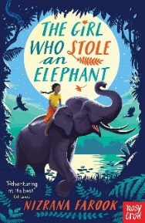  Unit 2: A range of non-fiction text about the rainforest.  (Non-fiction)  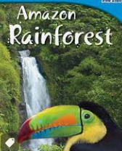 | Unit 1: Oliver Twist  By Charles Dickens (Fiction)  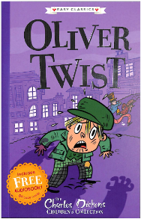  Unit 2: Information texts: the child labour act / Lord Shaftesbury  (Non-fiction)  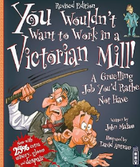 | Unit 1: India Incredible India by Jasbinda Bilam  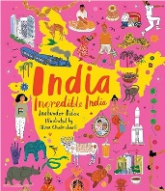  (Non-Fiction)  Unit 2: Seeds of Friendship by Michael Foreman  (Fiction)  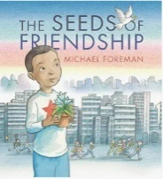 | Unit 1: Winter of the Wolves by Tony Bradman (Fiction)  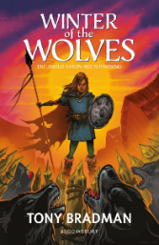  Unit 2: Beowulf by Michael Morpurgo (Fiction/Poetry)  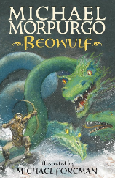 | Unit 1: How to Train Your Dragon by Cressida Cowell  (Fiction)  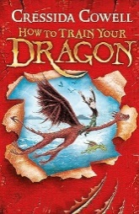  Unit 2: How to be a Viking by Jack Tite (Non-fiction)  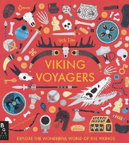 | Unit 1: Charlotte’s Webb by E.B. White  (Fiction)  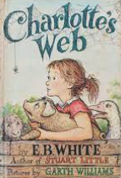
Fiction Outcome | Narrative  Purpose and audience:  To continue an adventure story in a rainforest setting in the style of the author, to entertain. | Narrative  Purpose and audience:  To write a diary from the perspective of Oliver Twist to inform and entertain. | Narrative  Purpose and Audience  To write an uplifting story about moving from New Dehli to Ilkley, to support a child nervous about change. | Narrative  Purpose and Audience  To write a descriptive extract for the story focusing on sustaining mood whislst creating atmoshere and tension | Narrative  Purpose and Audience | Narrative  Purpose and Audience
Non-Fiction  Outcome | Report  Purpose and audience:  To write a non-chronological report about the rainforest, writing to inform and share with year one as the experts. | Biography of Lord Shaftesbury  Purpose and audience:  Persuasion:  Write a formal letter persuading the house of Lords to abolish child labour. | Balanced Argument  Purpose and Audience:  Present the the advantages of living in each place to inform the decision of a tourist looking for a nice place to visit. |  | Viking Fact File  Purpose and Audience  To research the lives of Vikings in various non-fiction texts and produce a fact file about their lifestyle including information about homes, food, hunting, arts, crafts, Gods and myths. | Balanced Argument Local v’s Global  Purpose and Audience  Present the pros and cons of sourcing food locally rather than from further afield.
Poetry Outcomes |  |  |  | Poem about a monster  Purpose and Audience  To use the description of Grendel from Beowulf to write a poem about a monster.
Key skills being taught and built upon from the NC  (see AP assessment grids) | Unit 1:  Use expanded noun phrases and adverbials to develop descriptions of settings and characters.  Use a range of adverbs to add detail to writing.  Use fronted adverbials.  Unit 2:  Use paragraphs or sections to organise and structure according to purpose and audience.  Use a range of co-ordinating and subordinating conjunctions. | Unit 1: Use a range of co-ordinating and subordinating conjunctions.  Use present, past, progressive and perfect tense verb forms accurately  use expanded noun phrases and adverbials to develop descriptions of settings and characters  Unit 2:  Use paragraphs or sections to organise and structure according to purpose and audience  use fronted adverbials  use commas after fronted adverbials and with a reported clause | Unit 1: Use a range of co-ordinating and subordinating conjunctions.  Use sentences with different forms in their writing, including statements, questions,  exclamations and commands.  Use paragraphs or sections to organise and structure according to purpose and audience.  Unit 2: Use expanded noun phrases and adverbials to develop descriptions of settings and characters.  Use a range of adverbs to add detail to writing.  Use the full range of punctuation taught in KS1 and so far in KS2 mostly correctly (full stops,  capital letters, question marks, exclamation marks, commas in lists, apostrophes for  contraction and possession, inverted commas).  Make simple additions, revisions and proof-reading corrections to their own writing | Unit 1: Write for fiction with a growing awareness of the reader.  Use expanded noun phrases and adverbials to develop descriptions of settings and characters.  Use a range of adverbs to add detail to writing. (Creating tension and suspense).  Make simple additions, revisions and proof-reading corrections to their own writing  Unit 2: Poetry  To read and rehearse poems for presentation, focussing on understanding language and using expression  Use a range of precise vocabulary (nouns, verbs and adjectives)  Use poetic devices such as simile, metaphor and imagery.  Use expanded noun phrases and adverbials to develop descriptions of characters
Ongoing and developing objectives | write for both fictional and non-fictional purposes, with a growing awareness of the reader  Make simple additions, revisions and proof-reading corrections to their own writing  use the full range of punctuation taught in KS1 and so far in KS2 mostly correctly (full stops, capital letters, question marks, exclamation marks, commas in lists, apostrophes for contraction and possession, inverted commas)  produce legible joined handwriting

Year 5 | Autumn 1 | Autumn 2 | Spring 1 | Spring 2 | Summer 1 | Summer 2
Topic Title | The Greeks | The Alps | The Egyptians  (2024/2025 only) | Oceans | Victo | Hostile Earth
Texts | Unit 1: Fiction - Blog  Hercules and the Hydra – a selection of Greek Myths & Legends  Unit 2: Non-fiction non-chronological report  Ancient Greeks – a variety of no-fiction texts | Unit 1: Fiction – adventure story  The Brocken spectre  Unit 2: Poetry  Mountain/ Winter Poetry | Unit 1: Fiction  Secrets of a Sun King by Emma Carroll  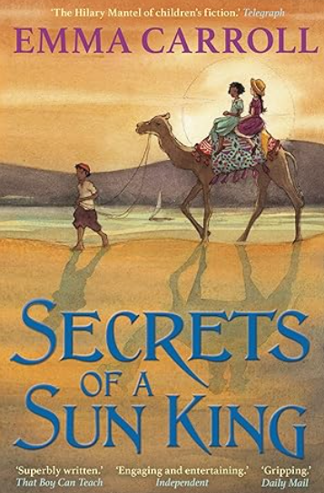  Unit 2: Non-fiction  Variety non-fiction texts about Egypt (Cairo)   | Unit 1: Fiction  This morning, I met a whale  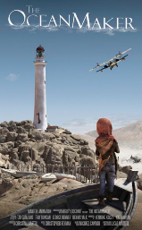  2: Non-fiction chronological report  This  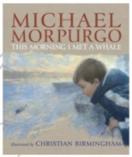 | Unit 1: Fiction My Story Bloody Tower by Valerie Wilding  Unit 2: | Holes  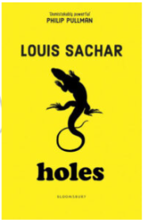  Louis Sachar
Fiction Outcome | Narrative - Retell Hercules’s 2nd labour in the style of a blog.  Purpose and audience: to entertain | Narrative: rewrite a section of the story including dialogue to convey a character’s emotions.  Purpose and audience: to entertain | Write an informal letter in character.  Purpose and audience: to entertain | ? | Narrative  Purpose and audience: To write a diary in first person from the view of a Tudor Monarch to inform and entertain others of their own age. | TBC - (new text to Y5)
Non-Fiction  Outcome | Non-Chronological report  Purpose and audience:  Write a non-chronological report about the Ancient Greeks |  | Persuasive leaflet about Cairo | Non-fiction report  Purpose and audience -  To inform young people about the  impact of climate change on endangered animals.  Create a class magazine. |  | Non chronological report on a lizard??
Poetry  Outcome |  | Poetry writing  Write a selection of poems about mountains and winter including haiku and concrete verse.6 |  | Read environmental themed poetry  Write an ocean themed poem | Read aloud and perform Victorian poetry | Write a desert Haiku or cinquain
Key skills being taught and built upon from the NC  (see AP assessment grids) | Unit 1:  NC. Discuss and evaluate how authors use language, including figurative language, considering the impact on the reader.  Learn a wider range of poetry by heart.  Prepare poems to read aloud and perform showing understanding through intonation, tone and volume so that the meaning is clear to an audience.  Write effectively for a range of purposes and audiences.  Unit 2:  Begin to use a range of devices to build cohesion (e.g. conjunctions, adverbials of time and place, pronouns, synonyms) across paragraphs.  Use expanded noun phrases to add detail, qualification and precision, e.g. with one or more adjectives, with a modifying adjective, with a preposition phrase  Use past verb tenses  to write in first person. | Unit 1:  In non-narrative writing, use simple devices to structure the writing and support the reader (e.g. headings, sub-headings, bullet points).  Use relative clauses, sometimes omitting the relative pronoun.  Use some punctuation for parenthesis (brackets, commas and dashes)  use paragraphs or sections to organise and structure.  Unit 2:  Use the full range of punctuation: inverted commas.  In non-narrative writing, use simple devices to structure the writing and support the reader (e.g. headings, sub-headings, bullet points)  use a wide range of clause structures, sometimes varying their position within the sentence. | Unit 1:  Begin to use a range of devices to build cohesion (e.g. conjunctions, adverbials of time and place, pronouns, synonyms) across paragraphs.  Use expanded noun phrases to add detail, qualification and precision, e.g. with one or more adjectives, with a modifying adjective, with a preposition phrase  Use verb tenses consistently  Integrate dialogue to convey character and advance the action  Use the full range of punctuation...  Unit 2:  In non-narrative writing, use simple devices to structure the writing and support the reader (e.g. headings, sub-headings, bullet points).  Use some punctuation for parenthesis (brackets, commas and dashes)  Use paragraphs or sections to organise and structure.  Use co-ordinating and subordinating conjunctions  Prepare poems to read aloud and perform showing understanding through intonation, tone and volume so that the meaning is clear to an audience. | Unit 1:  In non-narrative writing, use simple devices to structure the writing and support the reader (e.g headings, subheadings, bullet points).  +Use the full range of punctuation taught in KS1 and so far in KS2 mostly correctly (full stops, capital letters, question marks, exclamation marks, commas in lists, commas after fronted adverbials, apostrophes for contraction and possession, inverted commas and other speech punctuation)  Unit 2:  NC. Discuss and evaluate how authors use language, including figurative language, considering the impact on the reader.  Prepare poems to read aloud and perform showing understanding through intonation, tone and volume so that the meaning is clear to an audience.  Write effectively for a range of purposes and audiences.
Ongoing and developing objectives | Write effectively for a range of purposes and audiences.

Year 6 | Autumn 1 | Autumn 2 | Spring 1 | Spring 2 | Summer 1 | Summer 2
Topic Title | The Mayans | Population Changes | High Energy | WW2 | Crime and Punishment | Transitions  Changes the Play
Book (s) | Unit 1: Personification poem: Stationery War  Unit 2: The Explorer  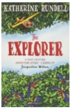 | Unit 1: The Arrival  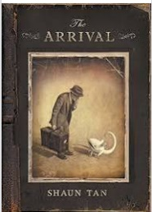 | Cogheart  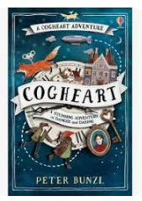 | Goodnight Mr Tom  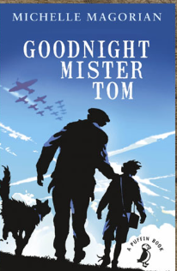 | The Highwayman  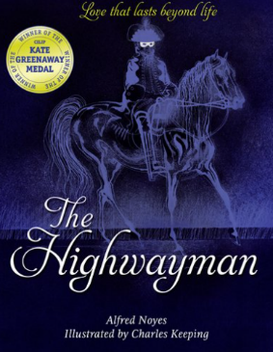  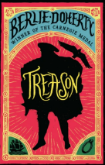  Treason | Skellig  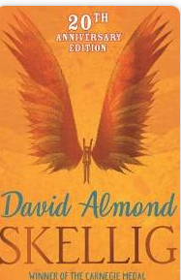
Fiction Outcome | Narrative writing using The Explorer  Purpose and audience:  To write an adventure story extract from the internal monologue of a character to entertain others. | Narrative writing using The Arrival  Purpose and audience:  To write a journal from the perspective of the man and his experiences in the new land.  Audience being other children Y6.  Purpose and audience:  To write and then record an audio description, to a visually impaired child. | Narrative: Tale of Fear  Purpose and audience:  To conduct a character interview: Pupils imagine they are interviewing one of the characters from "Cogheart”, with answers based on the character's perspective, providing insights into their motivations, feelings, and experiences throughout the story. Audience Y6 children. | Narrative: Dialogue  Purpose and audience:  To entertain others through writing a third person narrative integrating dialogue to convey character. | Narrative: rewrite poem in prose  Purpose and audience:  To entertain others through the translation of a poem into prose. | Narrative: Written as First Person Diary
Non-Fiction  Outcome |  |  | Purpose and audience:  To write a balanced argument: Are mechanicals good or bad? What are the consequences of technological advancements?  Audience being other children Y6. | Purpose and audience:  To write a summary report on aspects of WW2 to inform other children of a similar age. | Non-chronological report: | Explanation: Evolution and adaptation.
Poetry | Poetry writing  Purpose and audience:  To write a personification poem using figurative language to read aloud and perform. |  |  | Purpose and audience:  To write a piece of poetry based on WW2 to entertain and inform other children of a similar age.  To inform others on the hardship of conflict, as well as persuading against war through the tone of the language used. | The Highwayman | Poems about travel and moving on.
Key skills being taught and built upon from the NC  (see AP assessment grids) | Unit 1:  Write effectively for a range of purposes and audiences, (poetry) selecting language that shows good awareness of the reader, using similar writing as a model.  Select vocabulary and grammatical structures that reflect what the writing requires (personification).  NC. Discuss and evaluate how authors use language, including figurative language, considering the impact on the reader.  Unit 2:  In narratives, describe settings, characters and atmosphere, using a variety of techniques to engage the reader and choosing appropriate vocabulary that creates a consistent picture, e.g. verbs, preposition phrases, fronted adverbials, expanded noun phrases, relative clauses.  Use a range of devices to build cohesion (e.g. conjunctions, adverbials of time and place, pronouns, synonyms) within and across paragraphs.  Distinguish between the language of speech and writing and choose the appropriate register (internal dialogue v speech between characters). | Unit 1:  Write effectively for a range of purposes and audiences selecting language that shows good awareness of the reader.  Use a range of devices to build cohesion (e.g. conjunctions, adverbials of time and place, pronouns, synonyms) within and across paragraphs.  .  In narratives, describe settings, characters and atmosphere, using a variety of techniques to engage the reader and choosing appropriate vocabulary that creates a consistent picture. | Unit 1:  Write effectively for a range of purposes and audiences selecting language that shows good awareness of the reader.  Use a range of devices to build cohesion (e.g. conjunctions, adverbials of time and place, pronouns, synonyms) within and across paragraphs. | Write effectively for a range of purposes and audiences, selecting language that shows good awareness of the reader (e.g. the use of the first person in a diary; direct address in instructions and persuasive writing), using similar writing as a model (WAGOLL and other texts)  In narratives, describe settings, characters and atmosphere, using a variety of techniques to engage the reader and choosing appropriate vocabulary that creates a consistent picture, e.g. verbs, preposition phrases, fronted adverbials, expanded noun phrases, relative clauses | Write effectively for a range of purposes and audiences, selecting language that shows good awareness of the reader (e.g. the use of the first person in a diary; direct address in instructions and persuasive writing), using similar writing as a model (WAGOLL and other texts)  In narratives, describe settings, characters and atmosphere, using a variety of techniques to engage the reader and choosing appropriate vocabulary that creates a consistent picture, e.g. verbs, preposition phrases, fronted adverbials, expanded noun phrases, relative clauses
Ongoing and developing objectives | write effectively for a range of purposes and audiences, selecting language that shows good awareness of the reader  maintain legibility in joined handwriting when writing at speed  spell correctly most words from the year 5 / year 6 spelling list, and use a dictionary to check the spelling of uncommon or more ambitious vocabulary  Editing: Propose changes to vocabulary, grammar and punctuation to enhance effects and clarify meaning

