Use these prompts to write 100 words of a story. It can be about ANYTHING that comes to your mind when you see or read it. Whichever one you don’t do this morning you can do tomorrow morning. Be ready to share and capture the attention of your audience. Get creating!
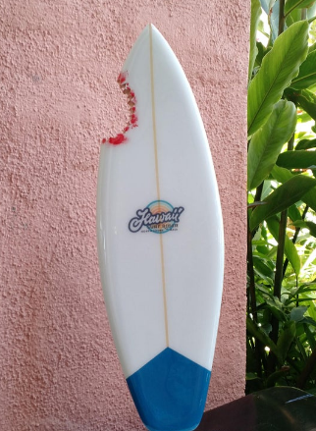
The last house on the street had always been empty. As long as I had been alive, years and years before even that. No-one ever moved in. It was never sold.
Until yesterday...
--------------------------------------------------------------------------------------------------------------------------------------------------------------------------------------------------------------------------------------------------------------------------------------------------------------------------------------------------------------------------------------------------------------------------------------------------------------------------------------------------------------------------------------------------------------------------------------------------------------------------------------------------------------------------------------------------------------------------------------------------------------------------------------------------------------------------------------------------------------------------------------------------------------------------------------------------------------------------------------------------------------------------------------------------------------------------------------------------------------------------------------------------------------------------------------------------------------------------------

--------------------------------------------------------------------------------------------------------------------------------------------------------------------------------------------------------------------------------------------------------------------------------------------------------------------------------------------------------------------------------------------------------------------------------------------------------------------------------------------------------------------------------------------------------------------------------------------------------------------------------------------------------------------------------------------------------------------------------------------------------------------------------------------------------------------------------------------------------------------------------------------------------------------------------------------------------------------------------------------------------------------------------------------------------------------------------------------------------------------------------------------------------------------------------------------------------------------------------

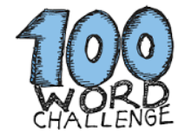

name

