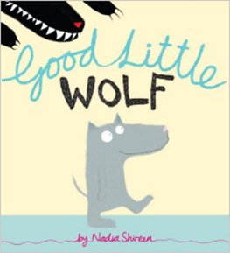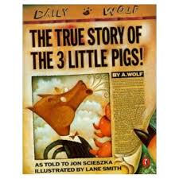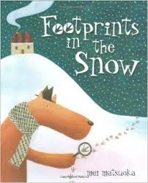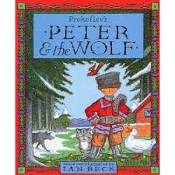

**WB: 12.7.21**

**I am learning to compare characters in stories I have read.**

This week we have shared many lovely stories. Each day I am going to think about if the wolf is bad or good and give reasons for this.