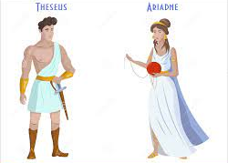
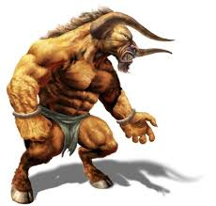
Identifying adverbs (1)

Look at the sentences below. Circle the adverb in each one.
- Theseus smiled cautiously.
- King Minos frowned angrily.
- He walked to the Labyrinth slowly.
- Carefully, he looked for the magic thread.
- Thankfully, it would all be over soon.

Adverbs word bank
cheerfully | sadly | shyly | noisily | gently | angrily | hungrily

Answer each question with an adverb. Use the Adverb Word Bank to help you. The first one has been done for you.
a) How did the Minotaur eat? He ate noisily.
b) How King Aegeus say goodbye to Theseus? King Aegeus said it ________________.
c) How did the Minotaur roar? The Minotaur roared_______________.
d) How did the boat rock on the sea? The boat rocked_________________.
e) How did Ariadne smile at Theseus? Ariadne smiled _________________

