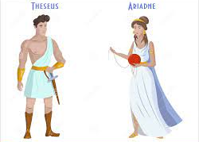
Identifying adverbs (2)

Look at the sentences below. Circle the adverb in each one.
- Theseus smiled cautiously.
- King Minos frowned angrily.
- He walked towards the Labyrinth slowly.
- Next, he looked for the magic thread.
- It would all be over soon.

Adverb Word Bank
next | tomorrow | quickly | nervously | carefully | patiently

Answer each question with an adverb. Use the Adverb Word Bank to help you. Some adverbs may match more than one sentences so make sure your sentences makes sense and you haven’t just used an adverb because it was the only one left.

- They ran _________________ back to their boat.
- There will be a wedding on Crete _________________.
- She wandered _________________ around the beach.
- _________________, she had to pass Theseus the magic thread.
- His father was waiting on the cliff _________________.

