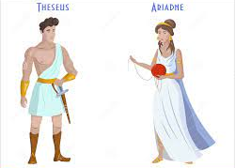
Identifying adverbs (3)

Look at the sentences below. Circle the adverb in each one.
- Ariadne smiled lovingly at Theseus.
- The Minotaur roared angrily.
- The guards roughly threw Theseus into the Labyrinth.
- Cautiously, he wandered down the winding passages.
- King Minos had recently eaten some fruit.

Use your own adverbs to complete these sentences.
- Theseus _________________killed the Minotaur.
- Theseus exited the Labyrinth _________________.
- The Athenian children ran _________________ towards Theseus.
- _________________, King Aegeus waited for his son and the other Athenian children.
- Surely, Theseus would return _________________ for Ariadne.

