Home Learning

St. Wilfrid’s Catholic Primary School
Reception

Week 3 (Spring Term)
Week beginning: 18th January 2021

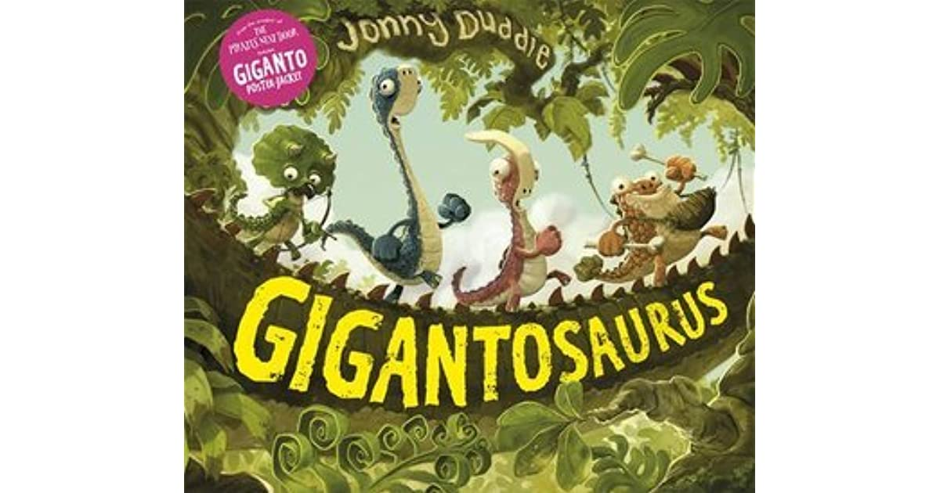

These weekly home learning documents will be on the school website and uploaded to SeeSaw with videos from Miss Dooner, additional guidance, and further activities for children to follow each week so make sure you are logging in daily.

This is the suggested timetable for the week.

 | Activity 1 (am) | Activity 2 (am) | Activity 3 (pm)
Monday | Literacy | Phonics | PSED
Tuesday | Literacy | Phonics | Understanding of the World
Wednesday | Maths | Phonics | P.E/Fine motor
Thursday | Maths | Phonics | Music
Friday | R.E | Phonics | Expressive Arts & Design

Monday (am)
Literacy

Last week, we started to learn about different types of dinosaurs, their names and their features.
Look at the Powerpoint to remind yourself of some of the names and features of some dinosaurs. (This will be uploaded to Seesaw or you can access here)
https://www.twinkl.co.uk/resource/t-t-28312-dinosaurs-what-am-i-interactive-powerpoint-game

Activity 1
This week, we are going to create our own dinosaur! Can you draw a new dinosaur of your own? Think about its features.
- Does it have spikes?
- A long or short tail?
- Is your dinosaur a herbivore or carnivore?
- How many legs does your dinosaur walk on?
- How does it move around?

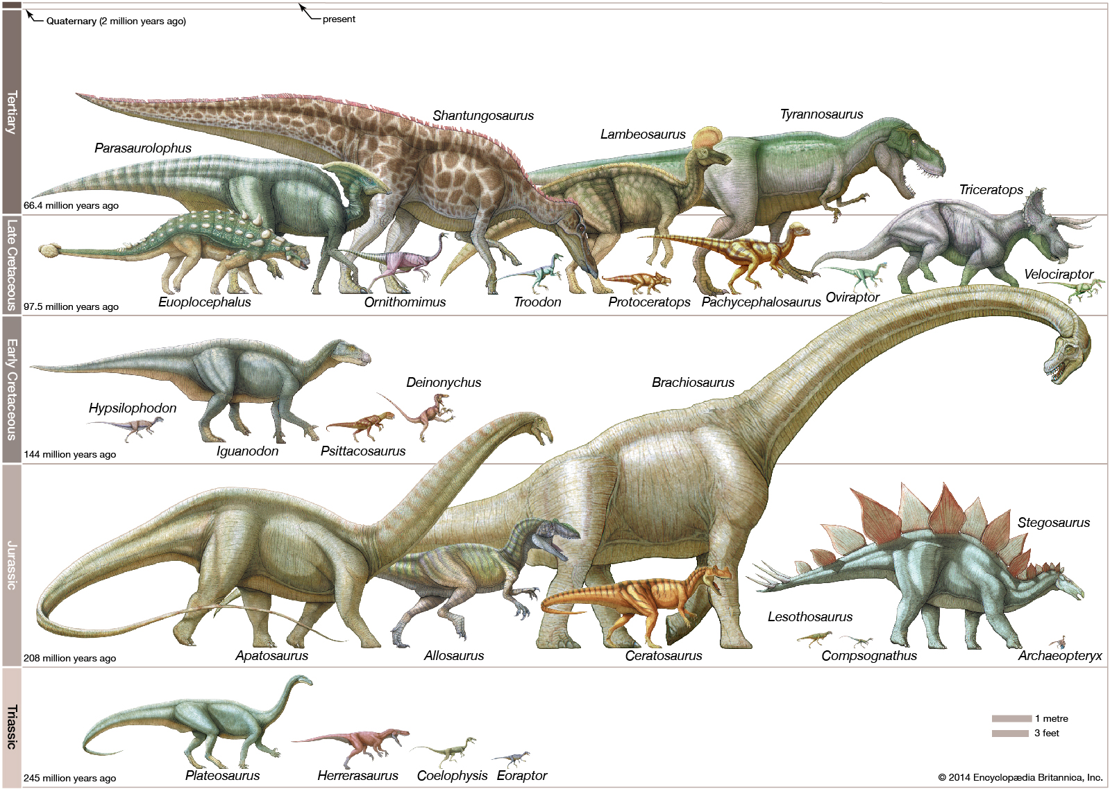
Draw a picture of your dinosaur and label its features by writing words and phrases.

Monday (am)
Phonics

We are practising reading sounds we have learnt so far, and learning a tricky word!
Lesson 46 - Reception

Monday (pm)
PSED/SCARF time
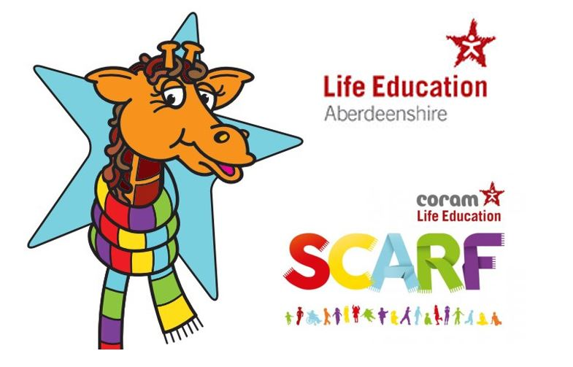

Read the story ‘Harold Shares his Scarf’
Think about;
- Why were Harold’s friends sad when he first saw them? (Each one of them was sad because someone had said something unkind about them).
- What did Harold say to help them feel happier?

Can you create a story map for Harold’s story? Who did Harold meet first? Who did he meet next? What happened at the end?

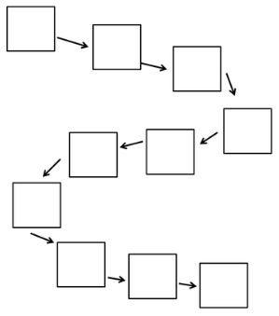

Tuesday (am)
Literacy
Yesterday, you drew a picture of a new dinosaur.
Today you are going to write a little bit about your dinosaur. Write the sentences on the lines in your home learning book underneath your picture.

Activity 1
Just like in the Powerpoint yesterday, can you write some clues describing your dinosaur. You clues can start with ‘I am...’ or ‘I have...’, then you can complete it with your own information.
For example;
I have a long neck.
I am a herbivore.

Activity 2
Last week, we looked at some dinosaur names, and learnt about how their names can tell us some information about them. This link will help you find out more about the names of dinosaurs if you need it.
https://www.kids-dinosaurs.com/dinosaur-names.html

Can think about what the name of your dinosaur will be? Use post-its or pieces of paper to build your name like we did last week.
- Choose the end of your dinosaur name. Remember, saurus = lizard, tops = face, odon = tooth.
- Choose the middle of your dinosaur name. A lot of dinosaur names have ‘o’ or ‘a’ but you can choose something different if you want to.
- Think of the beginning of your dinosaur name. Try and think of a word that will give us some information about your dinosaur name.
Once you have built your name, write it above your dinosaur picture.

Tuesday (am)
Phonics
We are practising reading sounds we have learnt so far, and learning a tricky word!
Lesson 47 - Reception

Tuesday (pm)
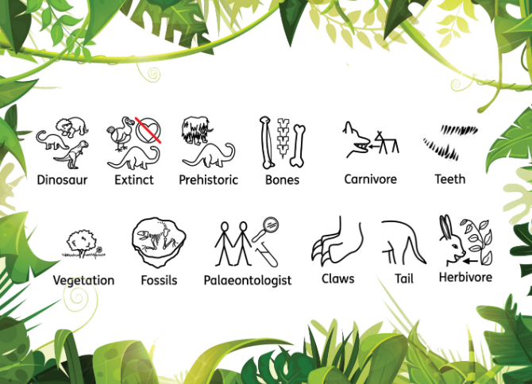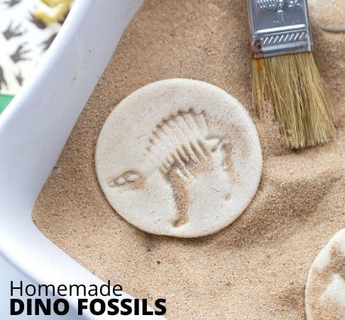
We are going to carry on with our dinosaur research we started last week and answer the question, ‘How do we know what dinosaurs looked like?’
The Powerpoint and lesson will be posted on Seesaw on Tuesday afternoon.
Here is the follow up activity;
https://littlebinsforlittlehands.com/salt-dough-fossils/

Wednesday (am)
Maths
Follow the link this week’s lessons.
https://whiterosemaths.com/homelearning/early-years/alive-in-5-week-1/
We are going to look at Sessions 1 and 2 today!
Here are the follow up activities;
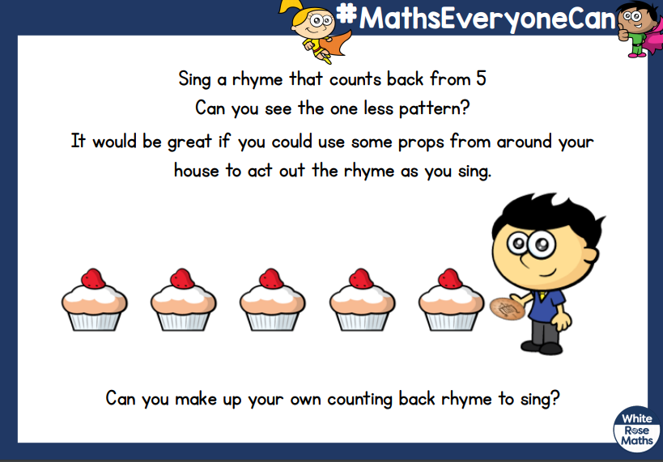

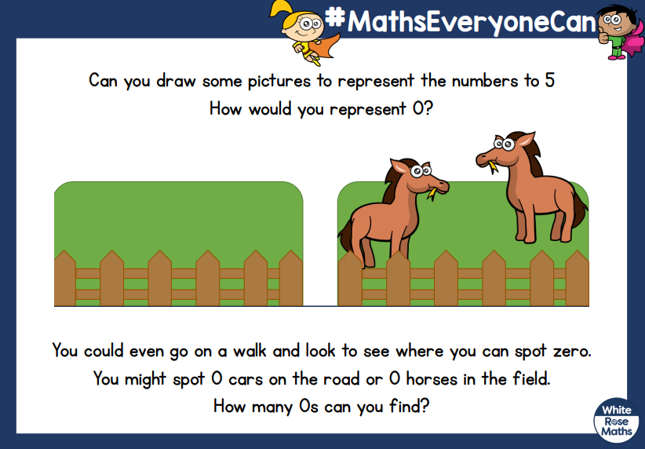

Wednesday (am)
Phonics
We are practising reading sounds we have learnt so far, and learning a tricky word!
Lesson 48 - Reception

Wednesday (pm)
P.E (Gross Motor Skills Practise)
Kids Yoga with Dinosaurs | Cosmic Kids

Fine Motor Skills Practise
We are going to practise our scissor skills this week. The videos will be posted on Seesaw, but you here is an alternative video you can also use!

Kindergarten Cutting

Thursday (am)
Maths

Follow the link for link this week’s lessons.
https://whiterosemaths.com/homelearning/early-years/light-and-dark-week-3/
We are going to look at Sessions 3, 4 and 5!
Here are the follow up activities;

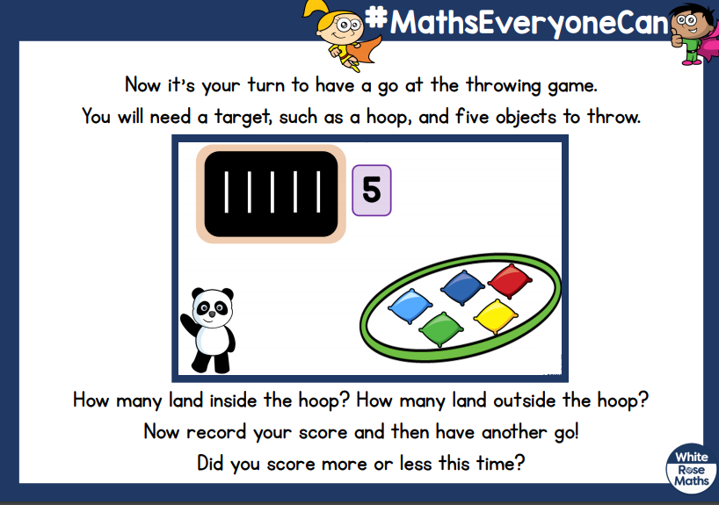

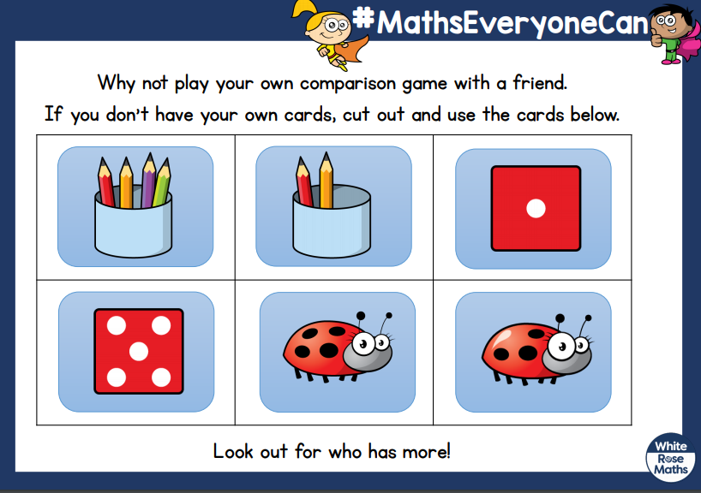

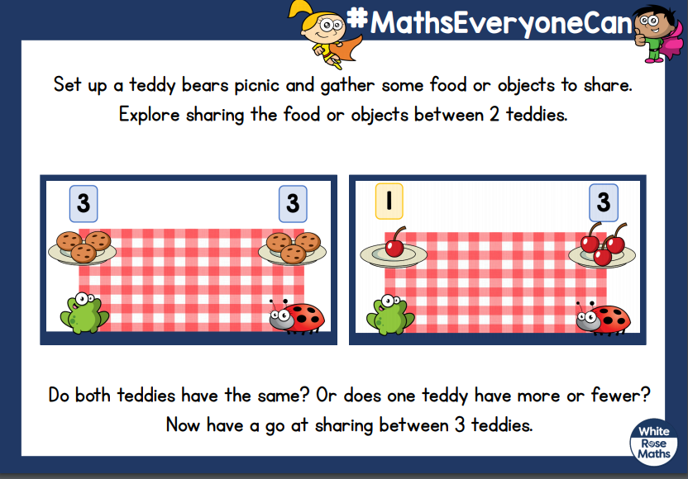

Thursday (am)
Phonics
We are practising reading sounds we have learnt so far, and learning a tricky word!
Lesson 49 - Reception

Thursday (pm)
Music
Follow the link for this week’s music lesson;
https://classroom.thenational.academy/lessons/sitting-on-the-bus-c4t64d

Friday (am)
Religious Education
Our R.E topic is Celebrating.
Activity 1
We are all part of a school family. Can you draw a picture of the children and adults in our school family? What are your favourite things to do with them?

Activity 2
Do you know what a parish is? All of children and families you meet at school and Church are part of St. Wilfrid’s parish. Do you know where St. Wilfrid’s Church is? Is there another Church you go to, or near your house?
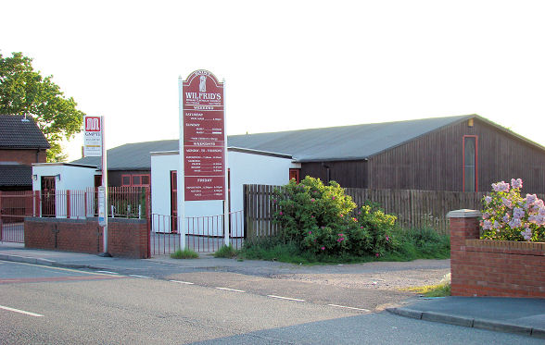

When we go to Church, we are part of a celebration. Have you been to a mass at a Church? Have you been to a Baptism? Or a wedding?
Look at these pictures. What is happening?

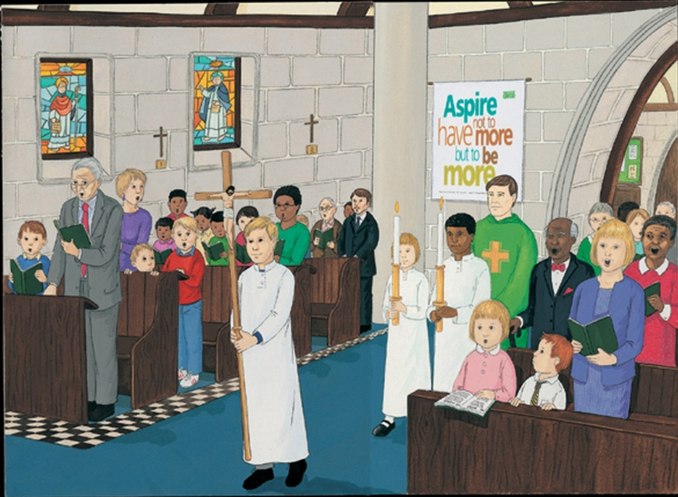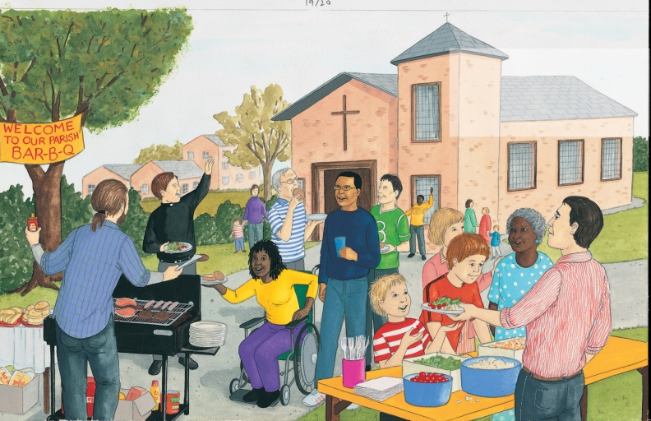

See if you can spot …the priest, crucifix, benches, hymn books, stained glass windows, baptismal font, altar, lectern and the notice board

Friday (am)
Phonics
We are going to review what we have learnt this week;
Lesson 50 - Reception

Friday (pm)
Expressive Arts & Design

On Tuesday, you created your own dinosaur. Can you make a model of your dinosaur. In school, we are going to use modelling clay to make our dinosaurs but you could use play dough or salt dough. You may be able to use tools such as a rolling pin or knife (with adult supervision!) to help you!

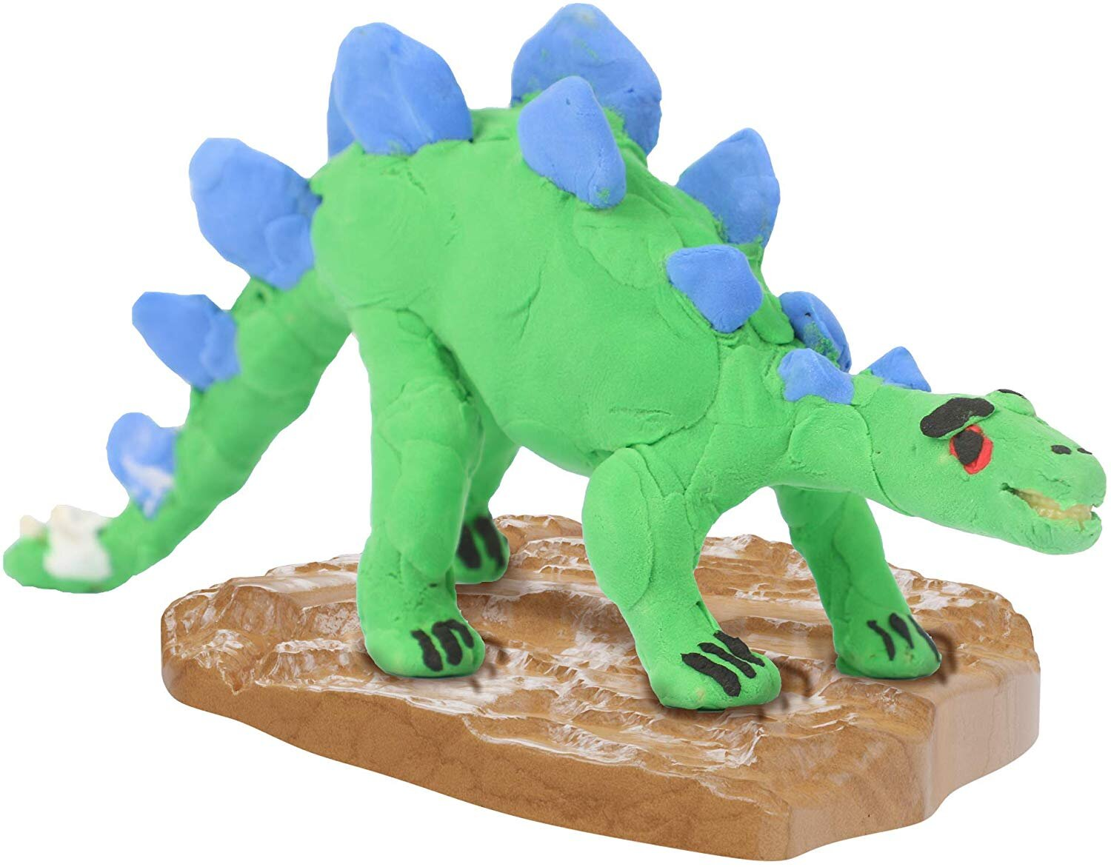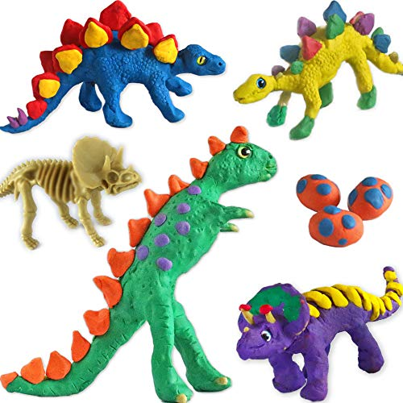

If you are using modelling clay, you could also paint your dinosaur model.

If you need help with anything, feel free to send me an email!
elizabeth.dooner@ashtonsaintwilfrids.wigan.sch.uk

