Home Learning
St Wilfrid’s Catholic Primary School
Year 1
Week 2
WB 18/01/21
Spring Term 1

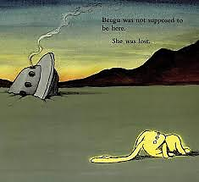

Home Learning Plan
Please note Suggested Timetable for the week:
 | AM | AM (30mins) | AM | PM
Monday* | Maths | Phonics | English | Handwriting
Tuesday* | Maths | Phonics | English | @Science
Wednesday* | Maths | Phonics | English | PSHE/wellbeing
Thursday* | Maths | Phonics | English | @Geography
Friday* | Maths | Phonics | English | PE/ RE
*READING 15 min each day @Virtual lesson Oak National Academy
Maths (White Rose)
For Maths, plans and video lesson see White Rose Home learning: See week 12 number place value within 20.
https://whiterosemaths.com/homelearning/year-1/
Phonics
DFE letters and sounds follow link on See Saw. Each video is a full lesson.
Mrs Georges group – see Seesaw for your lesson each day.
Miss Maclean/ Mrs Mellings group- Seesee Saw for your lesson each day
Extra phonics practice/ Reading ideas:-
www.Phonicsplay.co.uk
Phases 2, 3 and 4 User name: jan21 Password: home
OR Watch videos of Mr Thorn and Geraldine on YouTube.
https://www.youtube.com/channel/UC7sW4j8p7k9D_qRRMUsGqyw
English: Beegu – Work sheets attached See Seesaw for direction.
Handwriting – provided on See Saw

Science (Oak National Academy) Materials
lesson 3 What are objects made from? https://classroom.thenational.academy/lessons/what-are-objects-made-from-61gp8d
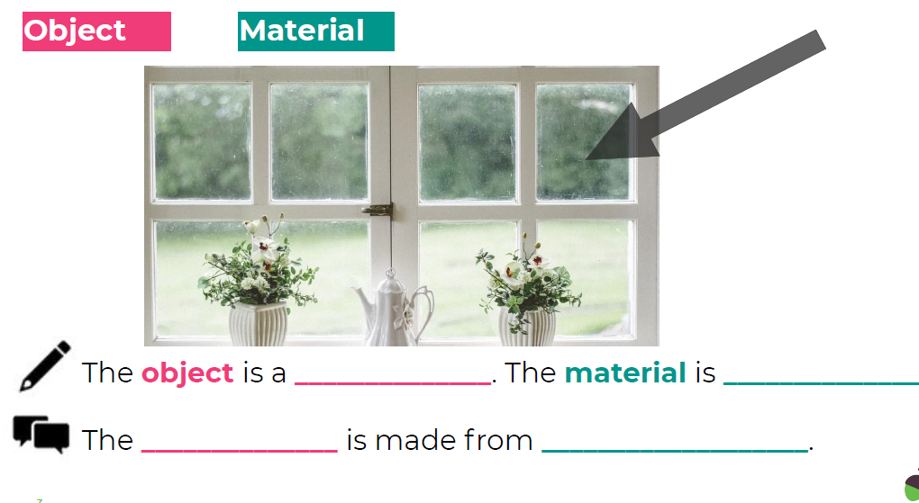
Geography (Oak National Academy) The seven continents: Lesson 3 What is Europe like?
https://classroom.thenational.academy/lessons/what-is-europe-like-60r64r
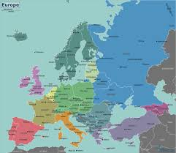

Mindfulness/Wellbeing:

Meditation for Kids | BREATHING EXERCISE | Guided Meditation for Children
https://www.youtube.com/watch?v=Bk_qU7l-fcU

RE
Our topic this term in Special people. You will find the overview of the lesson on the school website. This week you are doing lesson 2.

PE (BBC Teach) https://www.bbc.co.uk/teach/class-clips-video/physical-education-ks1-ks2-lets-get-active/z72yjhv
Joe wicks – google Joe Wicks (The body coach or PE with Joe) PE he is doing 20 minute live lessons at 9am Mondays Wednesdays and Fridays.
I am sure you will have plenty here to work on for now!

If you need further advice or support, please contact via email at: abbey.maclean@ashtonsaintwilfrids.wigan.sch.uk
Lorraine.melling@ashtonsaintwilfrids.wigan.sch.uk

English Monday Date: 18/1/21 (information and discussion sheet)
Watch the video of the story
Link: https://www.youtube.com/watch?v=OaX_zGZO0Y8 (to have the story read to you – notice he name! sounds like ‘Beejoo’)
https://www.slideshare.net/35chandos/beegu
(To read the story yourself)

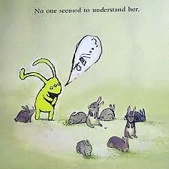
Discuss:
What might she be saying to the rabbits?
Why don’t they understand her?
Do you think she is asking them a question?
How do you know?
Write a speech bubble in your home learning book.

Tip: Write first then draw the bubble.

Tuesday 19/1/21
Sounds of the city https://www.youtube.com/watch?v=eXHURaIl7hA
(Sounds of the city)

Discuss:
What time of day is it now?
What do you think Beegu thinks the city could be?
How have her ears changed? What does this tell you about her?
Write in your home learning book:
I think Beegu thinks the city could be …
Perhaps you could draw a picture of Beegu and the city?

Wednesday 20/1/21
What is happening in the pictures?
Write some sentences to explain.
Remember to think about what you want to write, say what you want to write and use your writing targets.
(Hint: Capital letter, finger spaces, full stops. Does it make sense?)

Thursday and Friday we will focus on basic writing skills using BBC Bitesize.
Thursday
BBC Bitesize https://www.bbc.co.uk/bitesize/articles/zv78jhv

Learning focus
To use full stops accurately in correctly punctuated sentences.
This lesson includes:
- a video reminding you about capital letters
- a short introduction to full stops
- three activities
Friday
BBC Bitesize https://www.bbc.co.uk/bitesize/articles/z7hc47h

Learning focus
To use question marks to correctly punctuate sentences.
This lesson includes:
- a video to help you understand how to use question marks
- three activities

Handwriting
Continuous cursive handwriting
For further information on handwriting see: https://teachhandwriting.co.uk/teach-handwriting-parents.html

