Home Learning
St Wilfrid’s Catholic Primary School
Year 4
Week 9
WB 9/11/20
Autumn Term 2
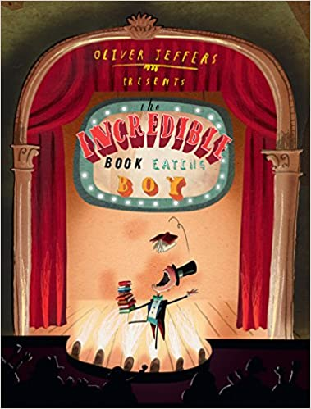

Mrs Atkinson

Home Learning Plan
Please note Suggested Timetable for the week:
 | AM | AM | AM | PM
Monday* | Maths | Spellings | English | Humanities (History)
Tuesday* | Maths | Spellings | English | Science
Wednesday* | Maths | Spellings | English | RE
Thursday* | Maths | Spellings | English | Music
Friday* | Maths | Spellings | English | PSHE /wellbeing
*READING: OXFORD READING BUDDIES 30 mins each day
English
Read up to page 7 Use you tube video
The incredible book eating boy
Grammar focus on possessive apostrophes
Maths
For Maths, plans and video lesson see White Rose Home learning: See week 9
https://whiterosemaths.com/homelearning/year-4/
See Worksheets attached
Spelling
Lesson1 https://classroom.thenational.academy/lessons/to-investigate-prefixes-6hgpae
Lesson 2 https://classroom.thenational.academy/lessons/to-practise-and-apply-prefixes-including-test-68t3ct
Lesson3 https://classroom.thenational.academy/lessons/to-investigate-more-prefixes-6cwkcd
Lesson4 https://classroom.thenational.academy/lessons/to-practise-and-apply-knowledge-of-more-prefixes-including-test-cmr34c
This week we continue to look at words with these patterns:
Prefix anti-, sub-, auto-, inter-

English
Comprehension : skills for prediction of text
RE: Calling
Islam
Lesson 1 https://classroom.thenational.academy/lessons/how-did-the-religion-of-islam-begin-74vk2r
Lesson 2 https://classroom.thenational.academy/lessons/what-are-the-five-pillars-of-islam-70t6cd
Lesson 3 https://classroom.thenational.academy/lessons/what-is-the-holy-book-of-islam-cmvk0d
Science
States of Matter: Evaporation of water

Music
Oak Academy
https://classroom.thenational.academy/lessons/understanding-pulse-and-rhythm-chj3cr?activity=video&step=1
followed with lesson 2
https://classroom.thenational.academy/lessons/exploring-4-beats-in-a-bar-cgwk2t?activity=video&step=1
PSHE/Wellbeing
http://www.coramlifeeducation.org.uk/scarf/home-learning-unit-2
Humanities
Hadrian’s Wall

