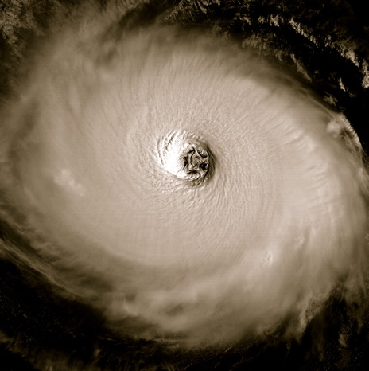
Hurricanes

- What is the bit in the middle of the hurricane called?

- What is the weather like there?

- How fast is the windspeed inside the hurricane?

- Where do hurricanes start? Is it over land or sea? What should the temperature be like?

- Does the hurricane revolve counter clockwise or clockwise in the Northern Hemisphere.

- Name one country where Hurricanes happen frequently.

- Give two examples of names that a hurricane could be called.

- What was the hurricane called that we looked at in the video.

