Theseus needs to get out of the Labyrinth quickly. Can you help him through the maze of consonants by following the vowels? You can go up, down, left or right.
Start
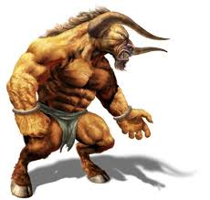

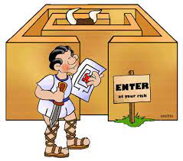

Finish

Can you think of three words that don’t contain any vowels?
Create your own maze using the blank grid below. You can make it a vowel or a consonant trail. When it is finished, challenge a friend to complete it.

