Monday 19/4/21 The Rabbit Problem
LO: To suggest what the ‘Rabbit Problem’ could be
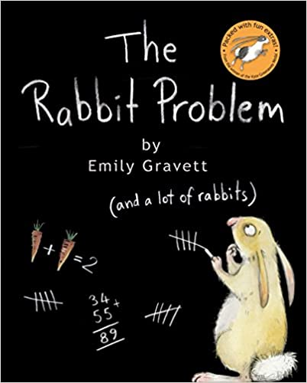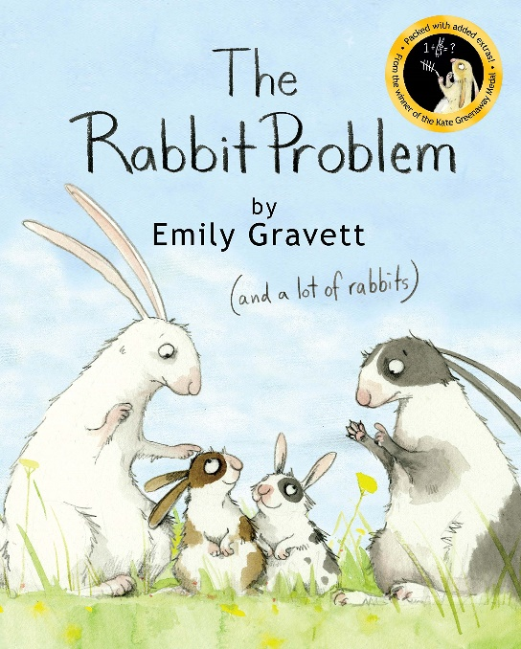
I think the problem could be ……

Tuesday 20/4/21
LO: I can make an invitation for a lonely rabbit. I can talk about feeling lonely

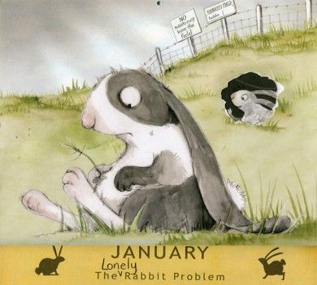

Invitation

Where?
Why?
When?
From

Wednesday 21/4/21
LO: I can give advice on how to stay warm in winter, written in a list format
Draw a picture of a rabbit ready for the February weather.  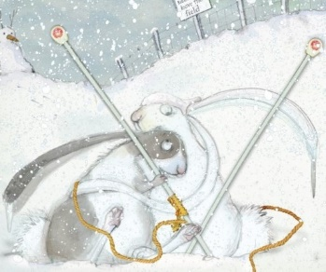 | Problem:  Dear children it is the month of February and the weather here is freezing!  Can you please help?

Thursday 22/4/21
LO: To write the names of the baby rabbits and make a list of baby rabbit needs.
Boys Names | Girls Names
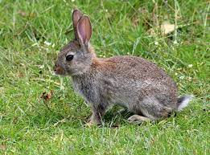
Rabbits need:

Friday 23/4/21
LO: To design and label a rabbit shelters to protect the rabbits from the rain
Which materials have you chosen and why?

