Home Learning
St Wilfrid’s Catholic Primary School
Year 1
Week 2
Summer Term
Spring Term 2

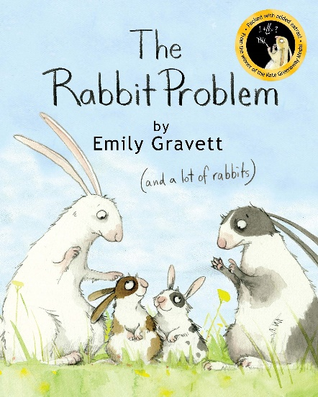
All lessons will be available on Seesaw with links for easy access.
Printed Home Learning packs are available on request.

Home Learning Plan
Please note Suggested Timetable for the week:
 | AM | AM (30mins) | AM | PM
Monday* | Maths | Phonics | English | RE Science
Tuesday* | Maths | Phonics | English | RE PE
Wednesday* | Maths | Phonics | English | Art Music
Thursday* | Maths | Phonics | English | RE Geography
Friday* | Maths | Phonics | English | PSHE Computers
*READING 15 min each day
Maths (White Rose)
For Maths, plans and video lesson see White Rose Home learning:
See Summer Term - This page takes you to the videos for the week
https://whiterosemaths.com/homelearning/year-1/summer-week-3-number-multiplication-and-division/ see week 3
Phonics (daily 20-30mins)
DFE letters and sounds follow link on Seesaw. Each video is a full lesson.
See Seesaw link for daily lesson.
https://lettersandsounds.org.uk/for-home/reception (Mrs M / Miss M)
https://lettersandsounds.org.uk/for-home/year-1 (Mrs G group)
Extra phonics practice/ Reading ideas:-
www.Phonicsplay.co.uk
English
See additional plan and worksheets
Also available on Seesaw link

Science (Oak National Academy)

Plants - How do I plant a bean?
In this lesson, we are going to be planting kidney beans. You will need soil, stones, a pot and a kidney bean but if you do not have these resources available, you can watch me plant a bean. We will be looking at what a seed needs to be able to grow into a healthy plant.
https://classroom.thenational.academy/lessons/how-do-i-plant-a-bean-cgwp6e

Mindfulness and Wellbeing
https://www.youtube.com/user/CosmicKidsYoga

RE
Our new topic this term is Holy days and Holidays. (Information on Seesaw)
For this week’s lessons see the additional RE handout on Seesaw

PE (BBC Teach) https://www.bbc.co.uk/teach/class-clips-video/physical-education-ks1-ks2-lets-get-active/z72yjhv

Geography What is the United Kingdom?
In today's lesson, we join Miss Browne in learning about the geographical location of the UK, and the countries within the UK. We will draw a map of the countries within the UK and label with seas surrounding it.
https://classroom.thenational.academy/lessons/what-is-the-united-kingdom-71k32c
Art Oak Academy – Introduction to sculpture
In this lesson we will explore what sculpture is, looking at different methods including assemblage, relief sculpture, carving and modelling and will find shapes in an artist's work to use as a starting point.
https://classroom.thenational.academy/lessons/introduction-to-sculpture-6nhk4r
PSHE
See scarf home learning, additional links and activities on Seesaw
https://www.coramlifeeducation.org.uk/scarf/home-learning-unit-1-early-years
Music Lesson
Sound effects and talking about sound https://www.bbc.co.uk/bitesize/topics/zk86qfr/articles/zk7wr2p
Computers Lesson
See seesaw link
https://code.org/learn

Handwriting
Continuous cursive handwriting
For further information on handwriting see: https://teachhandwriting.co.uk/teach-handwriting-parents.html
If you need further advice or support, please contact via email at: abbey.maclean@ashtonsaintwilfrids.wigan.sch.uk
Lorraine.melling@ashtonsaintwilfrids.wigan.sch.uk

