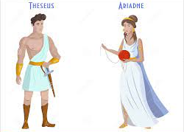
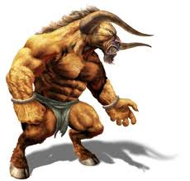
Verbs (1)
Read the sentences and circle the verbs

- Theseus walked towards the Labyrinth.
- “Good luck,” shouted Ariadne.
- The Minotaur licked his hairy lips.
- King Minos opened the Labyrinth’s gate.
- Theseus looked through the gate.
- The Youths and Maidens thought about their journey home.
- The guards shouted to the Minotaur.

said thought looked ran went touched

Choose three of the above verbs and write as many synonyms as you can think of.
Example; said – yelled or screamed.

Now use some of your synonyms to write three interesting sentences.

