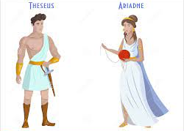
Verbs (2)
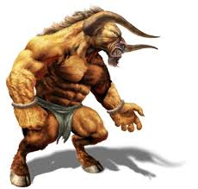
Read the sentences and circle the verbs

- Theseus ran towards the Labyrinth.
- “Don’t forget to raise a white flag,” yelled King Aegeus.
- The Minotaur nibbled the rotted flesh.
- Ariadne brushed her long hair.
- The Athenian children peered through the Labyrinth’s gate.
- Theseus wondered if he was doing the right thing.
- King Minos munched on some fresh fruit.

said thought looked ran went touched cried ate

Choose five of the above verbs and write as many synonyms as you can think of.
Example; said – yelled or screamed.

Now use some of your synonyms to write five interesting sentences.

