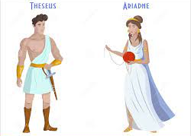
Verbs (3)
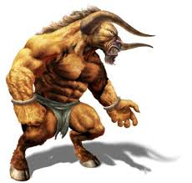
Read the sentences and circle the verbs

- Theseus slowly walked towards the Labyrinth.
- “You must kill the Minotaur,” demanded the Athenian children.
- The Minotaur wolfed down the pile of rotted flesh.
- Ariadne slowly brushed the comb through her long hair.
- The crew on the boat stared back at the island they had left Ariadne on.
- Theseus pondered if he should marry Ariadne.
- King Minos quickly scoffed the fruit and wine.

said thought looked ran went
touched cried ate walked slept like

Choose seven of the above verbs and write as many synonyms as you can think of .
Example; said – yelled or screamed.

Now use some of your synonyms to write seven interesting sentences

