St Wilfrid’s Y2 Home Learning
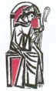
Summer 2

Mrs Stubbs
WB: 12.7.21
Please note I may add more resources to SeeSaw as I act upon feedback from the children and parents during the week.

St Wilfrid’s Catholic Primary School Y2 Summer 2 Week 6 Timetable 2020-2021
Day | 8.50 – 9.15 | 9.15-9.35 | 9.35- 10.15 | 10.15-10.30 | 10.30-10.50 | 10.50-11.50 | 11.50 – 12.00 | 12.00-13.10
Mon | Morning Activity linked to Maths Interim framework practise.  Transition Day | Reading  Comprehension  Log on to Reading Buddy  Spelling Test  Transition Day | Maths  Revision  Transition Day | Break  Transition Day | Phonics/  SPaG  Transition Day | FOCUS English  Working towards one piece of writing per week.  Transition Day | Handwriting  Transition Day | Dinner  Transition Day | RE | RE
Tues |  |  |  |  |  |  |  |  | PE | SCARF
Wed |  |  |  |  |  |  |  |  | Science | Art
Thurs |  |  |  |  |  |  |  |  | RE | RE
Fri |  |  |  |  |  |  |  |  | Transition Day

8.50 – 9.15  Mon-Fri | Morning Activity linked to Maths Interim framework practise.  Addition and Subtraction Revision Week. We are promoting independence with these activities as children are revisiting this learning.  Work booklet for this week will be emailed.  Monday Tuesday Wednesday Thursday Friday  Child Led Support Page 12 Adding 2-Digit Numbers and Ones Crossing 10 Child Led Support Page 13 Adding 2-Digit Numbers and Ones Crossing 10 Child Led Support Page 14 Subtracting Numbers and Ones from 2 – Digit Numbers, Crossing 10 Child Led Support Page 15 Subtracting Numbers and Ones from 2 – Digit Numbers, Crossing 10 Child Led Support Page 16 Adding 2 – Digit Numbers and Tens, Not Crossing 100
9.15 – 9.35  Mon - Thurs | Reading  Link to Reading Buddy - https://www.oxfordreadingbuddy.com/uk  Link for Monday and Wednesday - https://assets.publishing.service.gov.uk/government/uploads/system/uploads/attachment_data/file/805039/STA198200e_2018_ks1_English_reading_Paper1_reading_prompt_and_answer_booklet.pdf  Monday Tuesday Wednesday Thursday Friday  Guided comprehension Past Reading SAT Work through question together but promote children to read text and questions independently. Independent Reading Reading Buddy Quiz when ready. Guided comprehension Past Reading SAT Work through question together but promote children to read text and questions independently. Independent Reading Reading Buddy Quiz when ready. Shared Read Reading for pleasure  Extra Ideas  Reading for Pleasure  In Writing we have been reading Little Evie in the Wild Wood, Little Red Riding Hood and Hansel and Gretal so if you have any of these stories available it woud be a nice idea to share them together. All stories can be found on YouTube.
9.15 – 9.35  Friday  Spelling Test | 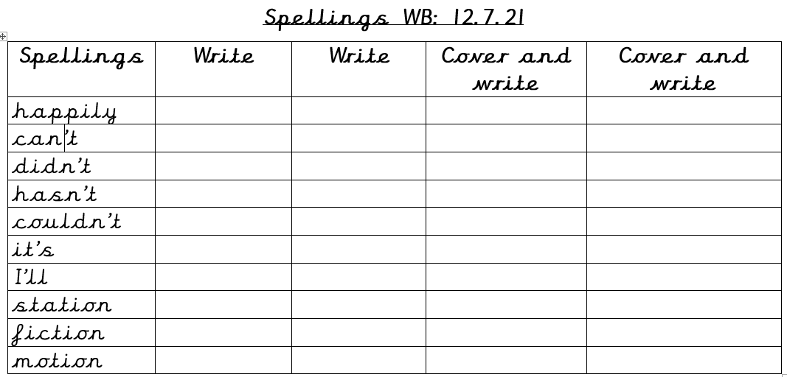  If any of these words are unfamiliar to you please discuss with an adult.  Learning your weekly spellings is great but remember if you use them in any independent writing we expect to see the correct spelling. Please upload weekly spelling scores to SeeSaw.  Challenge: can you write sentences including your new words.
9.35- 10.15  Mon - Fri | Maths  We have now come to the end of our WhiteRose Maths so we are now going to have a bit of fun and competition! We are going to be working in teams.  The activities below should be revision for your child.  All resources will be sent via email.
 | Monday  100 Square Counting Investigation | Tuesday  Coins Maths Investigation | Wednesday  Coloured Squares Maths Investigation | Thursday  Dice Maths Investigation  Halves and Quarters Maths Investigation | Friday  Odd and Even Numbers Maths Investigation
10.30 – 10.50  Mon - Fri | SPaG  Activitiies will be uploaded to SeeSaw daily.
10.50 – 11.50  Mon – Fri | English  This week we are going to share a new story each day. Ecah book has a wolf and we will complete a short response to the books each day.  Monday  Introduce the layout for the week. Tell your child that each day we will have a different story. Share the focus question with the children.  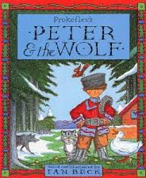  Share the story with together: https://www.youtube.com/watch?v=ickziSniXkI  After reading the story identify if the wolf is bad or good and give reasons why.  Record these in your Home Learning book or on paper.  Tuesday  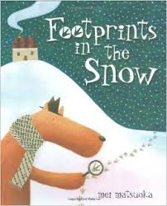  Share the story with together: https://www.youtube.com/watch?v=QYJvTqw1jrM  After reading the story identify if the wolf is bad or good and give reasons why.  Record these in your Home Learning book or on paper.  Wednesday  Share the story with together: https://www.youtube.com/watch?v=vB07RfntTvw  After reading the story identify if the wolf is bad or good and give reasons why.  Record these in your Home Learning book or on paper.  Thursday  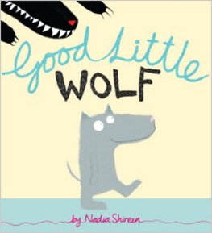  Share the story with together: https://www.youtube.com/watch?v=vhRGIQWmyR4  After reading the story identify if the wolf is bad or good and give reasons why.  Record these in your Home Learning book or on paper.
PM Lesson | Monday – RE  Our RE topic is:  Universal World – TREASURE  Each RE topic in school lasts for four weeks. We follow the same pathway for each topic.  Week 1 – EXPLORE  Week 2 – REVEAL  Week 3 – REVEAL  Week 4 – RESPOND  This week is our last week and is our second REVEAL week.  LEARNING FOCUS 3: To know that we are God’s treasure.  CONTENT  Explain that we are God’s treasure. Lead into reading Luke 12: 27-28 in God’s Story 2, page 69 (see teachers’ notes on page 99). Place greater emphasis on the last 3 lines (below), which focus on us as God’s treasure (see We are God’s treasure Powerpoint on CAFOD website).  You can be sure that God will take even greater care of you.  Never be upset or worried.  God your Father knows all your needs and will take care of you.  (based on Luke 12: 27-28).  SOME QUESTIONS TO ASK THE CHILDREN:  - What was Jesus asking us to think about?  - Does everything last forever?  - Why did Jesus say never be upset or worried?  - How does God look after us?  - Why does God look after us?  - How does God look after YOU?  - Why do YOU feel happy?  Show the rest of the We are God’s treasure PowerPoint (see www.cafod.org.uk/comeandsee) to illustrate ways that God is treasuring our sisters and brothers around the world.  - Ask the children to write how God looks after us. What makes us happy about God’s world and how do we treasure it?  SOME SUGGESTED ACTIVITIES | ADULT DIRECTED GROUP ACTIVITY  - Create a ‘Treasures of God’s Wonderful World’ frieze. Give groups of children different people, plants, flowers, and animals to draw/paint/collage, give the children speech bubbles so that they can describe the ways they care for God’s world and give reasons why.  ______________________________________________________________________________________________________  LEARNING FOCUS 4: To appreciate and value God’s treasure – water.  CONTENT  Zimi’s story  Explain to the children that we are now going to find out about a girl called Zimi. She appreciates and values the precious treasure of water in God’s world. Read and discuss Zimi’s Story (see www.cafod.org.uk/comeandsee).  SOME QUESTIONS TO ASK THE CHILDREN:  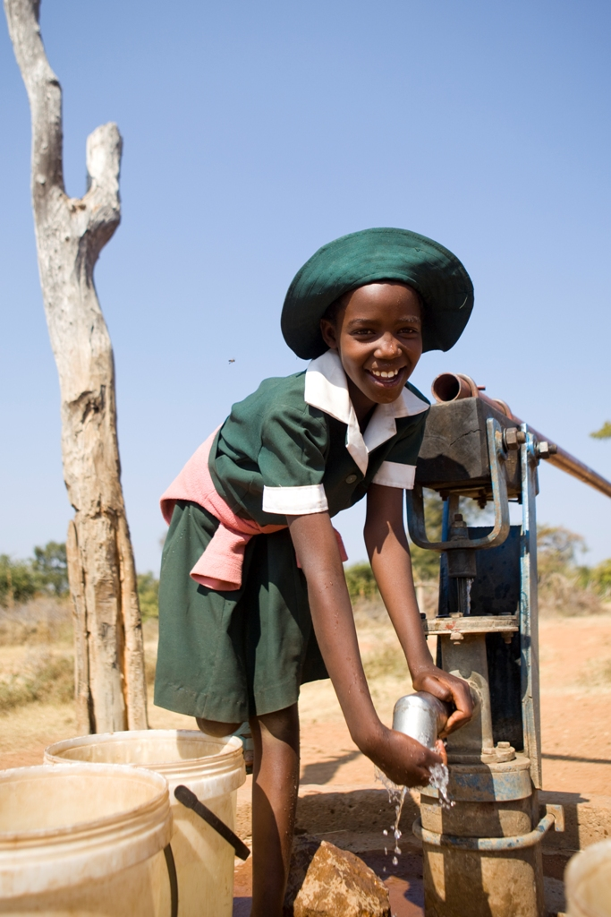  - Where did Zimi get her water from?  - How has CAFOD helped?  - Why is water a precious treasure for Zimi?  - How has having clean water helped Zimi?  - What can we learn about treasures from Zimi’s story?  - How should we treat God’s precious treasure of water?  Explain that everyone in our world should have a fair share of clean water. Discuss the importance of sharing God’s treasures with one another.  SOME SUGGESTED ACTIVITIES  - Complete the Isaiah worksheet below.  Using examples from Zimi’s story, as well as their own experiences,  children to think about why water is so precious.  Children to draw and/or write about ways that water is used.  Thursday  LEARNING FOCUS 5: Caring for God’s world – giving thanks and praise.  CONTENT  Read Psalm 147: 4-5, 8-9, 15-18 (see God’s Story 2, page 35).  Share with the children the response to the Psalm:  R. How loving, how powerful, how wise God is! Let’s sing praise, sing praise, sing praise!  Different groups could be given a verse of the Psalm to retell in a form of their choice (e.g. drama, pictures.) Say/sing the response together.  Show praise for God’s world PowerPoint (see www.cafod.org.uk/comeandsee). Talk about treasures of God’s world that the children can see from their window. The following text is contained in the Show praise for God’s world PowerPoint:  God made the earth and sky. God made all the people all over the world. God made spiders and dogs and butterflies and tigers and pandas and all other animals. God made the tulips, the trees, the tomatoes and all the plants. And, God tells us we must take good care of them. It is an important job. (The Principles of Catholic Social Teaching for Kids – Anne E. Neuberger 2005)  SOME QUESTIONS TO ASK THE CHILDREN:  - What are we praising God for?  - Why is God’s world a treasure?  - How would you give thanks for God’s treasure?  - What can you do to care for and protect God’s treasure – the world?  SOME SUGGESTED ACTIVITIES | ADULT DIRECTED GROUP ACTIVITY  - Invite the children to create their own prayer about taking care of God’s world. Give sentence starters such as:  On Monday, Lord help me to… On Tuesday, Lord help me to… On Wednesday…  Some children may like to use their own sentence starters.  LEARNING FOCUS 6: Give glory to God for the treasures of his world.  CONTENT  Play It’s A Wonderful World by Louis Armstrong.  The Gloria  Share together part of the Gloria (see Give glory to God PowerPoint on www.cafod.org.uk/comeandsee). Explain that this prayer is said by the parish family during Mass on Sunday. This prayer gives praise and thanks to God.  Glory to God in the highest,  and on earth peace to people of good will. We praise you,  We bless you, We adore you, We glorify you,  We give you thanks for your great glory.  Pray the Gloria together. Talk about the meaning of each phrase. Discuss why, as Christians, it is important to praise God.  SOME KEY QUESTIONS  - What do we praise God for?  - How can we praise God?  SOME SUGGESTED ACTIVITIES | ADULT DIRECTED GROUP ACTIVITY  Compose a class prayer to give praise and thanks to God for the entire world, using the children’s own ideas about treasures in God’s world.
PM Lesson | Tuesday - PE  Can you make your own mini sports day?  Activities to try:  Sack race, running, throwing the bean bags  Send us some pictures via SeeSaw
PM Lesson | Wednesday – Science  Our topic for this half term is: PLANTS  KS1 Science (Y2 Plants)  - Observe and describe how seeds and bulbs grow into mature plants;  - Find out and describe how plants need water, light and suitable temperature to grow and stay healthy.  Activity  What plants have we got in our garden?  Take pictures an share them with me.  Can we research the plants and name them?
PM Lesson | Wednesday –Art  This half term we are looking at Colour.  Today’s Focus  Share and discuss the video: https://www.youtube.com/watch?v=WhytqHqc63I  Can children create their own African Art pattern and can they colour it using the colours mixed last week.

