Finding Adjectives (1)
Read the sentences and circle the adjectives.

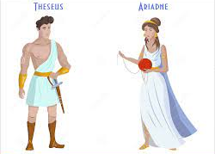
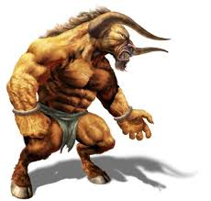
- The Minotaur is ugly.
- It has long legs.
- Theseus had a shiny sword.
- Happy Ariadne looked at Theseus.
- The big Minotaur ate people.
- The Minotaur had fluffy fur.

Now, choose three of the above sentences and rewrite them on some paper, changing the adjectives to make them more exciting.
Example; The Minotaur is grotesque.

