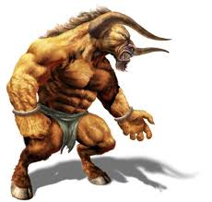
Finding Adjectives (2)
Read the sentences and circle the adjectives.

- The Minotaur had an ugly face.
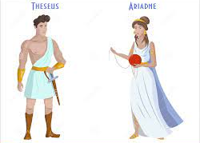
- The Minotaur had long legs.
- Theseus cut his hand on the rough walls of the Labyrinth.
- The shiny sword sparkled in the bright sun.
- Worried Ariadne looked at the dark gate on the Labyrinth.
- The huge Minotaur drank from a murky waterhole.
- The small island had soft, golden sand.

Now, choose five of the above sentences and rewrite them on some paper, changing the adjectives to make them more exciting.
Example; The Minotaur had grotesque face.

