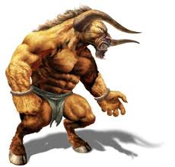
Finding Adjectives (3)
Read the sentences and circle the adjectives.

- The Minotaur had an ugly, dirty face.
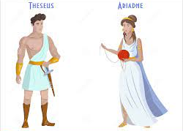
- The Minotaur had two long legs.
- King Minos laughed excitedly at foolish Prince Theseus.
- The sharp, shiny sword glistened in the bright sun.
- Worried Ariadne walked impatiently around the edge of the Labyrinth’s entrance.
- The enormous Minotaur stomped loudly down the dark passages in the Labyrinth.
- The small, quiet island had soft, golden sand and clear blue waters.

Now, rewrite all of the above sentences. Add more detail by extending the sentence or adding another adjective to make them more exciting.
Example; The enormous Minotaur had grotesque face, powerful legs and a poisonous, spiky tail.

