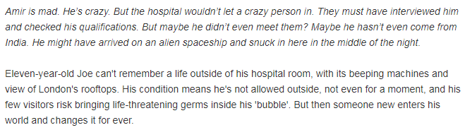

**Monday**

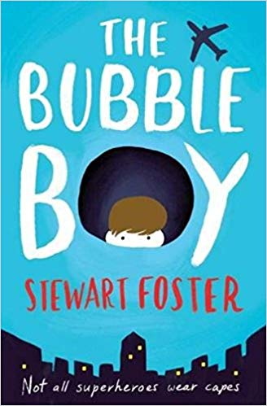

1) Look at the front cover: make a prediction about the story by using the title and the images on the front of the book.

__________________________________________________________________________________________________________________________________________________________________________________________________________________________________________ **(2 marks)**

2) Read the blurb. What does Joe’s condition mean he can’t do?

**____________________________________________________________________________ (1 mark)**

3) Why do you think that this book is titled, ‘The Bubble Boy?’

______________________________________________________________________________ **(1 mark**)

4) How do you think Amir relates to this story?

_______________________________________________________________________________**(1 mark)**

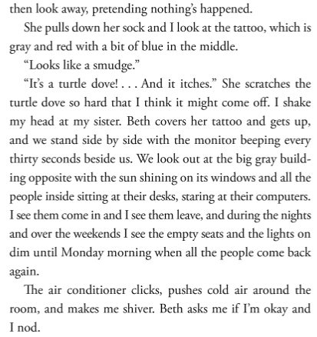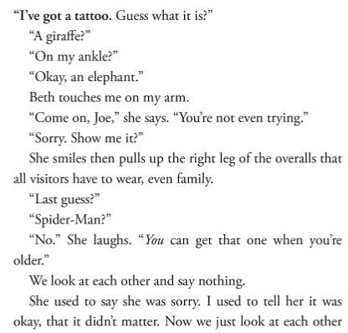

**Answer questions in your home learning book**

4) Why do you think visitors have to wear overalls? (1 mark)

5) Why do they, ‘look at each other and say nothing?’ (1 mark)

6) Find evidence that the narrator of the story doesn’t leave the room. (1 mark)

**7) List four different pieces of punctuation that are used in this extract. (1 mark)**

**8) Find and copy an adverbial phrase.**

**9) Why does the word, ‘nothing’s’ have an apostrophe?**

**10) Improve, ‘the shop’ by expanding this noun phrase.**

**________________________________________________________ (1 mark)**

**(1 mark)**

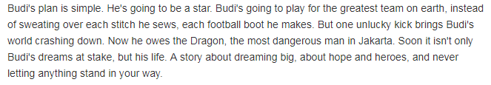

**Tuesday**

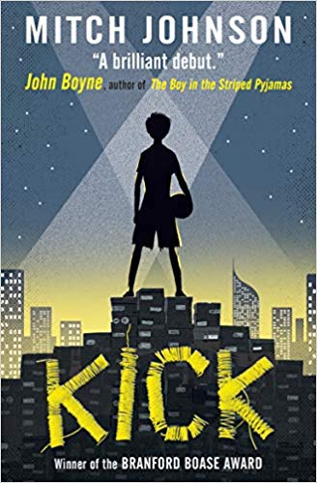

1) Look at the front cover: make a prediction about the story by using the title and the images on the front of the book.

__________________________________________________________________________________________________________________________________________________________________________________________________________________________________________ **(2 marks)**

2) Read the blurb. What is Budi’s plan?

**____________________________________________________________________________ (1 mark)**

3) What could have happened to make Budi owe the dragon?

______________________________________________________________________________ **(1 mark**)

4) Why is the front cover effective when comparing it to the final line of the blurb?

_________________________________________________________________________________________________________________________________________________________________________ **(2 marks)**

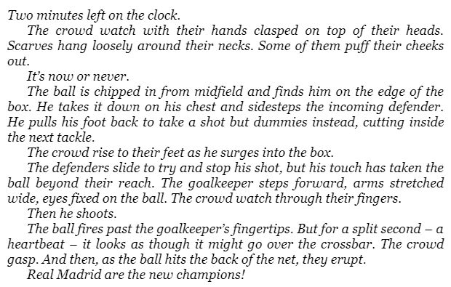

Read the extract of chapter one, **‘It’s now or never.’**

4) What does the word, ‘**surges’** mean**?**

_____________________________________________________(1 mark)

5) Why has the author use italics for the first part of this chapter?

____________________________________________________________________________________________________________________ (1 mark)

6) Why does Budi have blood trickling down his leg?

_____________________________________________________ (1 mark)

7) What does, ‘**the crumbling apartment blocks rise up like a stadium on every side’** suggest about where Budi and Uston are playing football?

____________________________________________________ (1 mark)

**Grammar focus**

**8) Find and highlight an example of parenthesis in the text.**

**9) Find and copy two verbs from the text.**

**_______________________________________________(1 mark)**

**10) Improve, ‘the crowd’ by expanding this noun phrase.**

**__________________________________________________ (1 mark)**

**(1 mark)**

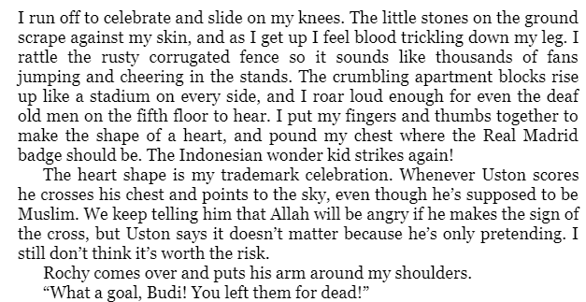

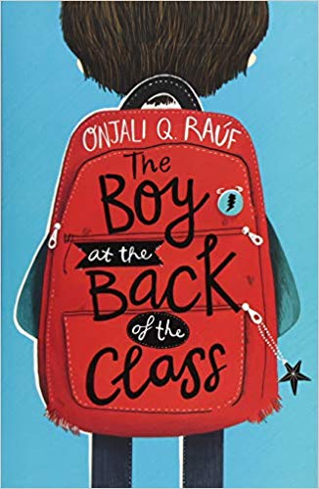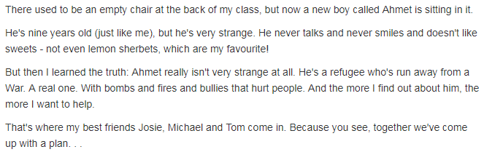

**Wednesday**

1) Look at the front cover: make a prediction about the story by using the title and the images on the front of the book.

__________________________________________________________________________________________________________________________________________________________________________________________________________________________________________ **(2 marks)**

2) Read the blurb. Clarify what a refugee is.

**____________________________________________________________________________ (1 mark)**

3) What impression do you get of the character Ahmet from the blurb?

______________________________________________________________________________ **(1 mark**)

4) What do you think the plan could be that they have come up with?

_________________________________________________________________________________________________________________________________________________________________________(**2 marks)**

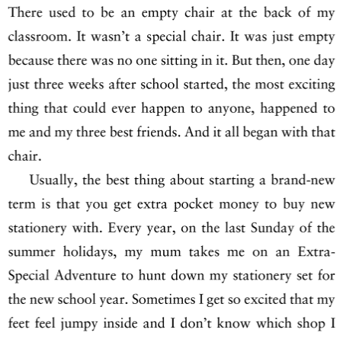

Read the extract of chapter one, **‘The empty chair.’**

4) What do you think the most exciting thing that could ever happen was**?**

________________________________________________________________(1 mark)

5) Why would the narrator get extra pocket money at the start of a brand new term?

________________________________________________________________ (1 mark)

6) What impression do you get of the character who is telling the story?

________________________________________________________________________________________________________________________________________ (2 marks)

**Grammar focus**

**7) Why has the author used a dash in the final part of the extract? _________________________________________________________________________________________________________________________________________(1 mark)**

**8) Find and copy a subordinate conjunction in the text.**

**_______________________________________________(1 mark)**

**9) Find an adverb in the text.**

**__________________________________________________ (1 mark)**

**(1 mark)**

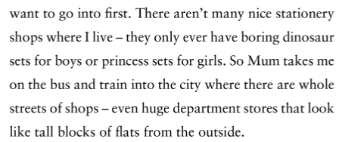

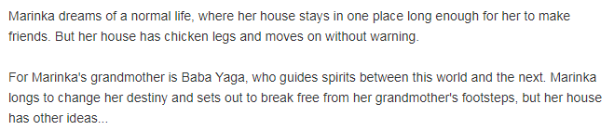

**Thursday**

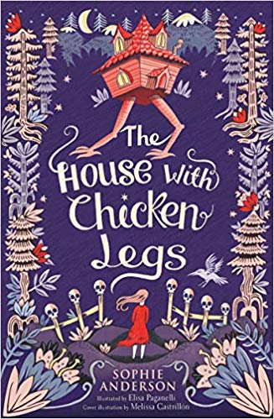

1) Look at the front cover: make a prediction about the story by using the title and the images on the front of the book.

__________________________________________________________________________________________________________________________________________________________________________________________________________________________________________ **(2 marks)**

2) Why does Marinka struggle to make friends?

**____________________________________________________________________________ (1 mark)**

3) Clarify what Marinka’s grandmother does.

______________________________________________________________________________ **(1 mark**)

4) What does it mean to break free from someone’s footsteps?

_________________________________________________________________________________________________________________________________________________________________________(**1 marks)**

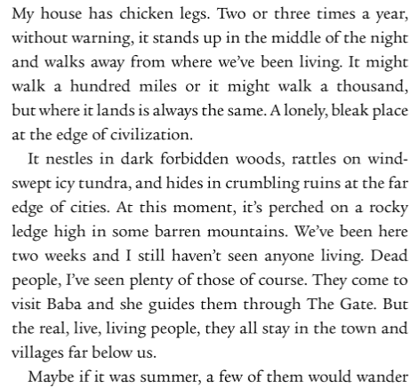

Read the extract of chapter one, **‘Prologue.’**

4) Explain what the narrator’s house does a few times a year.

________________________________________________________________(1 mark)

5) What is the same about where the house ends up?

________________________________________________________________ (1 mark)

6) Infer how the character might feel when their house moves again. Explain your answer.

________________________________________________________________________________________________________________________________________ (2 marks)

7) Find evidence that the narrator is desperate to have company.

______________________________________________________________________________________________________________________________________(2 marks)

**Grammar focus**

**8) Find and copy a modal verb in the text. ________________________________________ (1 mark)**

**9) Find and copy the word which is close in meaning to the word ‘bleak’.**

**_______________________________________________(1 mark)**

**10) Find an adverbial phrase in the text.**

**__________________________________________________ (1 mark)**

