Monday 24/5/21 LO: I can talk about events in the story, I can record the event in clear sentences.
Tuesday 25/5/21
Record your answers in full sentences, remember to say your sentence before writing.

Wednesday 26/5/21

Use the adjectives above to write sentences about Peter.
Eg. Peter was disobedient because him mother told him to stay at home.

Thursday 27/5/21
Can you recall the story using the story map images?

 | 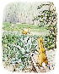 | 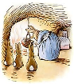 | 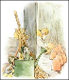
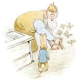 | 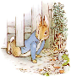 |  | 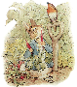
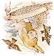 | 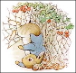 | 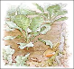 | 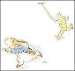
 | 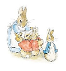 | Cut out and sequence the pictures in the correct order to make your story timeline.
Friday’s lesson will be to write the story using a selection of the pictures, perhaps you ca practise your ideas by saying a sentence for each picture, try to make your sentences interesting by using adjectives.
Poor Peter Rabbit was upset because he was lost and alone.

