
The aim of this SEND (Special Educational Needs and Disability) Information Report is to explain how we implement our SEND policy - we want to show you how SEND support works in our school.
If you want to know more about our arrangements for SEND, please read our SEND policy.
SEND policy:

Who is our SENDCO?   | Our SENDCO is …Gemma Blake-Hatton  If you would like to contact Mrs Blake-Hatton, please call school on 01342 822584 or email office@ashurstwoodprimary.co.uk
Which types of SEND does our school provide for? | Our school provides for pupils with the following SEND needs:
  AREA OF NEED | CONDITION
  Communication and interaction   | Autism spectrum disorder (ASD)
   | Speech and language difficulties
  Cognition and learning   | Specific learning difficulties, including dyslexia, dyspraxia, dyscalculia
   | Moderate learning difficulties
   | Severe learning difficulties
  Social, emotional and mental health   | Attention deficit hyperactivity disorder (ADHD)
   | Attention deficit disorder (ADD)
  Sensory and/or physical   | Hearing impairments
   | Visual impairment
   | Multi-sensory impairment
   | Physical impairment
How do we identify pupils with SEN and assess their needs?   | At Ashurst Wood Primary School we identify pupils who have a special educational need by ensuring we know both our children and families and by working together to establish need through some of the following methods:  *Ongoing discussions with parents and carers.  *Discussions with Pre schools or previous school settings.  * Observations and record keeping to establish strengths and weaknesses.  * Ongoing assessments of academic attainment through termly meetings with teaching and support teams. Looking at progress from starting points and comparison with age expectations.  * Monitoring social and emotional needs as well as wellbeing.  * Seeking advice from specialist practitioners including speech and language services and child development teams. This is done through a referral process in partnership with parents and carers.
What are our admission arrangements for disabled pupils?   | The parents of pupils with SEND apply through the usual admission route with West Sussex County Council. Prior to application or starting school, parents are welcome to come and have a tour of Ashurst Wood primary during school hours, so they can see the school in action and can have a discussion with the Headteacher, SLT and/or SENDCO. If a pupil has an EHCP, West Sussex SENAT will consult with Ashurst Wood Primary School, to see whether we can meet the needs of the child as set out in their EHCP. The School will liaise with SENAT if further adaptations/resourcing would be required
What training and expertise do our staff have to support pupils with SEND?  
  Our special educational needs co-ordinator, or SENDCO | Our SENDCO is Gemma Blake-Hatton  They have 7 years experience in this role and have worked as a class teacher across years R to 6. They have been phase leader for early years and hold their early years teacher qualification. They have also previously been deputy head teacher and have 22 years experience as a qualified teacher.  They achieved the National Award in Special Educational Needs Co-ordination in 2019.  They are allocated 1 day a week to manage SEN provision.
  Class teachers | All of our teachers receive in-house SEND training, and are supported by the SENDCO to meet the needs of pupils who have SEN.  Teachers and support staff receive training in ADHD, ASC, Dyslexia, emotional regulation and attachment and trauma, on a regular basis and according to current staffing needs. There is also bespoke training through out the year for particular staff members to enable them to meet the needs of children in their class.  Support staff also receive training to deliver evidence supported interventions.
  Teaching Assistants (TAs) / Learning Support Assistants | We have a team of 7 TAs, including 2 higher-level teaching assistants (HLTAs).  We have 3 teaching assistants who are trained to deliver interventions such as Nurture support and first class at number as well as FFT success for all phonics and reading programmes.  TAs receive the same SEN training as teachers.
  Learning Mentor / Emotional Literacy Support Assistant (ELSA) | We have two members of staff trained in ELSA support and who run learning mentor sessions, providing support across the school. Mrs Tjong and Mis Edwards have been running Nurture groups for 10 years.
  Therapists | Currently the school is lucky to provide a base for a private Music therapist as well as a play therapist from Local therapy centre Tobias.
What is our approach to teaching pupils with SEND?   | Children who have been identified as having additional SEND needs have yearly or termly targets which are reviewed with parents, teachers, support staff, and the SENDCO or SEND teacher. Children are supported by quality first teaching with adaptations as needed.  Children are monitored on a regular basis through ILP review meetings and pupil progress meetings between the class teacher and Senior Leadership Team (SLT). After discussion, provision is adapted if necessary and the impact of this is measured to ensure progress is being made.  We will follow the ‘graduated approach’ to meeting your child’s SEN needs.  The graduated approach is a 4-part cycle of assess, plan, do, review.  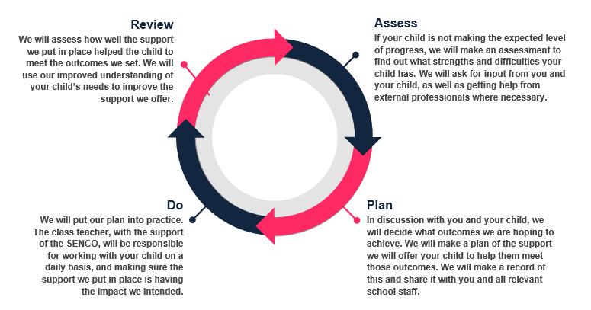
How is our broad and balanced curriculum for each year group adapted and made accessible for pupils with SEND?  How do we adapt the learning environment for pupils with SEND?   | Adaptations are made in all subject areas for pupils with SEND. Subject leaders have worked with the SEND team to identify adaptations that can be made in their subject area and what that could look like.  A guidance document has been created to be used by class teachers and LSAs to make the most effective adaptations across the curriculum.  Advice is sought from the SENDCO and SEND teacher, to make all lessons and experiences in school available and appropriate for all children.  Some possible examples of adaptions:
  AREA OF NEED | CONDITION | HOW WE SUPPORT THESE PUPILS
  Communication and interaction | Autism spectrum disorder (ASD) | Visual timetables  Social stories  Low arousal areas  Ear defenders  De-cluttering around whiteboards  Sensory resources in classroom  Sensory breaks in and outside the classroom  Access to the sensory room
  Communication and interaction | Speech and language difficulties | Speech and language small group work  Visuals alongside verbal information  Key word mats  Key vocabulary on topic displays  Use of Widgit  Use of computers and tablets
  Cognition and learning | Specific learning difficulties, including dyslexia, dyspraxia and dyscalculia  Moderate learning difficulties  Severe learning difficulties | Writing slope  Coloured paper / overlays  Ipad  Laptops and software  Talk tins  Edited text types  Additional time
  Social, emotional and mental health | ADHD, ADD | Quiet workstation  Sensory and brain breaks  Standing desks  Wobble cushions  Weighted blankets  Task planners
  Social, emotional and mental health | Adverse childhood experiences and/or mental health issues | Nurture groups  Zone of regulation sessions  Sensory bags and items  Communication options  Sensory breaks in and outside the classroom
  Sensory and/or physical | Hearing impairment | Positioning in classroom  Visual prompts
  Sensory and/or physical | Visual impairment | Limiting classroom displays  Positioning in classroom  De-cluttering displays and worksheets  Magnifiers  Clearly labelled easy to access resources  Peg or locker at end of row for easy access  Use of brightly coloured and noise emitting resources e.g. talk tins  Steps marked with yellow edges
  Sensory and/or physical | Physical impairment | Layout of furniture for ease of access to seat and resources  Wheelchair access to all classrooms  Lift to the 1st floor and lower ground floor
What additional support is available to children?   | For children who are on the special needs/inclusion register, the SENDCO co-ordinates provision throughout the school, deploying support staff appropriately to deliver provision and interventions.  As appropriate to the children’s needs and often with the receipt of an EHCP, SEND LSA support is provided to some children, in addition to the support from the class LSA. This is usually provided to pairs or small groups of children. This will occasionally be one-to-one if the child’s needs, as set out in an EHCP, are significant or there is a safety risk to the child or other children.
Which intervention programmes are provided for children who need them?   | The interventions which can be in school include the following:  *Lego Therapy  * First Class at number 1 and 2  *FFT success for all Lightning Squad  *FFT success for all Reading Quest  * Speech and Language Support as detailed by a speech and language plan  * Time to talk  * Nurture group
What facilities do we provide to help pupils with a disability access the school?   | *Doorways wide enough/double to accommodate a wheelchair  *Lift to KS1 or access around the playground.  * Flat access into all KS2 classrooms from inside the school building.  *1 disabled toilet  * Changing facilities (For children that may require toileting/intimate care we have members of support staff who are responsible for ensuring their needs are met. A Healthcare and or Intimate care Plan will be created detailing what the nature of the care is and how often it needs to be carried out).  * Appropriately sized furniture  * A training toilet seat and step stool is provided in some children’s toilets which can be used for children who have stability difficulties when on the toilet or small stature.  Accessibility plan  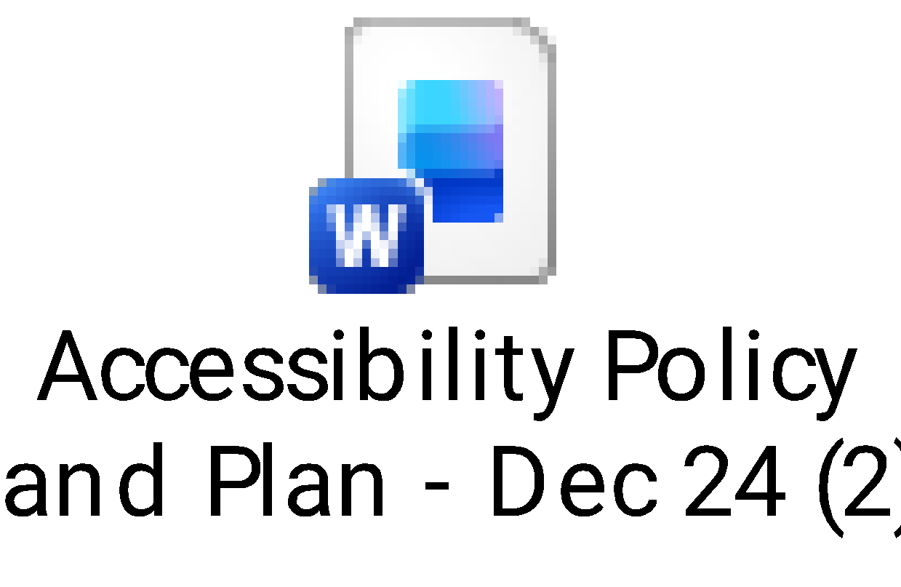
How do we enable pupils with SEND to engage in activities (including physical activities) with pupils who don’t have SEND?   | In lessons, all children are included. Adaptations are planned for and put in place by class teachers, across the curriculum, using guidance from Ashurst Wood’s subject-specific adaptations documents and the West Sussex ‘Ordinarily Available Inclusive Practice’ document.  In PE and other physical activities advice may be sought from outside professionals e.g. mobility officers, occupational therapists and physiotherapists to ensure children’s needs are met.  We strive to ensure that all children will be fully included with all activities outside of the classroom. We encourage outdoor learning and regular forest school sessions in local woodland.  At break and lunch times, staff monitor all areas of the playgrounds and field, and provide support to children as required.  Children with EHCP funded support, may receive 1:1 support at breaks times to ensure they can safety navigate the outside environment and manage the social, emotional and sensory aspects of break and lunchtimes.  For day and residential trips, arrangements are made for the transport and accessibility to the accommodation and activities with the trip provider or venue, in conjunction with the SENDCO and Educational Visits Coordinator. Risk assessments are undertaken by teachers and specific individual pupil plans are put in place as required and communicated to all staff on the trips. For children that would benefit from this, we give them additional preparation for a trip (visual timetable etc), as well as resources and extra adult support if necessary.  Staff at after-school and breakfast club provision are made aware of any needs and necessary adaptions to provide the appropriate support to meet the needs of all children attending the clubs
Which steps have we taken to prevent pupils with a disability from being treated less favourably than other pupils?   | Pupils with disabilities are planned for carefully by class teachers with the support of the SENDCO and SEND teacher. Adaptations are made in all lessons and extra-curricular experiences, so that everyone is included in all aspects of school life.  We are proud to be an inclusive school and this is reflected in our curriculum which includes lessons and assemblies about SEN including neurodiversity and neurodivergence.  The school has a neurodivergent ambassador club.  Co production of policy and procedures ensures that pupil and parent voice informs decision making at our school.
What access arrangements can we put in place for statutory assessments?   | All children with SEND or additional needs will be considered/assessed for access arrangements during statutory assessments.  For the Yr1 and Yr2 Phonics Check, the test can be broken up into sections with breaks in between. Children can go at their own pace – there is no time limit.  For the Yr4 multiplication check, the background colour can be changed to suit children’s needs, breaks can be put between questions to enable children to stay calm and adults can type in the children’s answers if appropriate.  For the Yr6 End of Key Stage 2 SATs, pupils may be entitled to an adult prompter to keep them focussed, rest breaks within the test, extra time if children have a slow, reading, writing or processing speed, an adult scribe to record their answers or a transcript done of their finished paper, to ensure all answers can be read, if handwriting or spelling makes it difficult to read.
How are the school’s resources and SEND budget allocated and matched to children’s Special Educational Needs and Disabilities? | We are constantly looking to update resources and explore research into new resources and intervention programmes that are available.  Staffing is allocated to year groups according to the children's needs in the year group.  Resources are allocated according to needs, particularly if children require specialist equipment, additional adult support or intervention programmes.  We have an adapted classroom which is used as both a calm space and a teaching space for children working in small groups and 1:1 on tailored timetables and adapted curriculums.  We have a sensory room which is accessed by children across the school as and when needed but also by individuals as part of a tailored timetable.  Staff attend training to deliver interventions and also to increase subject knowledge around specific SEN and disabilities.  Liaison with parents and advisory teachers/healthcare professionals occurs to gain a deeper understanding of the child’s needs to decide what resources are most appropriate  Our lift is maintained once a year.
How will we secure specialist expertise?   | Sometimes we need extra help to offer our pupils the support they need. Whenever necessary, we will work with external support services to meet the needs of our pupils with SEND and to support their families. These include:  - Speech and language therapists  - Educational psychologists  - Learning Behaviour Advisory Teachers (LBAT)  - Autism and Social Communication Advisory Teachers (ASCT)  - Occupational therapists  - Physiotherapists  - GPs or paediatricians (vis the Child Development Centre)  - School nurses  - Fair Access  - West Sussex Transition advisors  - Single point of Access (SPOA)  - Community Mental Health Liaison (CMHL)  - Child and adolescent mental health services (CAMHS)  - Education welfare officers (EWOs)  - Social services and other local authority (LA)-provided support services e.g. Early Help, Enabling Families  - Voluntary sector organisations e.g. Time 4 children, Reaching Families  For children that have English as an Additional Language or are from traveller families, we can access support from the Ethnic Minority and Traveller Achievement Service (EMTAS) who will provide advice and support to ensure their needs are catered for.  For families that require family support, the SENDCO can support them by referring them for Enabling Families or Early Help support accessed through the West Sussex Integrated Front Door. If a wider range of support is required to support the family, an Early Help Plan could be opened, which would enable a family to reach a variety of services that are offered within the locality. The SENDCO would attend regular Team Around the Family (TAF) meetings for a family with an Early Help Plan (EHP). This is a multi-agency meeting to co-ordinate the various services involved with a family.
How will we secure equipment and facilities to support pupils with SEND?   | We will work with external support services to secure equipment to meet the needs of our pupils. Services we work with include:  - Sensory Support team for visual, hearing or physical disabilities  - Mobility Officers  - Occupational therapists  - Physiotherapists  - ICT providers
What support do we offer pupils with SEND for their emotional, mental and social development?   | In school we have:  - LSAs  - Learning mentor  - External Play Therapist  - External Music Therapist  We work with external mental health support services to meet the needs of our pupils. Services we work with include:  - Single point of Access (SPOA)  - Community Mental Health Liaison (CMHL)  - Child and adolescent mental health services (CAMHS)  - Educational Psychology service
What anti-bullying measures do we have in place?   | We take pride in celebrating our uniqueness through PSHE and RE lessons and whole school assemblies. Any incidents are dealt with swiftly by teaching staff and SLT  Antibullying policy  
How do we assess and review pupil progress towards outcomes?   | Pupils are assessed termly across the curriculum. More in-depth assessments are carried out in phonics, reading, writing and maths – in these subjects children are assessed through both teacher assessment of their independent work and more formal testing such as end of unit one page sheets.  Assessment data is analysed termly for progress and attainment in relation to age-related expectations (ARE), and next steps are planned for children according to the results.  Children on the SEND register may also have shorter term targets detailed on ILPs. These are reviewed termly and provision adapted accordingly.  Children with EHCPs have annual review meetings where their yearly and end of key stage targets are reviewed with parents and all professionals involved in supporting them. Targets are also set for the next year (and key stage) with the required changes to provision identified.
How do we consult pupils and involve them in their education?   | Pupil views are collected using a range of methods throughout each school year including:  * Individual discussion with class teachers and support staff  * Creating one page profiles with SENDCO  * Pupil view questionnaires for the whole school.  * School council representation  * Subject specific pupil voice collection  * As part of the ILP and EHCP review process.  * Neurodivergent ambassadors
How do we consult parents/carers and involve them in the education of their child?   | All class teachers hold parents' meetings in the Autumn term to inform parents about the year's learning and to provide parents with ideas and strategies for supporting their children with their learning at home.  We hold parents’ meetings for parents of children in Early Years to provide information on how they can support their children, particularly with reading, phonics and maths.  We are being supported by Early help to hold a programme of informative SEND and Mental Health support sessions for parents on how to support their children e.g. with spelling, managing emotions etc.  We also hold termly informal coffee mornings for parents, run by parents, providing a safe space for parents to share advice about any topics relevant to their child.  We hold parents’ consultation evenings in the Autumn and Spring terms to give parents an opportunity to discuss their child’s progress. The SENDCO and SEND teacher are available to meet with parents at these consultations as well as the class teachers.  Parents of children with more significant needs, who have an ILP, are invited to termly ILP review meetings to discuss progress against the previous term's targets and be involved in setting new targets for the next term. We provide parents with ideas of how to support their children on their ILP targets at these meetings too.  The SENCO is available to meet with parents according to needs as they arise
Which voluntary services can parents/carers access?   | Reaching Families https://www.reachingfamilies.org.uk/  West Sussex Parent and Carer forum https://www.wspcf.org.uk/  National Association for Special Educational Needs http://www.nasen.org.uk  Whole School SEND http://www.sendgateway.org.uk  Council for Disabled Children http://www.councilfordisabledchildren.org.uk  Autism: www.autismlinks.co.uk , www.autism.org.uk https://www.aspens.org.uk/  Dyslexia: www.bdadyslexia.org.uk www.dyslexiaaction.org.uk, https://www.patoss-dyslexia.org/  Dyspraxia: www.dyspraxiafoundation.org.uk
How do we support pupils to transition between phases of education?   | Starting Primary: The EYFS and SENDCO visit identified children in nurseries/pre-schools, who have EHCPs, inclusion plans or may need extra transition support. Parents are invited to a new parents meeting and there are short story time sessions in the summer before the new start, to allow the children to meet their teacher and get to know their classroom environment.  In addition, all children and parents are invited to have a 1:1 meeting with their class teacher and or a home visit, in September before their start. The start of term is gradual with morning only sessions increasing to include lunch times and then into full days. This is usually contained to within the first 5 days but may be adapted due to how the start of term falls across weekdays. Transition starts can be flexible after a discussion with the class teacher, SENCO and head teacher.  Internal class transitions: We hold a transition day at the end of the summer term each year, so that children can visit their new classroom, meet their new teacher and LSA and ask any questions they may have. Following these, transition videos and one page profiles are made available on the school website, for all children, which detail the classroom, key staff etc. for the next year  Secondary: We have a very structured transition programme in place and liaise closely with the Secondary Schools. For some children additional visits prior to the transition can be organised to their new school/college if we feel it is appropriate. We have a visit from secondary school transition mentors/tutors, prior to the September transition. These visits provide children with opportunities to ask questions and begin to understand how their new school operates. For children who have additional/special educational needs, the SENDCO of Ashurst Wood meets with the SENDCO of the secondary school prior to the transition to inform them of the provision the children may require. All files relating to children with additional special educational needs will be handed on to the next school, so they are fully aware of any external agency advice.  Nurture provision can be used for certain children who may be anxious about the move to Secondary School. These provide an opportunity to explore situations which may arise once they have moved and how these situations can be dealt with.
What arrangements do we have in place to support children that are looked after by the local authority (Children we care for), who also have SEND?   | We have a designated teacher for ‘Children we care for’ (previously known as ‘Looked after Children’ LAC or ‘Children Looked After’ CLA). Our designated teacher is our Headteacher, Mrs Lisa Hobby.  These children have a Personal Education Plan (PEP), which is reviewed termly at PEP meetings. If pupils also have an identified SEND an ILP will run alongside this and their progress and attainment will be monitored termly by the SENDCO as well as the designated teacher, and appropriate extra support/provision will be put in place.  Their education is overseen by ‘The West Sussex Virtual School’. ‘The West Sussex Virtual School’ also provide school staff with training e.g. trauma informed approaches.
How do we evaluate the effectiveness of our provision for pupils with SEND?   | The SENDCO holds termly meetings with the SEND Governor to report upon the impact of provision and any current issues within the school.  The SEND Governor reports back to the Governing Body detailing the number of children with SEND that are currently in the school, the type of provision they are receiving and the impact of this provision.  Provision is monitored regularly using assessment data to ensure impact on children’s progress.
Who in the school should parents/carers or pupils contact if they have concerns?   | If a parent has a concern about SEND provision or the policy they should, in the first instance, raise it with the SENDCO who will try to resolve the situation. If the issue cannot be resolved, the parent can raise their concern with the Headteacher. Any issues that remain unresolved at this stage will be managed according to the school’s Complaints Policy. This is on the school’s website.
How can parents/carers complain about the school’s SEN provision and how will complaints be handled? | Complaints policy  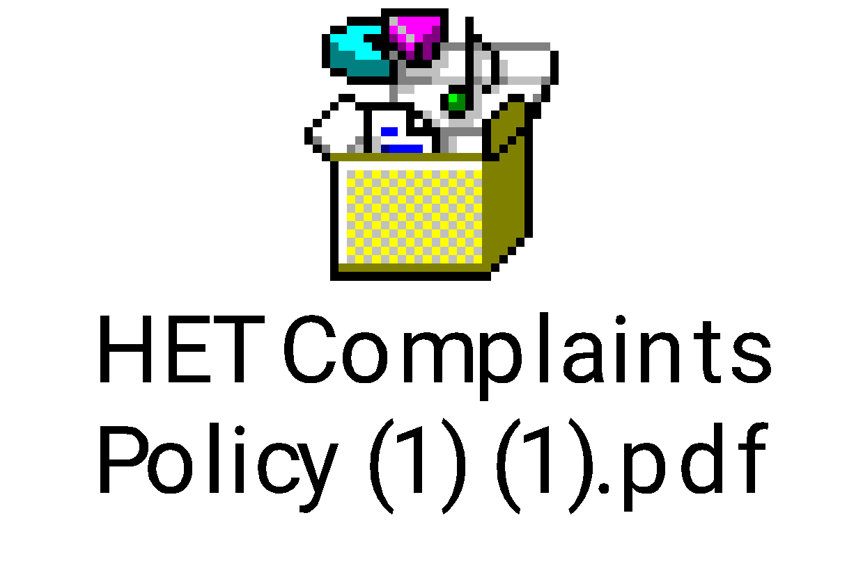
What is in the West Sussex local offer?   | Please see the West Sussex Local Offer Website https://www.westsussex.gov.uk/local-offer/
What does our school contribute to the local offer?   | Link to local offer  
What do these SEND terms and acronyms mean?   | SEND Glossary:  - Access arrangements – special arrangements to allow pupils with SEN to access assessments or exams  - Annual review – an annual meeting to review the provision in a pupil’s EHC plan  - Area of need – the 4 areas of need describe different types of needs a pupil with SEN can have. The 4 areas are communication and interaction; cognition and learning; physical and/or sensory; and social, emotional and mental health needs  - CAMHS – child and adolescent mental health services  - EHC needs assessment (EHCNA) – the needs assessment is the first step on the way to securing an EHC plan. The local authority will do an assessment to decide whether a child needs an EHC plan  - EHC plan (EHCP) – an education, health and care (EHC) plan is a legally-binding document that sets out a child’s needs and the provision that will be put in place to meet their needs  - First-tier tribunal / SEND tribunal – a court where you can appeal against the local authority’s decisions about EHC needs assessments or plans and against discrimination by a school or local authority due to SEND  - Graduated approach – an approach to providing SEND support in which the school provides support in successive cycles of assessing the pupil’s needs, planning the provision, implementing the plan, and reviewing the impact of the action on the pupil  - Intervention – a short-term, targeted approach to teaching a pupil with a specific outcome in mind  - Local offer – information provided by the local authority that explains what services and support are on offer for pupils with SEND in the local area  - Outcome – target for improvement for pupils with SEND. These targets don't necessarily have to be related to academic attainment  - Reasonable adjustments – changes that the school must make to remove or reduce any disadvantages caused by a child’s disability  - SENCO/SENDCO – special educational needs and disabilities co-ordinator  - SEN – special educational needs  - SEND – special educational needs and disabilities  - SEND Code of Practice – the statutory guidance that schools must follow to support children with SEND  - SEN information report – a report that schools must publish on their website, that explains how the school supports pupils with SEN  - SEN support – special educational provision that meets the needs of pupils with SEN  - Transition – when a pupil moves between years, phases, schools or institutions

