**Girls & Boys Football Finals Tournament (Y5/6) – Wednesday 9th October**

This event is taking place on **Wednesday 9th October** for selected children from Years 5/6 at the East Grinstead Sports Club. The girls’ event is taking place from **10am to 12 noon** and the boys’ event from **1pm to 3pm**. Football kit will be supplied by the school. Please refer to the letter sent out on 30th September for the full details with regards to timings etc. **Please can all consent forms be returned to the office no later than Monday 7th October in order for your child to attend.**

**Phonics Meeting for Reception/Year 1 Parents – Thursday 10th October**

We would like to invite Reception parents (Y1 parents are also welcome)to a Phonics Meeting on **Thursday 10th October between 6pm and 7pm.** In this meeting you will learn how to help your child with their phonics and early reading. We look forward to welcoming you.

**Harvest Festival – Friday 11th October**

We are delighted that we will be holding our Harvest Festival at St Dunstan’s Church on **Friday 11th October** commencing at **11am**. We would very much appreciate a small donation from each child to support the East Grinstead Foodbank. They do require a large number of donations to make up Christmas bags for local families and we would appreciate receiving donations on the morning of Friday 11th October.

We would very much appreciate assistance with walking the children to the Church and if you are able to assist, please let us know. You are very welcome to stand at the back of the Church and watch the service if you are able to help. We will be leaving school at approximately **10.30am** and returning to school at approximately **11.30am**. Thank you.

**Cross Country Run at East Court (Y4 to Y6) – Sunday 13th October**

Thank you to all the children who have signed up for this event and to all the parents and Mr Gowers for giving up their Sunday afternoon. We have now registered our team. Please refer to the letter sent out on 18th September with the full details and timings of the races. If there are any parents that could assist with training the children during school lunchtimes this week, please speak to Mrs Pitcaithly or email the school office – thank you.

**Hot School Meals – Chartwells ‘Back to School’ Menu**

When we return from the October half-term on **Monday 4th November**, we will be on a ‘back to school’ menu, therefore parents will need to reorder the meal for this day as all previous meals have been cancelled.

**Chartwells Christmas Lunch**

The Christmas Lunch is taking place on **Thursday 12th December**. If you would like to order a hot school lunch for this day, please do so on ParentPay no later than **Thursday 28th November**. The menu is attached.

**Nasal Flu Vaccination – Thursday 7th November**

A letter was circulated from the NHS Immunisation Team on Wednesday 2nd October giving details on how to book the flu vaccination for your child, which is taking place in school on **Thursday 7th** **November.** Please follow the link on the letter as permission cannot be given via the school. If you require a paper copy of the letter, please ask the school office.

**The Annual Scarecrow Trail**

The Scarecrow Trail is coming up and this year we're celebrating The Creatives.  Find your muse whether it's Banksy, Beethoven, Tim Burton or even the greatest creative of all - yourself!  Be as creative as you like, the only limit is your imagination. The Scarecrow Trail will be running over half term from **Sunday 27th October – Sunday 3rd November** but entries are open now! Send your entries to [ptfa@ashurstwoodprimary.co.uk](mailto:ptfa@ashurstwoodprimary.co.uk) or drop them into the school office **(application form attached).**

We need your name, address where the Scarecrow will be displayed and £5 entry fee (£20 for businesses which includes an advert in the booklet) to secure your Scarecrow.  The Scarecrow's name and identifying question would also be useful but that can be supplied later on.

**Ashurst Wood School News Letter**

**Week 5 – 7th October 2024**

Attendance last week: 96.53%

Attendance from September 2024: 95.56%

**Tuesday 8th**

Year 2 Forest Schools (AM)

Reception Forest Schools (PM)

**Wednesday 9th**

Year 5/6 Football Finals – EG Sports Club: Girls 10am to 12 noon/Boys 1pm to 3pm

Football Club (3.20pm to 4.20pm)

Sewing Club

(3.20pm to 4.20pm)

Karate (3.25pm to 4.25pm)

**Thursday 10th**

Headteacher’s drop in (9am to 10am)

Year 1 Forest Schools (AM)

Eagles Forest Schools (PM)

Phonics Meeting for Parents – YR/Y1 (6pm to 7pm)

**Friday 11th**

Harvest Festival at St Dunstan’s Church (11am)

Achievement Assembly – all welcome (2.50pm)

Kicks Dance (3.30pm to 4.30.

**Sunday 13th**

Cross Country Run (Y4 to Y6) – East Court

**Polite Reminders & Notices**

**This week’s Dates to remember**

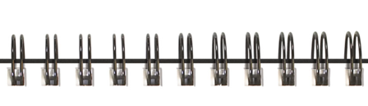

On Wednesday 2nd October, a team of Year 3/4 children were invited to attend a Netball Festival. The purpose of this event was to introduce the younger children to the game of netball and although this wasn’t a competition we played extremely well and showed great team spirit. Our thanks are offered to Isabelle, Thea C, Grace, Florence, Joshua, Halley, Isabella, Fran, Thea S, Grayson and JJ for representing our school at this event.

**Achievements**

**Meet your Member of Staff**



Hello everybody, my name is Mrs Hayley Davis. I have been at Ashurst Wood for 6 years and I have been teaching for 13 years. I am Key Stage One lead, as well as leading Maths and Science across the school. Many of you would have been used to seeing me in Key Stage 2, but after returning from maternity leave and having my daughter, I have come back into Hawks class and am loving every minute of it!

After completing my degree and before working as a teacher, I was cabin crew with British Airways. I had an amazing time traveling the world and seeing some fantastic sights. This allowed me to experience a broad range of cultures and gain valuable life experience.

I have a husband and three children who are 9, 7, and 1. They all keep me very busy when I am not at work! In my spare time I enjoy spending quality time with my family; going on walks, spending time in my garden, and dancing around the kitchen with my children (this is a really good giggle)!

I love teaching at Ashurst Wood as we really are a small school with a big heart. I enjoy my daily interactions with the children, getting to know them on an individual basis and building strong relationships; to me, this is fundamental to teaching. I love hearing the children share their successes, and on occasion being a part of those achievements. Seeing and sharing in these really special moments in teaching is great. For me, teaching is not just a job but my passion; I wish to inspire all children to reach their full potential ready for the next stage in their life, whatever that may be.



The new play equipment has arrived. Thank you to our amazing PTFA – The children love it!

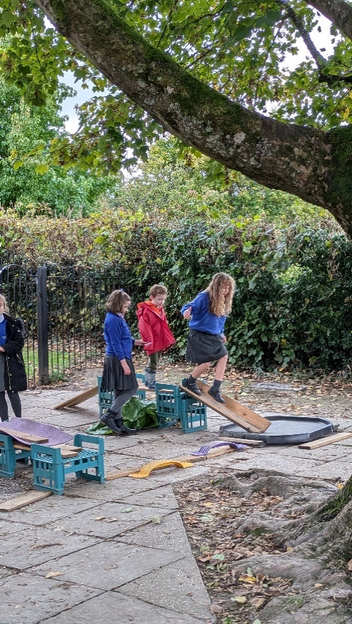

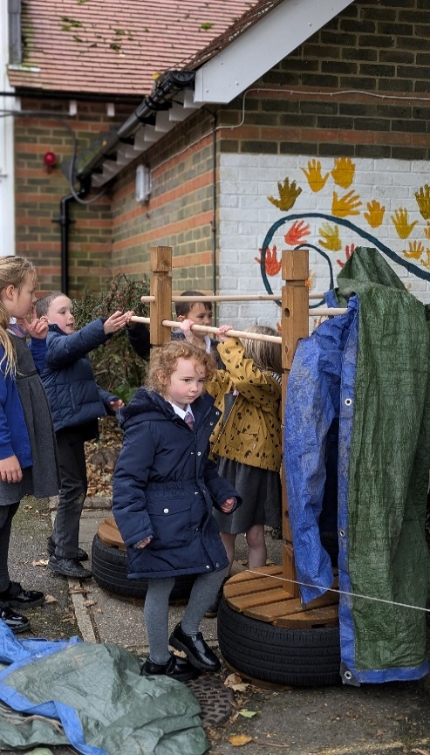

## **English: Inverted Commas**

These are used to indicate direct speech for example, the conductor shouted, “Sit down!”

They used to be called speech marks but the National Curriculum uses the vocabulary inverted commas.

**Maths: Number Line**

A line where numbers are represented by points upon it.

**Curriculum Vocabulary**

## **Maths Word of the Week…**

**‘Number Line’**

A line where numbers are represented

by points upon it

## 