Ashurst Wood Primary School

School Uniform Policy

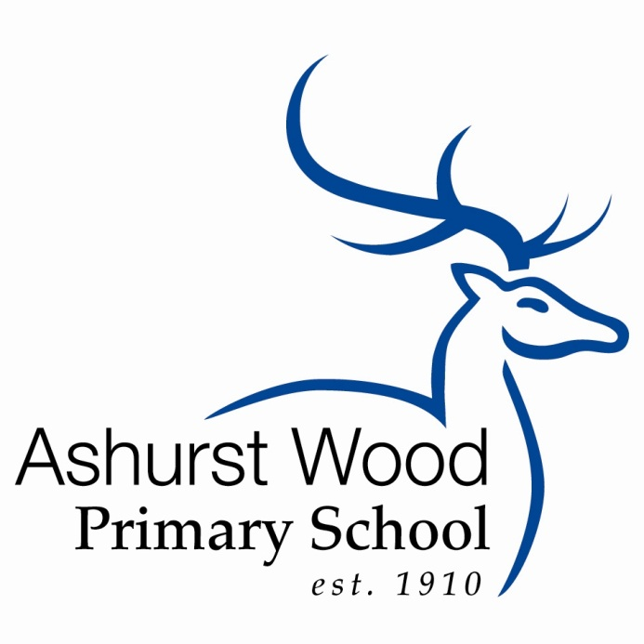

Reviewed June 2026

Review Date Summer 1. 2027

Ashurst Wood Primary School Uniform

At Ashurst Wood we pride ourselves in being smart, well presented and ready for learning. We ask children to take pride in their personal appearance. It is our school policy that all children wear school uniform when attending school, or when participating in school-organised events outside normal school hours.

We make every effort to consult with parents when making decisions concerning uniforms. Following consultation, a simplified active uniform will commence from September 2026. There will be a two-year transition period with all children wearing the new uniform by September 2028.

Uniform items can be purchased through Taylor made uniforms

Our policy on school uniform is based on the belief that we are pleased to wear a uniform that:
• Promotes a sense of pride in our school
• Helps to create a sense of community and belonging towards the school
• Identifies pupils with the school
• Supports the school’s commitment to inclusion
• Prevents pupils from wearing ‘fashion clothes’ that could be distracting in class • Is practical, smart, and designed with health and safety in mind
• Is considered to be good value for money

Jewellery, Hair Ornaments, Make-up and Nail Varnish

For many reasons, including safety, we do not allow children to wear jewelry. The exceptions to this rule are ear-ring studs in pierced ears, one piercing in each ear only. Children are required to remove any items during P.E. lessons to prevent them from causing injury. For this reason, piercings should only happen during the summer holiday so that ears have six weeks to heal before having to be removed. Please note: teachers are not permitted to remove earrings.

Hair bands, ribbons/bows or ‘scrunchies’ should be plain and either royal blue or pink to match our uniform. Hair bands should not have large flowers or other decorations attached.

Make up and nail varnish should not be worn to school. Extreme hairstyles are not appropriate for school. The use of styling products should be kept to a minimum and children should not have decorative patterns cut into their hair or have their hair coloured or dyed. Tattoos, temporary or otherwise are not permitted.

Footwear

All children are required to wear plain black leather or leather like material trainers or trainer like school shoes. (Fabric top trainers are not waterproof and are therefore not permitted). Visible logos are not permitted.

The Role of Parents

We believe that one of the responsibilities of parents is to ensure that their child has the correct uniform and that it is clean, in good repair and that the child’s name is visibly labelled on all items. If a parent has difficulties for any reason with fulfilling this request, they are asked to speak confidentially to a senior member of staff to discuss the issues. Parents should be assured that we will do all we can to help.
Children who arrive at school wearing non-school uniform clothing will be loaned an appropriate item from our lost property to wear for that day if possible. The same system will apply for children who do not have a Forest School kit. Parents will be contacted to discuss the matter.
The school welcomes children from all backgrounds and faith communities. If there are serious reasons, for example on religious grounds, why parents want their child to wear clothes that differ from the school uniform, the Uniform Policy will consider such requests sympathetically. If any parent would like to request an exception to the uniform policy they should, in the first instance, contact the Headteacher. If not resolved follow the complaints policy which available vis the school's website. Ashurst Wood Primary School Policies

The Role of Governors

The governing body supports the Headteacher in implementing the School Uniform Policy. It considers all representations from parents regarding the Uniform Policy and liaises with the Headteacher to ensure that the policy is implemented fairly and with sensitivity. It is the governors’ responsibility to ensure that the school uniform meets all regulations concerning equal opportunities. Governors ensure that the School Uniform Policy enables children to dress sensibly, in clothing that is hardwearing, safe and practical.

Monitoring and Review

The Governing Body monitors and reviews the School Uniform Policy through its committee work by:
• seeking the views of parents, to ensure that they agree with and support the policy;
• considering, with the Headteacher, any requests from parents for individual children to have special dispensation with regard to school uniform.

Forest School Kit
It is advised that school uniforms are not worn on Forest School days and old clothes that may become dirty are recommended. Clothes that will probably be needed are listed below, but please take into account local weather conditions and dress children appropriately.

Forest School Winter Uniform | Forest School Summer Uniform
Vest or T-shirt | Long sleeved light T-shirt  Arms must be covered in the woodland
Long sleeved top | Light trousers – NO shorts  Legs must be covered in the woodland
Hooded top/Fleece or thick jumper  On really cold days layers with 2 or 3 jumpers are most effective | Socks
Waterproof jacket | Wellington boots or walking boots  Trainers, sandals and flip-flops are NOT suitable
Thick socks / Thermal socks or 2 pairs thin socks | Sunhat
Warm trousers | Sunglasses if required
Waterproof trousers | Sunscreen/Insect Repellent  Pupils are responsible for providing and applying their own sunscreen/repellent
Wellington boots or walking boots
Hat, gloves and scarf
Flannel/small towel | Flannel/small towel
Metal or plastic mug with handle and  teaspoon | Metal or plastic mug with handle and  teaspoon

Buying & Sizing Guide
For Ashurst Wood Primary
www.taylormadeuniforms.co.uk

When to Buy: End of July or Early August This allows your child to grow a bit more – so you will have the right size and will last them the year.

What to Buy: 1 or 2 Training tops These wash easily and dry quickly however you may wish to have two so that you do not have to turn around any emergency washing needs in one night.

1 or 2 Polo shirts

1 or 2 pair of joggers In the warmer weather children can wear shorts or a
or leggings from Y2 skort.

All other items available are optional.

For Example: If your child is already wearing a size 5/6, then order the 6/7. Always go up one size, to make it last the whole year.
All orders are processed within 24 hours, please check your SPAM file for our confirmation email.

Returns:
Returns & Exchanges will be accepted as long as all items are in their original packaging and with tags still attached.
Please email us with the order number and details of what you wish to change, so that we have time to prepare your exchange.
Exchanges takes 24 hours.

Sizes
Training top |  | Polo shirt |  | Cool Polo shirt
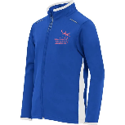 |  | 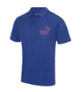 |  | 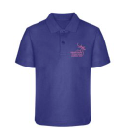
4/5 Yrs 22/24  5/6 yrs 24/26  7/8 yrs 26 / 28  9/10 yrs 28/30  11/12yrs 30/32  12/13yrs 32/34  13/14 yrs 34/36 |  | 4/5 Yrs 24  5/6 yrs 26  6/7 yrs 28  7/8 yrs 30  9/10 yrs 32  XS adult 36 |  | 3/4 Yrs 26  5/6 yrs 28  7/8 yrs 30  9/11 yrs 32  XS adult 36
Track suit bottoms | Leggings  (Y2 up) |  | Shorts |  | Skort
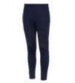 | 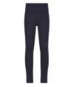 |  | 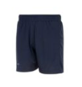 |  | 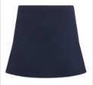
4/5 Yrs 16/18  5/6 yrs 18/20  7/8 yrs 22/24  9/10 yrs 26/28  11/12yrs 28/30  13/14 yrs 32 | 3/4 Yrs 98/104cm  5/6 yrs 110/116cm  7/8 yrs 122/128cm  9/10 yrs 134/140cm  11/12yrs 146/152cm |  | 4/5 Yrs 18/20  5/6 yrs 20/22  7/8 yrs 22/24  9/10 yrs 24/26  11/12yrs 26/28  XS adult 28/30 |  | 4/5 Yrs 18/20  5/6 yrs 20/22  7/8 yrs 22/24  9/10 yrs 24/26  11/12yrs 26/28  XS adult 28/30

Collections can be made once you have received your confirmation email.
Please use RH12 4ST for Sat Nav – follow pink signs and flags. We are not at the farm; we are next door to Travis Perkins opposite Kilnwood Vale (in the industrial estate).
Please check your SPAM file for our confirmation email.
During the school year we deliver free of charge to the school every Friday, please order by 3pm Thursday.
www.taylormadeuniforms.co.uk

