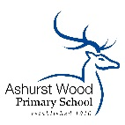
ASHURST WOOD PRIMARY SCHOOL-ART POLICY

CURRICULUM INTENT
At Ashurst Wood Primary our curriculum is designed to facilitate the school vision.
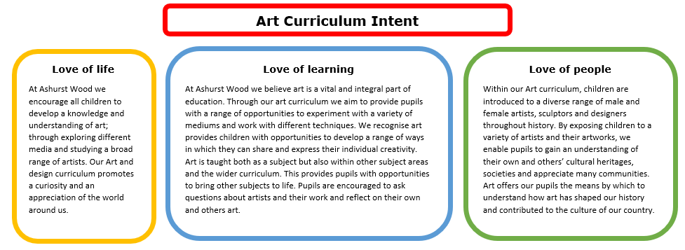

Art, craft and design embody some of the highest forms of human creativity. A high-quality art and design education should engage, inspire and challenge pupils, equipping them with the knowledge and skills to experiment, invent and create their own works of art, craft and design. As pupils progress, they should be able to think critically and develop a more rigorous understanding of art and design. They should also know how art and design both reflect and shape our history, and contribute to the culture, creativity and wealth of our nation. (National Curriculum, 2014)

Implementation Overview
The implementation of the Art and Design curriculum at Ashurst Wood Primary School is based on the National Curriculum for Key Stage 1 and 2 and the Early Years Foundation Stage (EYFS) programmes of study. Children at both Key Stages and EYFS will develop knowledge, skills and understanding through a well-planned and ambitious curriculum. Children receive a rich and exciting Art curriculum which is designed to build knowledge and skills as well as enabling children to express their own personality and creativity. There is a focus on exploration and reflection through sketch books.
The school’s high quality art curriculum is supported through the availability of a wide range of quality resources, which are used to support children’s confidence in the use of different media.

Teaching of Art in EYFS
The EYFS provides a rich environment in which we encourage and value creativity. Art is a fundamental part of the work covered throughout the year in EYFS. Pupils are provided with opportunities to explore and experiment with different art styles through these different topics. The pupil’s creative development is underpinned by the objectives set out in the programmes of study.

We use a variety of teaching and learning styles in our Art and Design lessons to cater for the variety of learning styles of pupils. Teachers provide demonstrations of techniques in unit of work. They model techniques and talk through the processes involved. Children study a range of artists and use similar techniques to the artists. Throughout the curriculum children evaluate their won and their peers work.

CURRICULUM PLANNING
Teachers are provided with a long-term plan which has three core threads: Drawing and sketch books, surface colour and working in three dimensions. One unit from each strand is taught each term and in the half term that art is not a key focus sketchbooks are used each week to continue developing key knowledge and reflection. The long-term plan builds upon prior learning and offers children the opportunity to develop and practise knowledge and skills as they move up through the school.

Teachers and children work collaboratively to design an engaging, enriching, and relatable curriculum which stimulates curiosity and imagination. Other curriculum areas are also used to explore different areas of Art such as: Science i.e. making close observations of rocks and plants and recording these through drawing. Some of our Art teaching is further enhanced through our Forest School provision and outdoor learning. Forest School sessions provide pupils with opportunities to create clay animals using natural materials, experiment with carving wood and recreating artwork based on different artists such as Andy Goldsworthy.

SPECIAL EDUCATIONAL NEEDS
At our school, we teach Art to all pupils, regardless of their ability and individual needs. This is in accordance with the school's curriculum policy of providing a broad and balanced education to all children. Teachers provide learning opportunities matched the needs of the children in their class to ensure all children are making good progress and can reach their full potential in the art and design curriculum. We aim to include all children in their art and design lessons by differentiating the learning outcome, using different resources or adult support from the teacher or teaching assistants to enable equal access to learning in art and design. A variety of children’s outcomes are displayed around the school to highlight all children’s successes within their art learning.

SPIRITUAL, MORAL, SOCIAL & CULTURAL DEVELOPMENT
At our school children will have opportunities in Art and Design to:
Spiritual
Be introduced to the work of great Artists and experience wonder and awe at the achievements of these great works of art.
Use imagination and creativity to explore ideas, feelings and express themselves through their own art and design outcomes.
Moral
Show compassion and consideration when assessing the work of others and be able to understand how their comments can build up or upset another’s self-belief.
Social
Work in pairs or groups collaboratively to create a piece of artwork, research an artist or evaluate a piece of art. Thus, developing teamwork and cooperative skills.
Respect each other’s ideas and opinions when talking about pieces of art including the work of their peers.
Cultural
Study art as part of a topic and be given an insight into other cultures and providing strong links with our past.
Understand the ideas behind art in different cultures and religions.

ASSESSMENT & RECORDING
Teachers assess children’s knowledge, understanding and skills in Art and Design by making informal judgements as they observe pupils working during lessons. Teachers will provide children with verbal feedback throughout lessons, particularly when exploring and practising key skills, which will support them to make progress within the subject. Pupils are also encouraged to be self-reflective and articulate their own next steps. At the end each unit the teacher makes a summative judgement about the work of each pupil in relation to the knowledge and skills they have developed. The teacher judgements are reported to parents as part of the child’s annual school report. This information is also passed on to the next teacher at the end of each year. Art learning is also recorded in sketchbooks across the school. Pupils’ development of knowledge and skills, their observations, planning and evaluations are included in their sketchbooks. Progression from each year groups should be clear. Teachers may also store photographs of finished pieces in their sketchbooks.

MONITORING & REVIEW
The monitoring of the standards of children’s work and the quality of the teaching in Art is the responsibility of the individual teachers. Teachers work collaboratively to support each other in the teaching of Art, understanding and applying current developments in the subject, and providing direction for the subject in the school. The Art champion should evaluate the strengths and weaknesses in the subject and indicate areas for further improvement.

IMPACT
Artwork produced is of high-quality and pupils take pride in what they have created. Our art lessons are meaningful to pupils. Pupils become creative learners who have a web of knowledge about different artists from around the world. All children will have embedded the key art and design knowledge and skills needed to allow them to produce imaginative and original pieces of art. We aim to inspire children, thus gaining a love for art and possibly wanting to pursue this in the future.

