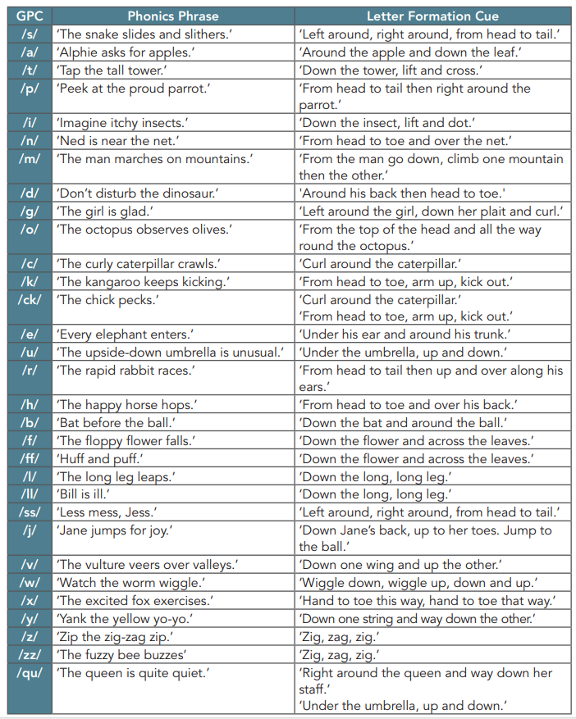
Alliterative Phrases for letter formation.

