Ashurst Wood Primary School Teaching for Mastery

A Mathematics Guide for Parents

What does Mastery of Mathematics mean at Ashurst Wood?

• It is achievable for all – we have high expectations and encourage a positive ‘can do’ mindset towards maths in all pupils, creating learning experiences which develop children’s resilience in the face of a challenge and carefully scaffolding learning so everyone can make progress.

• **Deep and sustainable learning** – lessons are designed with careful small steps, questions and tasks in place to ensure the learning is not superficial. • The ability to build on something that has already been sufficiently mastered – pupils’ learning of concepts is seen a continuum across the school.

• **The ability to reason about a concept and make connections** – pupils are encouraged to make connections and spot patterns between different concepts (E.g. the link between ratio, division and fractions) and use precise mathematical language, which frees up working memory and deepens conceptual understanding.

• **Conceptual and procedural fluency** – teachers move maths from one context to another (using objects, pictorial representations, equations and word problems). There are high expectations for pupils to learn times tables, key number facts (so they are automatic) and have a true sense of number. Pupils are also encouraged to think whether their method for tackling a given calculation or problem is Appropriate, Reliable and Efficient (A.R.E).

• **Problem solving is central** – this develops pupils’ understanding of why something works so that they truly have an appreciation of what they are doing rather than just learning to repeat routines without grasping what is happening.

• Challenge through greater depth - rather than accelerated content, (moving onto next year’s concepts) teachers set tasks to deepen knowledge and improve reasoning skills within the objectives of their year group.

The aim of this booklet is to provide our families with an understanding of what Teaching for Mastery looks like at Ashurst Wood; how we teach the four calculations and how you can support your children at home with their maths learning.

In line with the National Curriculum and current best practice, the children are taught to become fluent in the fundamentals of mathematics (including calculation strategies); reason mathematically using mathematical language and apply their knowledge and understanding to problem solving tasks. In order to achieve these objectives for all our pupils, we have begun to embed a Teaching for Mastery approach.

Our aim at Ashurst Wood is for all children to enjoy maths and have a secure and deep understanding of fundamental mathematical concepts and procedures when they leave us to go to secondary school.

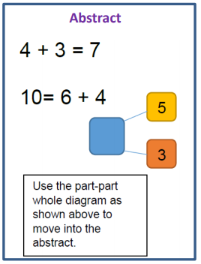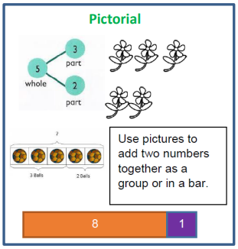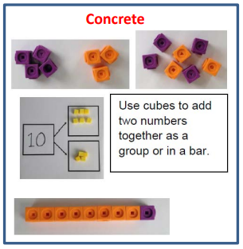

This approach is the cornerstone of how we support pupils who are finding a concept more difficult to grasp. Wherever possible, we bring the learning back to the concrete and pictorial.

Addition: Combining two parts to make a whole.

Teaching for Mastery at Ashurst Wood has CPA at its core:

Concrete - providing children with objects and resources to manipulate in order to demonstrate their mathematical thinking.

Pictorial - providing opportunities for children to represent their mathematical thinking through diagrams, images, drawings or models.

Abstract – providing opportunities for children to become more familiar with formal mathematical representations including signs, symbols and digits.

Reasoning: Talking and thinking like a mathematician: The strategies below are used in school and can be reinforced at home too.

Maths language often uses common words in a new context, for example: table, right, difference and product. It is crucial children have a secure grasp of mathematical vocabulary. For a comprehensive and interactive online maths dictionary visit [www.amathsdictionaryforkids.com](http://www.amathsdictionaryforkids.com)

Always encourage your child to explain how they have gone about solving a problem, and work with them to test, prove, explain, reflect



Questioning and prompts are powerful tools to boost your child’s mathematical thinking. Encourage your child to answer in complete sentences using accurate mathematical vocabulary. Reasoning about and discussing maths problems in a way that others can understand, demonstrates depth of understanding – another fundamental aspect of mastering maths.

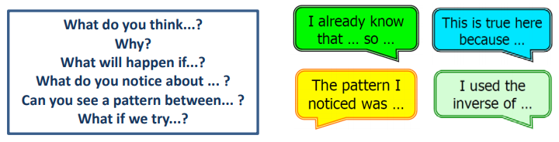

In school, teachers give children access to different types of reasoning questions, including: 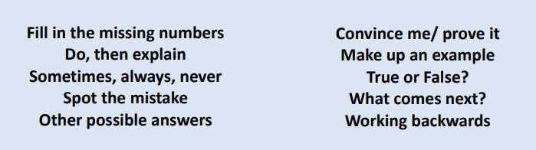

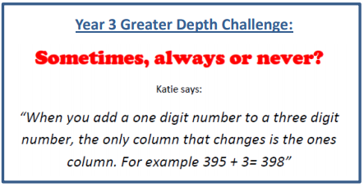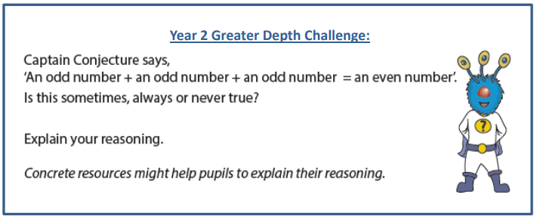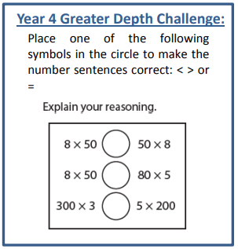

If your child finds maths tricky, you may be concerned that they will not keep up with whole class teaching. However, we aim to break learning down into small, deliberate, purposeful steps. By using a CPA approach, wherever possible, and spending more time on difficult concepts, we build pupils’ understanding and confidence. Pupils may also be given extra time to practise with an adult if needed.

**How do we ensure all children succeed?**

The 2014 Curriculum set higher expectations for pupil achievement and the expectation is that the majority of pupils will move through the programmes of study at broadly the same pace. To develop true fluency, reasoning and problem solving skills, mastery is about keeping children together and not moving on at an over rapid pace.

All pupils benefit from deepening their conceptual understanding of mathematics, regardless of whether they have previously struggled or excelled. Pupils are given time to fully understand, explore and apply ideas, rather than accelerate through new topics. This approach enables children to truly grasp a concept, and the challenge comes from investigating it in new, alternative and more complex ways. Teachers will set challenge or investigative tasks accordingly. This means that pupils who grasp an idea quickly will not be raced onto content from a higher year group.

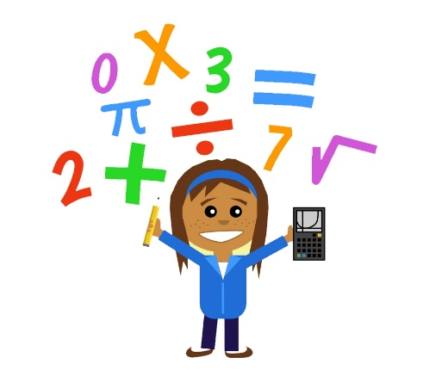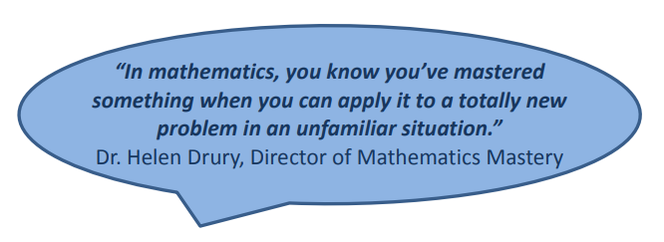

**How can you help at home?**

**Encourage a growth mindset** – all children can achieve in mathematics! There is no such thing as a ‘Maths person’, (the belief that some pupils can do maths and others cannot)). By doing this at home and at school, we will foster the following beliefs in your children:

• effort creates success.

• skill and ability can be increased over time.

• mistakes should be viewed as an opportunity to learn and develop.

• resilience – don’t give up easily.

**Help your child learn times tables and key number bonds at home** - having key facts at their fingertips frees up their working memory**. By the end of Year 4 they should know all of their tables to x12**. If they can learn them quicker than that – all the better! ENCOURAGE your child to practise their multiplication tables or number bonds for 3 minutes a day. Make it FUN, use timers, songs and computer games.

Useful websites and multiplication games:

[www.topmarks.co.uk](http://www.topmarks.co.uk)

[www.everyschool.co.uk](http://www.everyschool.co.uk) - Learn Your Tables

And remember Times table Rock stars <https://ttrockstars.com/>

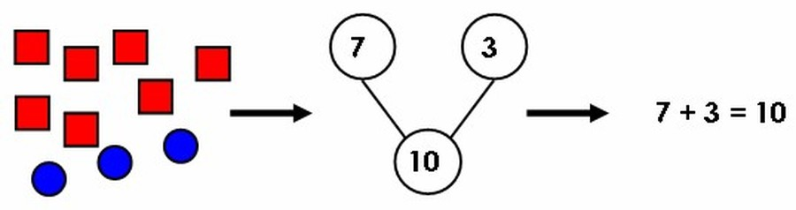

**Ideas for KS1 parents**

Sing number rhymes together—there are lots of commercial downloads and CDs available.

• Give your child the opportunity to count a range of interesting objects (coins, pasta, shapes, buttons etc.). Encourage them to touch and move each object as they count.

• Count things you cannot touch or see (more difficult!!). Try lights on the ceiling, window panes, jumps, claps or oranges in a bag.

• Play games that involve counting (e.g. snakes and ladders, dice games, games that involve counting objects).

• Look for numerals in the environment. You can spot the numerals at home, in the street or when out shopping.

• Make mistakes when chanting, counting or ordering numbers. Can your child spot what you have done wrong?

• Choose a number of the week e.g. Practise counting to 5 and on from 5. Count out groups of 5 objects (5 dolls, 5 bricks, 5 pens). See how many places you can spot the numeral 5.

• Halve and doubling numbers, ordering random numbers, counting in 2s, 5s and 10s.

• Learning number bonds up to ten using your fingers. Give your child a number up to ten and ask your child to give you the different ways of making it e.g. 7 could be made by adding 6 + 1 or 5 + 2 etc..

• Throw two or more dice. Ask your child to find the total of the numbers (+) and the difference between (-). Can they do this in their heads?

• Use a set of playing cards. Turn over two (progressing to three or more) cards and ask your child to add or subtract them. If they answer correctly, they keep the cards. How many cards can they collect in two minutes?

• Play ‘ping pong’ to practise number bonds with your child. You say a number. They reply with how much more is needed to make 5, 10 and 20. Encourage your child to answer questions quickly, without counting or using their fingers.

• Plan an outing during the holidays. Ask your child to think about what time you will need to set off and how much money you will need to take.

**Ideas for KS2 parents**

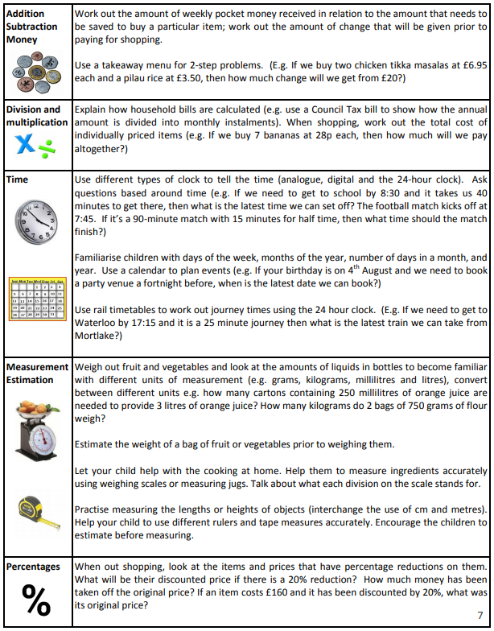

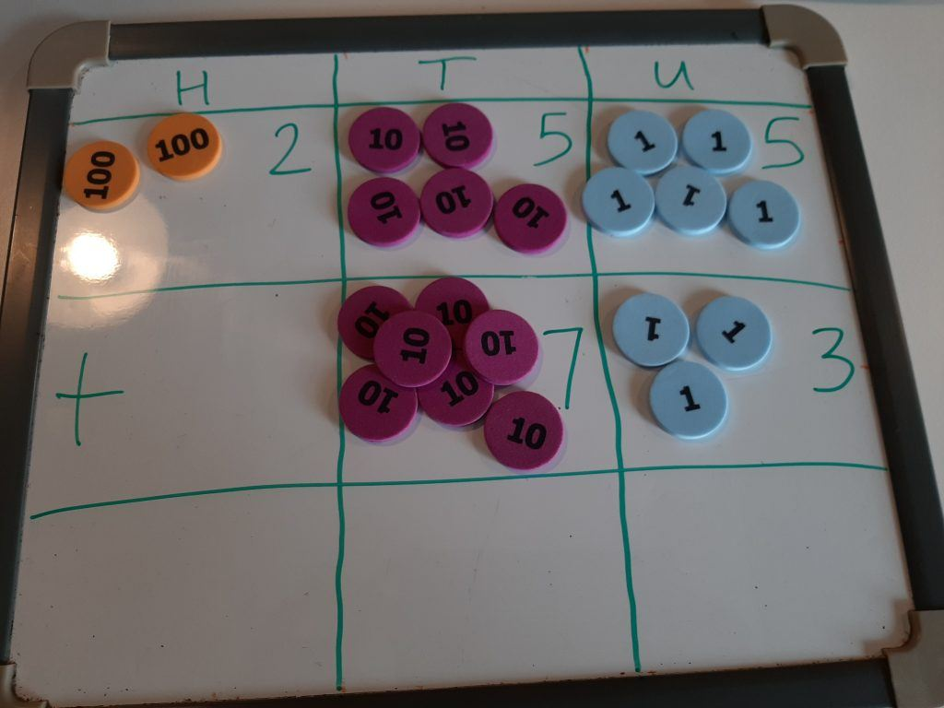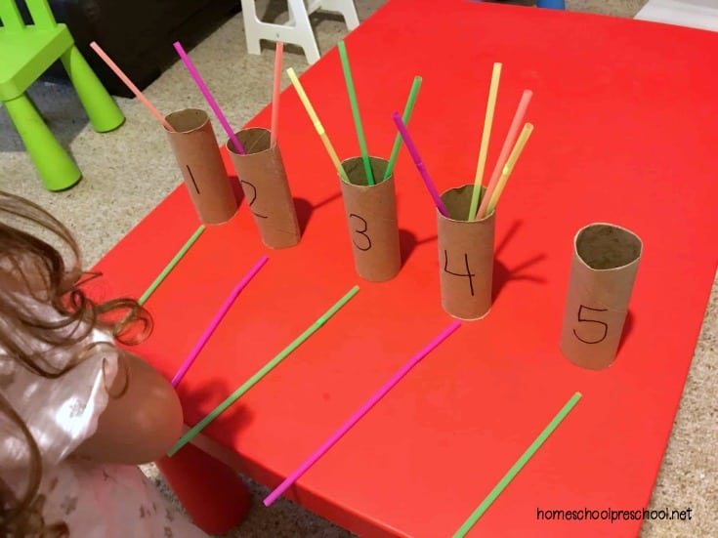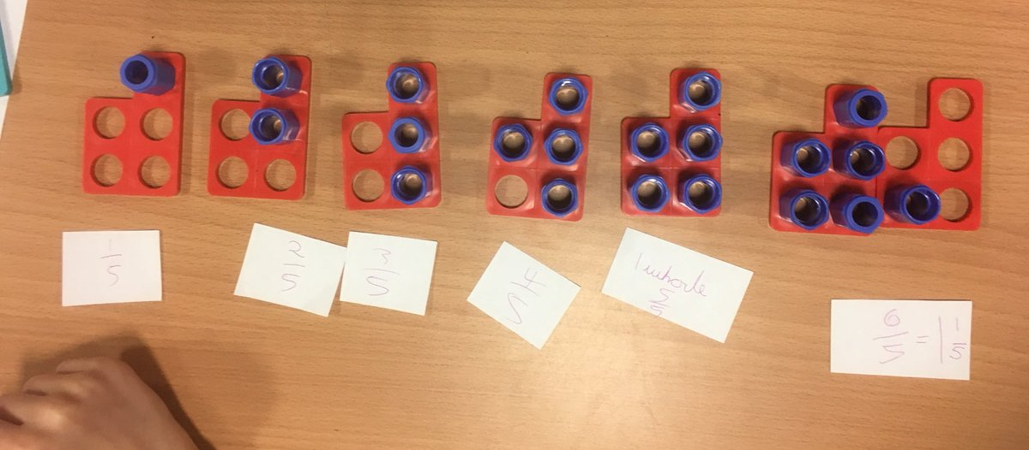

**Calculation methods**

The children are introduced to a number of different calculation methods throughout their time at school. They are encouraged to recognise and use methods of calculation which they can complete accurately and with increasing efficiency. Wherever possible, children are encouraged to work mentally to solve calculations and consider which method is most efficient for a given calculation. In the face of more challenging, multi-step problems, the children are taught to employ systematic formal written methods.

Pupils are also encouraged to discuss with their teachers and each other the efficiency and suitability of different mental and written strategies, explaining their thinking with the appropriate mathematical vocabulary. Through this process, they are able to demonstrate their own understanding and share their mathematical knowledge with others.

Some useful maths websites for children and parents:

[www.nrich.maths.org](http://www.nrich.maths.org)

<http://www.amathsdictionaryforkids.com/dictionary.html>

<http://www.bbc.co.uk/schools/websites/4_11/site/numeracy.shtml>